|  |
| --- |
|  |
| Strategic Planning & Response Monitoring |
| *Monitoring Implementation and Quality* |
|  |
| **Global WASH Cluster** |

Table of Contents

1. Humanitarian Response Planning (HRP) 1

2. Response Monitoring 2

3. Actionable Gap Analyses 4

1. Humanitarian Response Planning (HRP)

The WASH Cluster Coordinator develops the WASH HRP in collaboration with a Strategic Advisory Group (SAG), and may draw from an existing Strategic Operating Framework (SOF), or use the HRP process to simultaneously develop a more detailed SOF.

The Information Management aspects of the process involve:

1. The identification of needs, partner capacity and WASH Cluster caseload information to define the humanitarian response to the assessed needs of the affected population (covered in the previous Chapter).
2. The identification of appropriate (i.e. SMART) indicators, baselines and targets for the WASH response logframe & their integration in the response tracking system
3. Ensuring smooth information flow within the participative process

***Strategic Indicators for SOF, SRP & 4W***

Once the overall Strategic Objectives (SOs), parameters, boundaries and assumptions have been defined for the response by the Humanitarian Country Team (HCT), Clusters will organise around the SOs to agree on how to collaborate and ensure an integrated approach. Formal or informal agreement on areas of overlap with other clusters will be important to identify and agree on respective roles & responsibilities; the inter-cluster matrices in the *Useful Resources* provided a basis for discussion.

Having defined how to work together, the Clusters develop their respective cluster response plans, logframes and priorities to contribute to the overall country strategy / SOs, and within the parameters and boundaries of the overall response. ***It will be critical to ensure a clear linkage from the Strategic Indicators, through the WASH logframe, to the Activity Tracking (aka 4W) system***.

***Participative process***

In defining the WASH response framework, various working groups or workshops might occur to discuss and validate the response logframe, priorities, indicators, baselines and targets. It will be important to maintain a smooth flow of information to all stakeholders during this process.

The Cluster Coordination Unit will also organise a transparent project validation process, for which clear selection criteria will need to be elaborated, ideally in conjunction with the SAG. It is critical that these are considered and communicated to cluster partners. Some tips in this regard include:

* Easier identification of duplications or gaps requires the pre-agreed use of the Enhanced Geographic Fields (EGFs) as detailed in OPS reference materials, or some alternate tracking mechanism.
* Use of ‘indirect costs’ as a selection criteria will require joint pre-agreement on the definition of ‘indirect costs’ – ideally under the Inter-Cluster Coordination mechanisms.
* Pre-Agreement with other key clusters as to how to manage joint reviews / multi-sectoral projects – e.g. WASH in Schools or Health Centers – within the overall HRP timeline.

|  |  |
| --- | --- |
| 1. Key Resources | * 1. Additional Resouces |
| **A WASH monitoring framework & calculations**   * + An example of a monitoring framework and indicator calculations   **A WASH HRP Overview for partners**   * + One excel providing an overview of the HRP process provided to partners including: project selection criteria; timelines; and WASH framework detailing priority areas and indicative activities   **A WASH projects vetting matrix & analysis**   * + One excel providing an overview of the project validation process by the coordination unit, including: identification of potential duplications or gaps; analysis by funding, coverage, objective and priority. | **Strategic Operating Framework**   * + A guide on how to develop a SOF – overlapping and complementary to many key elements of the HRP (e.g. standards; data flows; priority activities; best practice outputs from TWGs). The iterative document provides orientation to any incoming WASH actor, and can be drawn on in the development of any HRP.   **Inter-Cluster Matrices**   * + Inter-Cluster Matrices of Roles & Accountabilities: global-level agreements on the respective roles and accountabilities of Clusters in areas of potential overlap. As a general rule, this seeks to ensure that other Clusters take responsibility for the WASH aspects within their institutions (e.g. health centers; schools; etc.), while WASH is responsible outside the institutions, and can provide technical support, standards, etc.   + These documents are intended to be adapted in-country, and will be important to define amongst Clusters around specific SOs, prior to the development of cluster / multi-cluster response plans.   **Environment and Gender Markers**   * + In most countries one or both of these markers may be used. Resources provide an overview of what they are, and some basic guidance to provide partners to facilitate their consideration during project elaboration.   **Online Project System**   * + Basic reference documents related to the OPS (check for updated versions on the OPS site). |

1. Response Monitoring

While the HRP and WASH SOF are being finalised, the WASH IMO should, in tandem and in consultation with the coordinator, be developing a WASH response monitoring system. Response Monitoring is defined by the IASC as: *a continuous process that records the aid delivered to an affected population as well as the achieved results against the objectives set out in the HRP. It tracks the inputs, and the outputs resulting from interventions to affected populations; charts the outcomes of cluster activities; and measures progress towards the objectives of the HRP, while considering the diversity of the affected population and their perspectives of the response.*

**Inputs**

**Activities**

**Outputs**

**Outcomes**

**Impact**

Resources

Results

* $ 50,000
* 10 WASH staff
* Construct latrines: 40 male; 60 female
* Install 100 handwashing stations
* # of males / latrine
* # of females / latrine
* % of latrines with handwashing stations
* # and % of affected population with access to minimum sanitation
* Reduced risk of diarrhoeal disease propagation

**Activity tracking: W-tool**

*Capacity Mapping / FTS*

*Triangulation*

The core of response monitoring is via ‘W-tools’ (Who, What, Where, When, for Whom, commonly known as the ‘4/5/6Ws’) which are structured around the WASH SOF or HRP, and track progress in implementation of the Cluster activities and derived indicators.

In addition to providing an overview of the response, a 4W tool should be able to stratify along geographic, sub-sectoral, temporal, donor/actor, and beneficiary lines, and to provide an indication of service-level against any applicable minimum standards.

The W-tool data is usefully complemented by other datasets from ongoing needs monitoring, quality monitoring and capacity tracking when implementing operational analyses. Nonetheless, even as a standalone system, a well-structured W-tool will be able to:

* Track progress towards HRP objectives and targets
* Highlight disparities to inform adjustments in the response – these might be geographic, sub-sectoral, by type of beneficiary or response, inter-cluster, etc.
* Highlight service-level indicators for the activities, measured against the minimum standard benchmarks
* Facilitate transparency and accountability to WASH partners, donors, public and affected population

A core function of the IMO is to ensure that such operationally relevant data is available in a timely, digestible manner to support operational decision making. A well-constructed activity tracking system will also minimise the time required to fulfil upward reporting obligations, in order to maximise the time available for strengthening each part of the IM system, to enable more specific gap analyses.

***Reporting requirements***

The Cluster response tracking systems will feed into overarching response tracking systems maintained by OCHA and the CLA, and which will vary slightly from context to context. It is critical to clarify information requirements, format, and frequency, and to factor this into the Cluster’s system design.

Where possible UNICEF Humanitarian Performance Monitoring indicators should be aligned with the WASH SOF or HRP indicators, this can allow the use of the Cluster W-tool for activity reporting, and thus minimise reporting obligations for partners.

Reference and support materials are maintained both by OCHA and the CLA, and can be accessed via the links below.

|  |  |
| --- | --- |
| 2.1 Key Resources | 2.2 Additional Resources |
| The resource pack includes the necessary elements to establish a basic activity tracking system for the WASH response:  **4W Guidance Note**   * + A brief guidance note on structuring and adapting the 4W templates   **Adaptable 4W templates**   * + Series of adaptable 4W templates   **Country-level examples**   * + Collection of country-level examples of 4W structures | **OCHA PMR**  OCHA Humanitarian Monitoring resources can be found here: <https://www.humanitarianresponse.info/en/programme-cycle/space>  **UNICEF HPM**  UNICEF Humanitarian Performance Monitoring Toolkit contains useful examples and approaches, notably to quality monitoring, and can be found here:  <http://www.unicefinemergencies.com/downloads/eresource/HPM.html> |

1. Actionable Operational Gap Analyses

In addition to fulfilling our upward reporting obligations, the IMO should seek to focus the majority of their efforts on downward operational and gap analyses. Such analyses will involve the crossing of activity-tracking data (W-tool) against other datasets, nonetheless, even a standalone activity-tracking system can facilitate the analyses highlighted in blue in the diagram below, and should be mapped out while developing the *analysis plan* and building the response monitoring system:

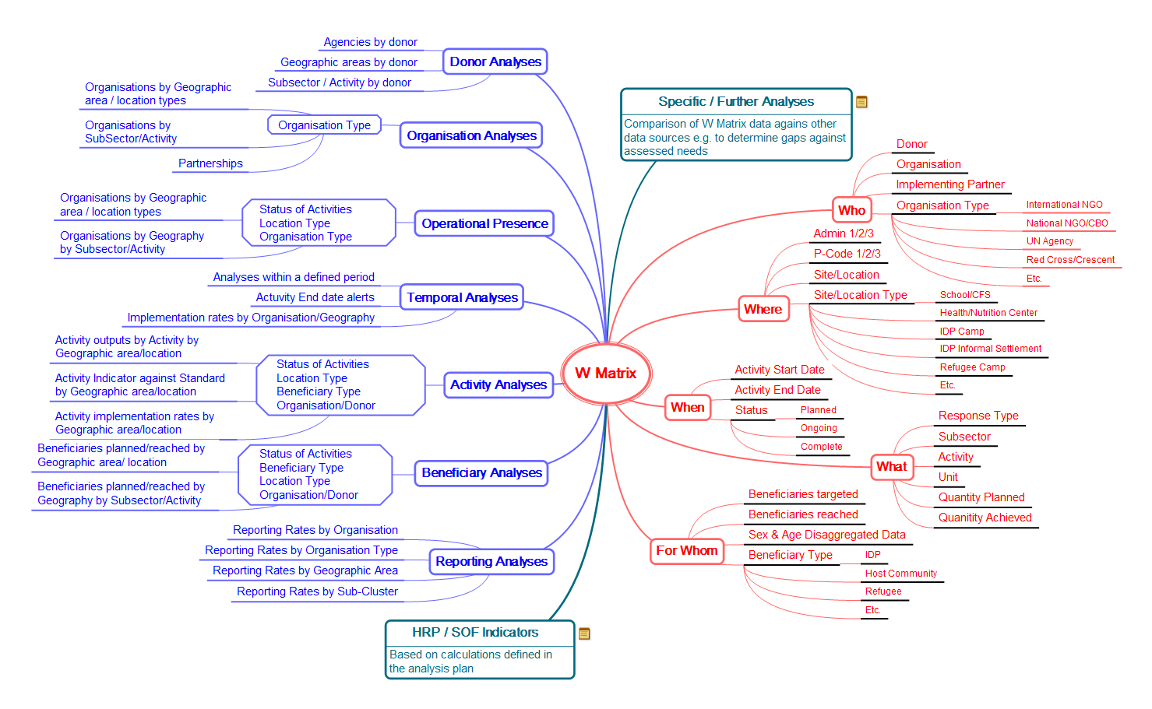

For example, highlighting any:

* Imbalances in sub-sector implementation e.g. a focus on water and hygiene at the expense of sanitation
* Imbalances in activity implementation e.g. a focus on temporary measures rather than semi-durable systems
* Imbalances amongst locations of intervention e.g. a focus on easy to reach at the expense of hard to reach
* Donors / Agencies with interventions consistently below minimum standards i.e. not in line with the HRP/SOF response framework
* Slow rates of implementation e.g. slow activity progress reported against planned outputs
* Potential forthcoming gaps in response as activities end e.g. ongoing operations and maintenance costs,
* Gaps in response as compared to assessed Needs (as available)
* Etc.

***Presentation and Access***

Such Operational analyses should be produced more frequently than HRP quarterly updates. Products should be developed iteratively to incorporate feedback, and ensure their operational relevance. Visualizing data to appropriately present analysis is one of the key tasks of the IMO, and further resources are available in the *Reporting and Visualisation* Chapter of the IMTK.

***Monitoring Quality***

While self-reported indicators of service-level can be derived from a W-tool, this is an inadequate measure if taken alone. Tracking quality can help to identify ‘hidden’ gaps in response, respond to arising issues in a timely manner, and ensure that common technical issues are identified and addressed, amongst many others.

Some approaches to quality monitoring can be found in UNICEF’s HPM resources. Maximising the use of existing resources through *triangulation* will be key; making use of existing data collection initiatives to track our harmonised needs indicators, and to provide avenues for feedback and complaints, for example:

* Monitoring of functionality, access, quality by hygiene promoter (or other) networks using a common or harmonised tool e.g. UNICEF HPM monitors
* CCCM / Shelter – monitoring of WASH service provision and needs in camps / settlements / informal settlements; complaints mechanisms
* Health – monitoring of WASH-related standards in Health centers according to national SOPs; surveillance data; public water quality monitoring systems
* Education / Child Protection – monitoring of WASH-related standards in Schools and Child-Friendly Spaces or according to national SOPs
* Protection – monitoring of specific WASH needs of vulnerable groups / regions
* WASH Service Providers – monitoring of inputs and works implemented / provided

|  |  |
| --- | --- |
| * 1. Key Resources | * 1. Additional Resources |
| **Guidance**   * An OCHA brief on different types of gap analyses. *Work is ongoing to develop a WASH specific guide for different emergency types.*   **Examples**   * + An example of an online Tableau dashboard, providing facilitated analysis of operational response data. | **UNICEF HPM**  UNICEF Humanitarian Performance Monitoring Toolkit contains useful examples and approaches, notably to quality monitoring, and can be found here:  <http://www.unicefinemergencies.com/downloads/eresource/HPM.html> |