**Somalia**

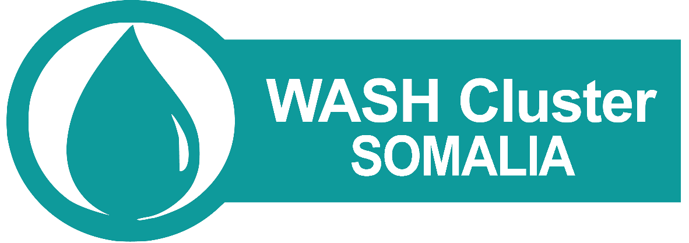

**Report on Water price Monitoring for Trucked Water in Somalia**

**July 2017**

**Summary**

Emergency water trucking to populations faced with severe drought or those facing an epidemic like cholera can be considered as a life saving measure if all other alternatives are explored and are deemed not productive in addressing these challenges. Following the cyclic drought and AWD pattern owing to poor rainfall and immense water scarcity, the WASH cluster considers water trucking a last resort. Despite the fact that this approach is expensive and unsustainable, there are checks and balances that need to be put in place to ensure high levels of transparency and accountability among service providers. The focus here is to address the immediate lifesaving needs of populations affected by drought and reduce the negative impacts they experience in regard of loss of livelihoods and coping mechanisms.

This document presents data on water prices as reflected in different locations during the drought Response initiatives in 2017. The prices indicated are meant to provide ground for comparison and to facilitate dialogues with relevant stakeholders to ensure that water prices are checked during emergencies to ensure that needy populations are supported within the minimum provisions for WASH in emergencies as per the SPHERE standards.

**Introduction**

Water trucking as conducted in emergencies is normally a short –term life-saving response aimed at ensuring that those in need of water have access to desirable quantities to be able to meet used to daily survival requirements. The intervention must be complemented by efforts to improve access to water through rehabilitation of existing and non-functional facilities, as well as developing new facilities where needed as an exit approach.

The exercise was launched on the 12th of April 2017 and closed on 6th June 2017, attracting 29 responses from agencies working in drought stricken areas of Somalia where water was being trucked in the wake of the drought response initiatives taking place at the time. From the survey the e trucking was being conducted either directly or preceded by vouchers. The Survey was rolled out through the survey monkey platform and circulated to all WASH cluster partners. This was necessitated by the view that several agencies were undertaking water trucking interventions in the affected areas at varied costs and the need to understand why the water prices were low in some locations and high in others for the sole purpose of getting value for money and for purposes of accountability.

The cost of water varies from one location to another depending on certain variables i.e. distance, road conditions, lack of regulatory frameworks, competition among others which compose the main determinant factors on what the end user will pay for water. The prices are often pre-determined and is used to cover beneficiaries support throughout the stipulated time frame.

REACH through the Global partnership with the WASH cluster, has been trucking the cost of water of accessed water points in Gedo region in response to lack of sufficient information on various water prices over time and between the different areas of Somalia. Data collected is aimed at allowing humanitarian actors to better analyse humanitarian needs in areas particularly affected by drought and inform responses or interventions undertaken.

The initiative was developed within the framework of REACH’s global partnership with the Global WASH Cluster (GWC), with the aim to develop a reliable system for robust data collection and reporting on water prices in areas experiencing cumulative and/or prolonged drought conditions.

**Survey findings**

The survey targeted both local and international that had participated in water trucking interventions in response to drought situation in Somalia. The objectives of the survey included:-

* Collecting and mapping out data on water trucking costs in drought affected locations in Somalia
* Understanding how distance impacts on water costs
* Understanding safety measures put in place to ensure that water accessed is safe for human consumption.

The results of the survey were analysed and have been disseminated to cluster partners with presentations having been done in the WASH working group and the WASH cluster monthly meeting. The coverage and pricing was as indicated in the map below;

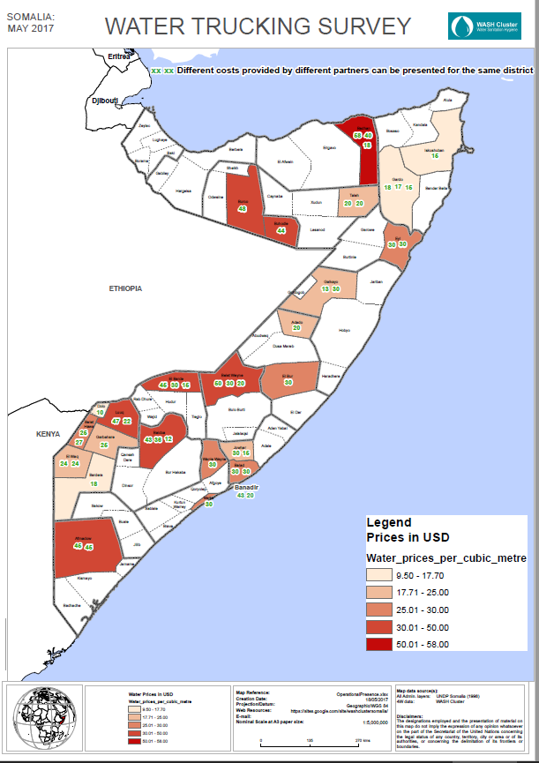

The districts covered with water trucking responses had been mapped out as water scarce areas where human and animal population were in dire needs of water as a live saving measure. The water prices varied from region to region with prices per litre ranging between USD 0.0095 and USD 0.058 across the target locations.

The price per cubic meter on the other hand ranged between USD 9.5 and USD 58 as indicated in the chart below.

Payment for water services should be done on the basis of equity ensuring that the services weather by private water facility owners or publicly owned are affordable for all target groups.

From the responses below, 58% of the responding agencies (17) do not treat water before distribution while only 42% (12) treat water before distribution to the end user. Distributing untreated water from water truckers remains a health risk and agencies need to factor this in their response to ensure that beneficiaries access safe water.

Of the 42% above (12) who treat water, 34% (4) treat their water in the tanker before distribution while 66% (8) treat their water at the source before collecting for distribution.

When asked whether AWD cases had been reported in their respective locations, 52 %( 15) reported no, 41% (12) reported Yes and 7 %( 2) did not know. A lot of sensitisation needs to take place to ensure that water treatment is prioritised before water is given to the end user. In the event that this is not possible then communities should be well prepared to adopt household water treatment and safe storage mechanisms to ensure that water consumed is safe.

The distance covered from point of water collection to pint of distribution ranged between 2 km and 160Km probably also describing the range in prices. The districts indicating highest prices had their water collected from distant locations from the distribution points. This is a major problem attributed drying up of water points like berkads and shallow wells and high salinity levels in some areas that impact on ability to use water from drinking from some sources.

The survey sought to know whether the water trucking was preceded by the Voucher approach and results indicate that 65.5% (19) adopted water trucking through vouchers, while a further 31% (9) did not adopt this approach meaning they conducted mass water distribution in select areas and 3.4% (1) did not know whether they water trucking conducted was through vouchers or not.

Normally water access through vouchers is practiced in areas where water trucking markets exist especially in areas with scarce resources and people cannot afford water from the tankers, More often than not when contracts with water companies are done, they cover the price for the duration of the distribution cushioning the community in further price escalations in the event that this happens. Pre- printed vouchers are distributed to beneficiaries and are used for the duration of the intervention.

Agencies were asked to detail whether communities are encouraged to practice other water treatment methods at household level and the information shared reveals that boiling water at home and the Use of aqua tabs are common methods employed in water treatment at household level. Straining, sedimentation and ceramic filtration constitute other methods used.

Factors rated highest as impacting on water prices include, distance, road condition and scale of need. Competition, the lack of a regulatory framework and security are also determinants of water prices in the target locations.

The water prices for a 20 litre Jeri-can ranges from USD 0.0039 to USD 1 in the various districts where data was collected from. See table below for details. The water prices per barrel also varied with cost ranging between 0.19 USD to 6.6 USD In most of the locations, the water costs were high during the drought period with very few districts registering slight or no change.

**Price comparison before and during drought**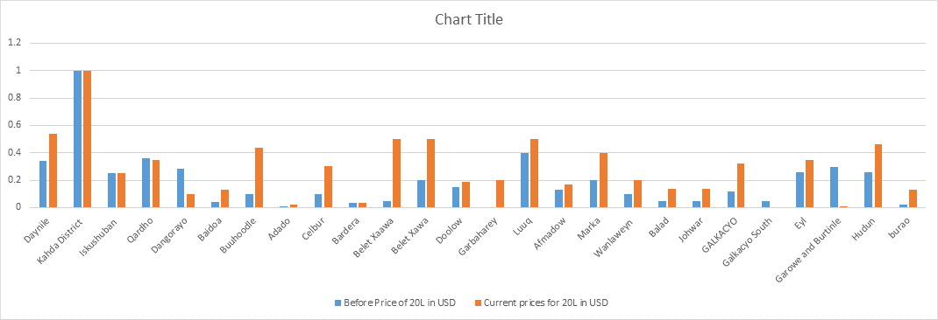

For purposes of comparison we needed to also know whether distance influences the water prices. The map below shows no correlation between distance and water prices. The uniqueness of each district in relation to water access and pricing has contributed to the trends seen herein where there are locations that are so distant but with low water prices while some are so near with marked high water prices.

Based on the above data, the survey recommends that:

* WASH Cluster partners should coordinate at field level, work hand in hand with the governance structures available to ensure that water prices are harmonised to improve water access for the most vulnerable during emergencies
* Re-evaluate the water trucking approach and seek to find out whether the modality and level of intervention is appropriate and whether there is value for money
* Try to underscore the kind of effects brought about to local markets during water trucking and how they affect water affordability for vulnerable groups
* Improve future program designs , drawing from lessons learnt during this exercise

**Annex 1: Survey Monkey: Proposed questions for monitoring of water trucking interventions**

The WASH Cluster and associated partners have developed some guidelines for water trucking. The guidelines are designed to provide critical information for those planning, implementing and monitoring water trucking operations. This includes Government, especially at Regional, Zonal and district level, NGOs and UN Agencies, including UNICEF. The guideline may also be useful for donors considering how best to support this intervention.

Despite the fact that water trucking is to be considered a last resort, the current drought situation experienced in the Horn of Africa including Somalia has left no choice but trigger water trucking to save lives and livelihoods. This survey is aimed at mapping out water prices in the specific affected locations and will be the basis for advocacy and further discussion with different states in an effort to get the current water prices lowered.

**NOTE***: The questionnaire targets organizations both local and international that are providing or have provided water trucking in response to the drought situation. If you are working in multiple district with different prices kindly feel free to provide further detail. The survey will take about 10 minutes to complete*

**Objectives of the Assessment**

1. To collect and map out data on water trucking costs in drought affected locations in Somalia
2. To understand how distance impacts on water costs
3. To understand safety measures put in place to ensure that water accessed is safe for human consumption.

**Questions**

1. Region:___________ District:_______________ Location:__________GPS:____________
2. What are the current water trucking prices in your location
3. Price per litre( USD): ____________
4. Price per metre cubic( USD)_____________
5. Has the water been treated at source or in the tanker before distribution?

* Yes
* No
* Don’t know

1. If yes who is chlorinating the water?
2. Briefly explain the water chlorination process from source to point of use?
3. Are there cases of AWD in the areas where you are providing trucked water?

* Yes
* No
* Don’t Know
* If yes name them.

1. What is the approximate distance covered from the water source to the water trucking distribution points?
2. Is the water trucking proceeded by the voucher system?

* Yes
* No
* Don’t Know

1. Is your organization promoting any additional treatment at household level for the water delivered by truck? ***Tick all that apply***

* Boiling water at household level
* Straining
* Aqua tabs/PUR etc
* Sedimentation
* Solar disinfection
* Ceramic filtration
* No treatment
* Others ( Specify)­­­­­­­­­­­­­­­­­­­­______________

1. What are some of the factors affecting water prices in your location? ***Tick all that apply***

* Distance
* Road condition
* scale of need
* Competition
* Lack of a regulatory framework
* Security ***(Explain)***
* Other? *Please specify*

1. What were the water prices before the drought for

* 20 litre Jerri can______________ Local currency used/USD
* 1 barrel ( 200 litres)______________ Local currency used /USD

1. What are the current prices for

* 20 litre Jerri can______________ Local currency used /USD
* 1 barrel ( 200 litres)______________ Local currency used /USD