GLOBAL WASH CLUSTER

REPORT DRAFTING GUIDELINE
This document presents the standard layout template which should be used for GWC assessment reports, and is recommended for all national WASH clusters to follow. This template can also be used for other type of reports, such as monitoring and evaluation reports or secondary data reviews. Guidance on drafting as well as writing tips is included for each section of the report layout template, and this document should be combined with the GWC Graphic Chart Style to ensure a proper harmonization of reports produced by the WASH clusters.

DRAFTING TIPS AND BASIC RULES

Writing
Keep your aim and target audience in mind when writing: The report is not only intended to inform and relay findings, but rather a mean to assist decision-making and ultimately guide response. In this perspective, when writing your report, keep in mind what your reader will do with this information. To do so, you must know who are/should be the primary readers and users of this report.
Keep the writing clear and jargon-free. Aim for clarity - keep sentences short and simple
- State a fact or an idea directly. You can do so by using the active voice rather than the passive voice
  - Active: UNICEF provided schoolbooks to 800 children.
  - Passive: Schoolbooks were provided to 800 children.
- Avoid complex or abstract words. Always prefer a simple word whenever you can, and minimize the use of phrases that are created by putting together two, three or four nouns and adjectives (ex: proactive system-based solutions)
  - Complex: We endeavoured to assist them. vs Simple: We tried to help them.
  - Words such as aspect, concept, elements, facilities, inputs, operation, resources, situation and variables are common in abstract writing so ensure you clarify their meaning when using them.
- Use appropriate language for your target audience. This is particularly important if you are writing a more technical report. Make sure that a reader who is not an expert can still understand the content of your report.
Proofread. After completing a first draft of the report, read it carefully for any errors in language or logic. Do not rely on the computer’s spell check to catch every mistake.
- You should proofread the summary and conclusion with extra care as they are the most important sections of the report. Have someone look over it if you can; it never hurts to have an extra pair of eyes!
- Ensure that all figures have clear, concise and meaningful headings, even when taken out of the report.

Presentation
- In running text, justify paragraphs, use ‘Normal style’ with single spacing, separated by one line.
- Use one space between the full stop and the following sentence. Never use double spacing.
- Key findings may be highlight in the text by using bold font. However, this does not mean that all numbers/percentages should be written in bold as these are not findings in themselves. You need to highlight the object/subject the percentage is referring to. For example:
  - 92% of surveyed households did not change water source after the typhoon.
- You may also use bold font to highlight key words, ideas and concepts throughout the reports, but don’t overdo it or you may lose the intended effected i.e. to attract the attention of your reader on specific points.
- Paragraphs should not be indented. Try to avoid ‘widows’ (very short lines at the end of a paragraph and ‘orphans’ (very short lines at the top of a page or column)
- Section headings and subheadings: capitalize only the first word of section headings, unless the heading contains a proper noun or a book title, e.g. Facts for Life.
- Subparagraphs normally begin with a lower-case letter and end with a semicolon, even if a complete sentence is contained in the subparagraph. The last item then ends with a period. However, if the subparagraphs are very long, they can begin with a capital letter; the important thing is to remain consistent. Line spaces above and below subparagraphs may also be used. Any further divisions under the subparagraphs should be differentiated by indentation. For example:
- here I list things;
and a few details about this first point
- and more things;
- and then I finish.

Numbers
The general rule is to spell out one to nine in running text and use numerals for 10 and above; do not put numerals in parentheses after numbers written in words, e.g. two (2).
- Exception no.1: Always use numerals for ages, dates, decimals, degrees, page references, percentages, ratios; dates and time of day; numbers with decimal or vulgar fractions; statistics; and measurements (8kg; 7 per cent; 6 years old; 0.5° C)
  - Exception to the exception: Spell out age when it is expressed as a hyphenated word (you will write “under age 5” but should write “under-five mortality rate”)
- Exception no.2: Always spell out a figure if it is at the start of a sentence, unless it is a year.
- Use a comma, not a full stop, to denote thousands and millions (1,234; 3,430,500).
- Do not abbreviate number with the # symbol. Use “no.” (e.g. in tables).

Footnotes
- Numbering:
  - If any punctuation immediately follows the word, phrase or sentence to which a footnote refers, place the footnote number after the punctuation.
  - Place the footnote number after the final round bracket if it refers to a text in round brackets. Otherwise it should be placed immediately after the word or phrase to which it refers.
  - If a footnote refers to a quotation, place the footnote number after the final quotation mark.
- Form: Different types of documents require different types of layouts. All official layout guidance is fully explained in the United Nations Editorial Manual Online (http://dd.dgacm.org/editorialmanual/ed-guidelines/footnotes/footnotes_index.htm).
  - Published document/report (with organization as the author)
    - Inter-Agency Standing Committee, Women, Girls, Boys and Men - Equal Opportunities: Gender Handbook in Humanitarian Action (Geneva 2006).
  - Internet sources
    - Internet sources are displayed with the URL in standard font (not italics) and without angle brackets (< >) (e.g. http://ochanet.unocha.org). Omit the http from a reference when the URL contains www (e.g. www.unhcr.org).
  - Newspaper article
    - E. Goode, “Friction Infiltrates Sunni Patrol on Safer Iraqi Streets”, The New York Times, 22 September 2008.
- ibid.: You don’t need to italicize ibid. and should use it whenever appropriate
  - Ibid. (ibidem, meaning ‘in the same place’) refers to a single work cited in the note immediately preceding. Ibid. takes the place of the author’s name, the title of the work and as much of the succeeding information about the reference as is identical.

REPORT SECTIONS

Summary
- Write the summary when you completed the drafting of the rest of the report.
- The summary is the most important part of the report. It is the first (and sometimes the only) thing others will read. It should provide a brief overview of the key contents and findings of the report.
- A summary should include only short paragraphs and make sense if you have not read the whole report.
- Try to keep it somewhere between 5% and 10%, never more. For summaries that are longer than one page, include the following headings: Context; Assessment; Findings; Conclusions.
- Use graphics, bullet points, and headings if they effectively enhance understanding and/or make the summary easier to read.
Structure
First paragraph: Briefly describe the context, such as the situation within which the assessment was carried out. Where are we? What type of emergency is it (conflict or disaster)? What caused the emergency (secession, coup d’état, earthquake, typhoon, etc.)? How many people are affected? Include the most up-to-date numbers of deceased and injured persons, refugees, etc. as per official statistics (UN and/or government). Present key stakeholders (national/international, government/non-government - who is in charge/responsible?) and the main coordination mechanisms (clusters? working groups? etc.) i.e. the institutional back-drop/framework for the assessment/activity.
Second paragraph: Briefly state the objective of the assessment / activity. What critical information did the assessment manage to gather, but also what information remains unavailable? Introduce the assessment/activity. What type of assessment is it? When and where was it carried out? What is the scope/coverage? By whom and within which institutional framework? Who funded it? Aside from donor(s), also cite key partners/contributors.
Third paragraph: Briefly highlight key (and not all) findings from the assessment/activity. You may use a bullet-point list format and highlight key words in bold.
Fourth paragraph: Briefly lay out the main conclusions and identified priority actions. What readers should most of all remember? What, if any, are the recommendations / next steps?

Contents
- Write ‘Contents’ not ‘Table of Contents’
- Use leaders (dotted lines linking each heading to a page number)
- Remember to update the table of contents upon completion of the draft report. Ensure all sub-headings and annexes are effectively reflected in the table.
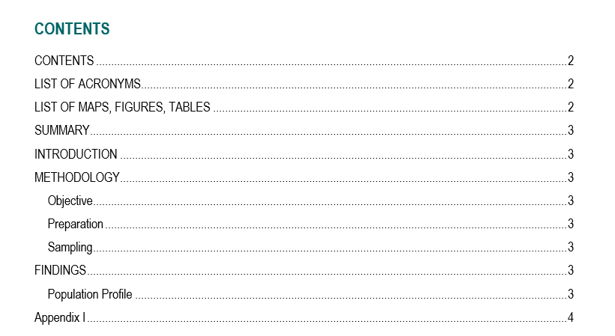

List of Acronyms
The list should be formatted into one single column, in alphabetical order, in singular form (e.g. NGO not NGOs), and include numbers first as shown below:
GWC Global WASH Cluster
WASH Water, Sanitation and Hygiene
- The list may include acronyms, short titles and abbreviations:
  - Acronyms: Formed from the initial letters of other words (e.g. UNDP); written entirely in capital letters and without periods between letters (UNICEF, not U.N.I.C.E.F.)
    - Do not use an apostrophe to form the plural of abbreviations and acronyms (write NGOs, not NGO’s)
    - Acronyms should normally be used without the definite article (WFP, not The WFP)
  - Short titles: Used to replace a name or title that occurs many times in a document, provided that the full name is used the first time it occurs and that there is no risk of ambiguity (ex: the ‘United States of America’ can become ‘United States’ and the abbreviation ‘US’ may be used as adjectives and in tables).
  - Abbreviations: Shortened form of a word or phrase. It usually consists of a letter or group of letters taken from the word or phrase; a very common abbreviation is for example, ex. or e.g.
    - Abbreviations for the most common units of weight and measure, such as cm, kg and km, need not be written out and should not be followed by a period.
    - English has a number of contractions that are commonly used in speech and informal writing, mostly involving the elision of a vowel (which is replaced by an apostrophe in writing, such as I’m for I am or don’t for do not. These contractions should not be used in GWC documents.
Some notes about acronyms and abbreviations
- The name or title should be written out in full the first time it occurs in a document, followed by the abbreviation or acronym in parentheses; thereafter the acronym/abbreviation should be used consistently throughout the text.
- Abbreviations and acronyms should not be used for names that rarely appear in a text unless the abbreviation/acronym is more familiar than the full name.
- Abbreviations and acronyms are not used in document titles or headings.
- When deciding whether to use a or an with abbreviations and acronyms, be guided by pronunciation (e.g. an MSF programme).

Geographic Classification
Brief explanation about the administrative units you are referring to in the report. Below is an example for Nepal:
District The administrative units that make up administrative zones; Nepal contains 75 districts.
Municipality Lower administrative units that make up districts.
Ward The lowest political-administrative unit. Each municipality contains 9 wards.
Town/Village The lowest administrative unit.

List of Maps, Tables and Figures
Consists of a list of all the figures and tables in the order they appear in the report.
- Complete this table at the end of the report; if your tables have been numbered automatically (right-click on the table/figure to number and choose Insert Caption), you can simply click on the tab References, and click on Insert Table of Figures.
- Double check the numbering for all figures and tables both in the list and in the text of the report.
- Review the headings for all figures and tables to ensure they make sense when taken out of the report.

Introduction
The introduction is structured along the same line as the first three paragraphs of the Summary (see the Summary section). As it does not include the overview of key findings and conclusions, it allows to include more details/develop further the first three components (ex: the context can be more detailed). The introduction should not be longer than 10% of the total length of the report.
In the last paragraph, you should present and outline the structure of the report i.e. main sections.

Methodology
This sections contains the following elements, divided in paragraphs:
- A presentation of the methodological approach and the reasons for choosing it
- An outline of the consultative process with the relevant mandating platform/agency; e.g. degree of consultation with the WASH cluster at the national and sub-national level at the various steps of the given assessment
- A detailed description of the sample and sampling method used for data collection
- The dates/duration/timeline of the assessment/activity
- The recruitment and training for enumerators
- The contributions (financial, material, staff) from different partners
- The challenges encountered during the assessment and how they were addressed

Findings
Each paragraph should convey one clear message and paragraphs within each sub-section should coherently follow each other. Before drafting the findings section, prepare a “skeleton” outlining contents for each paragraph.
Include a short introductory paragraph at the beginning of this section, and an introductory sentence at the beginning of each sub-section. For example:
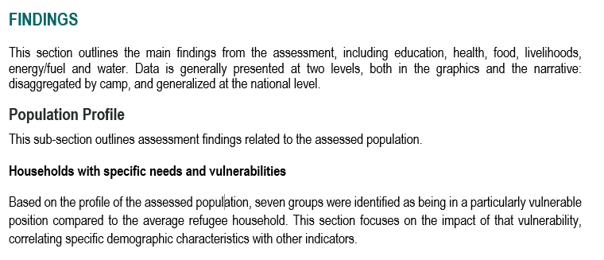

Conclusion
Keep in mind that the conclusion is often what a reader remembers best and the longest. The conclusion should stress the importance of the findings from the assessment/activity, give the report a sense of completeness and leave a final strong impression on the reader.
Synthesize, don’t summarize: do no repeat what is already written in the report. Instead, put an emphasis on the usefulness of the methodology designed and applied for this assessment/activity, as well as the value of your approach to analysing the collected data.
One common strategy to help writing the conclusion is the «So What» game. For example:
- Basically, I’m just saying that education is important for refugee children > So what?
- It’s important to ensure their parents/caretakers could provide for their schooling > So what?
- There is a need to provide targeted assistance to the most vulnerable refugee households who are not able to cover their children’s education needs as they prioritize other essential goods and services such as food and health care > So what?
- Particular attention and support should be given to single-headed refugee households, as well as refugee households including children living with a disability.
The conclusion should be structured as follow:
- Opening paragraph: briefly re-present the main focus and purpose of the assessment/activity
- Middle paragraphs: review key (not all) findings and provide suggestions on how the issues may be further investigated, if needed, or addressed.
- Closing paragraph: provide a sense of closure by connecting back to the introduction and by giving a final word about the assessment/activity as a whole.

