Creating a profile in Humanitarian ID
Registering on humanitarian ID will help the Sector Coordination Team keep the contact list up to date and send relevant information to the right people at the right time. Please follow the 6 easy steps described below. It should only take 10 minutes of your time! If you experience any problems, please contact washsudan@gmail.com. We are more than happy to help!
Watch the video attached to this email to get a 2 minute introduction to Humanitarian ID.
- To register, please visit humanitarian.id
Click on “Register” and fill out the required fields. You will receive an authentication email, please follow the instructions in the email to continue your registration.
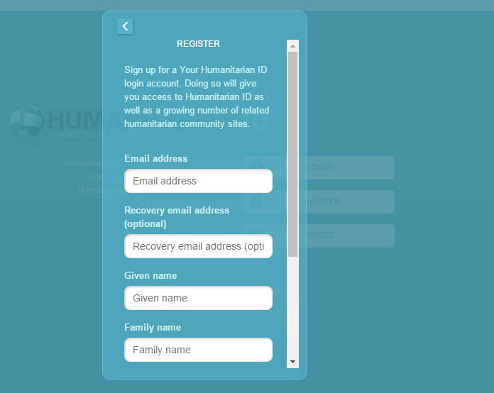

- The Activation link in the email will take you to this page:
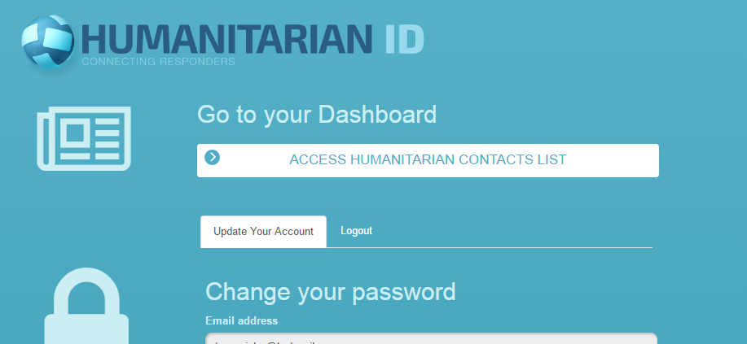
Click on “Access humanitarian Contacts List”. After accepting the terms and conditions, you will be taken to this page: Please click on “Global Profile”
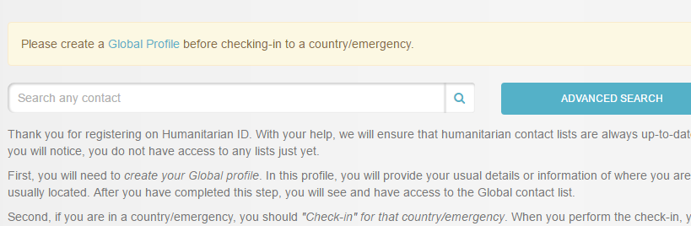
- Fill out your Global Profile. Please give as much information as possible (email, phone number, position, location, etc).
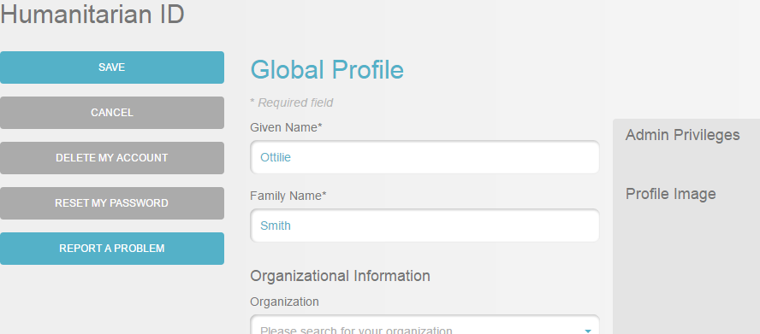
- Once you saved your Global Profile you can “check in” to an emergency. Click on “Check in” to register as a humanitarian responder in Sudan.
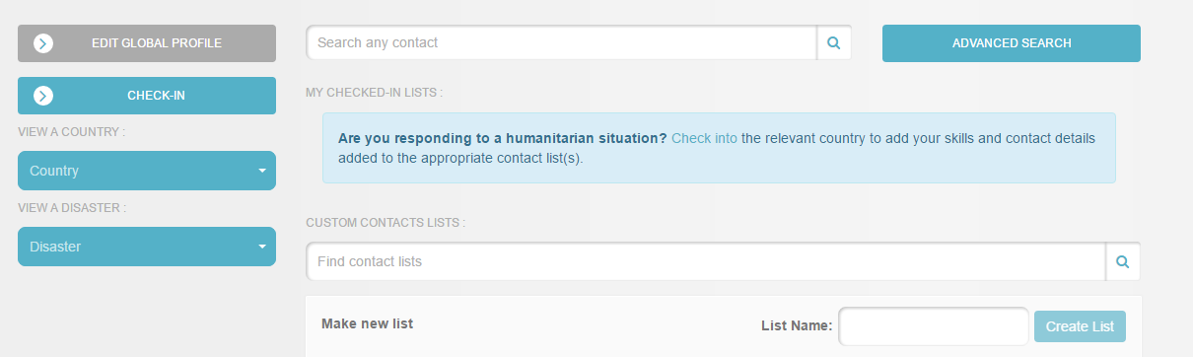

- Choose Sudan from the list of countries. You will then be redirected to the page where you update your “local profile”. This mean you enter information specific to your role and length of stay in Sudan.

Make sure to choose “Water Sanitation Hygiene” as your group
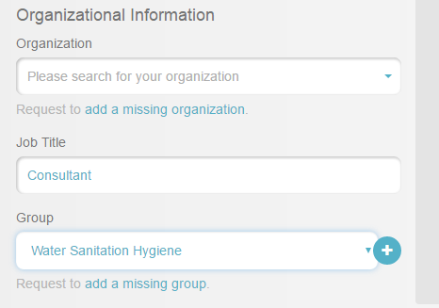

Please also choose your departure date, if you know how long you are likely to stay (you can change this at any time by editing your profile). This is crucial to ensure the contact list stays updated and also to make sure you are no longer receive information you don’t need when you leave.
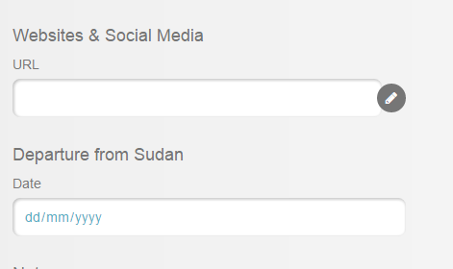

- After clicking “Check-in” you have successfully checked in and registered as a WASH responder in Sudan. On the next page, you will be asked to subscribe to the WASH Sector Mailing List. Please do so to receive information from the WASH Sector.
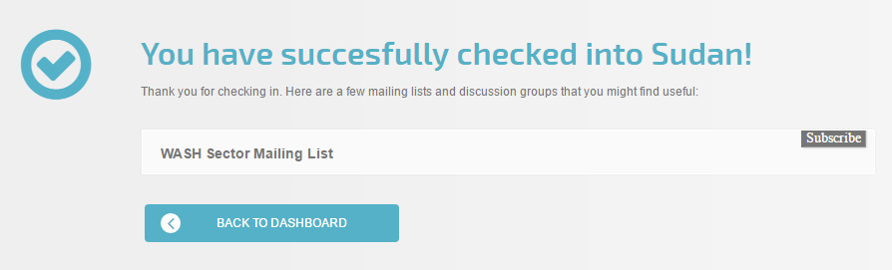
CONGRATULATIONS!! You are now a registered humanitarian responder on Humanitarian ID and registered on the Mailing List of the WASH Sector.
You can use humanitarian ID to find other responders when you go to “Dashboard”
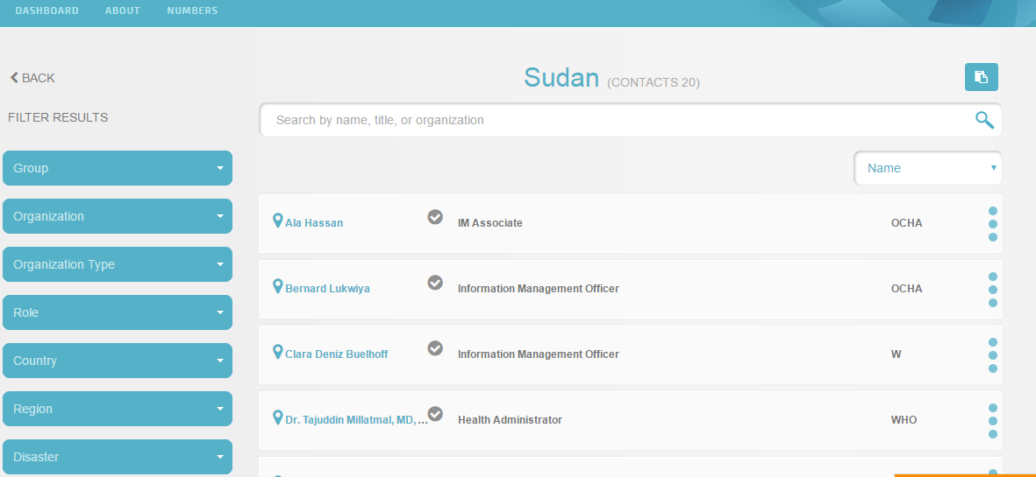

You will also be able to see the Contact list of the WASH Sector on humanitarianresponse.info
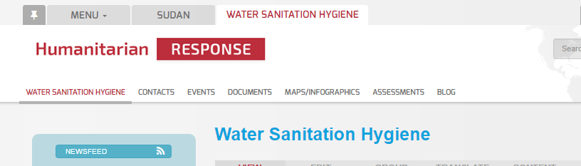
Contact information entered in humanitarian.id is automatically updated in humanitarianresponse.info. So you can see the most up to date contact list and export it in excel at any time.
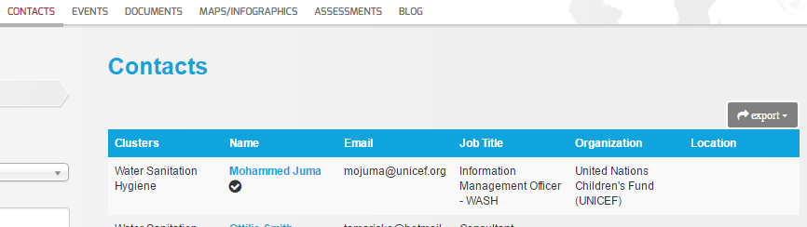

The WASH Sector Coordination Team would like to thank you for your contribution to improving coordination. If you have any questions, comments, or suggestions please contact us any time at washsudan@gmail.com.

