Mailchimp: Guidance Note

Mailing lists are relevant to manage information that are in between “Confidential information” (i.e. information linked to persons, finance or security) and “Public Information” (i.e. information cleared or endorsed by an authoritative body). The management of a contact list is fastidious. Keeping subscriber information up to date is a time consuming task. Building on good practices, Mailchimp can be used as a single unified repository for contact lists.
MailChimp offers the following advantages:
- Capacity for the member of the contact list to register, subscribe and unsubscribe directly by themselves.
- Consolidated repository for all contacts: one unique list to maintain instead of many working group list (no excel sheet using different versions in different services). Possibility to extract a snapshot of the list when needed. Possibility to import excel contact lists in csv format as well.
- Detailed Email Campaign Reports: analytics showing you how email campaigns are received; who is being reached; which users are opening the email and reading the attachment.
- Possibility to define the real regular user (subscriber who really open the mails) within the list in order to prepare some specific communications

Contents
Confidentiality 1
Setting up your account and introduction 2
Create lists, add subscribers, groups and sign- up forms 2
Creating email templates and sending campaigns 8
Reports and tracking 11
Humanitarian ID / HR.Info and Mailchimp 11
Useful tips and tools for Mailchimp: 11

Confidentiality
As a generally accepted good practice, it is NOT recommended to send sensitive data (personal information, financial information or information that can put the organization or someone at risk) via email unless your message either:
- Is encrypted (as in this case the sender and the recipient would need to preliminary share the same encryption key), or
- Stays within your own organization email systems (i.e you send message to persons in the same email domain).
In the context of a refugee operation, access to refugee personal information is granted through specific system with a proper user access right (i.e progress or RAIS) that enforce their own level of security and allow for a proper user management. It’s good to keep in mind that emails are NEVER fully confidential:
- Statement such as “The information contained in this e-mail is confidential, privileged, or otherwise protected from disclosure.” Are in reality almost impossible to enforce due to diverging national regulation
- E-mails may be forwarded to colleagues for handling and their dissemination become out of control.
- You should also know that if sending e-mails from work, your employer has a legal right to read your e-mail if he or she chooses.
Setting up your account and introduction
Go to mailchimp.com and subscribe to a new free account. It is important that you use an email address which is the email address that users will see when they receive new campaigns or newsletter. It is recommended to use a generic IM-WASH-COUNTRY HR.INFO email account or your company’s email. There are some constraints in using a gmail and could result in some delivery failures (read why here). It is important to be able to transfer this email address to another person whenever that is required. Once you subscribe, you will get to this dashboard view.
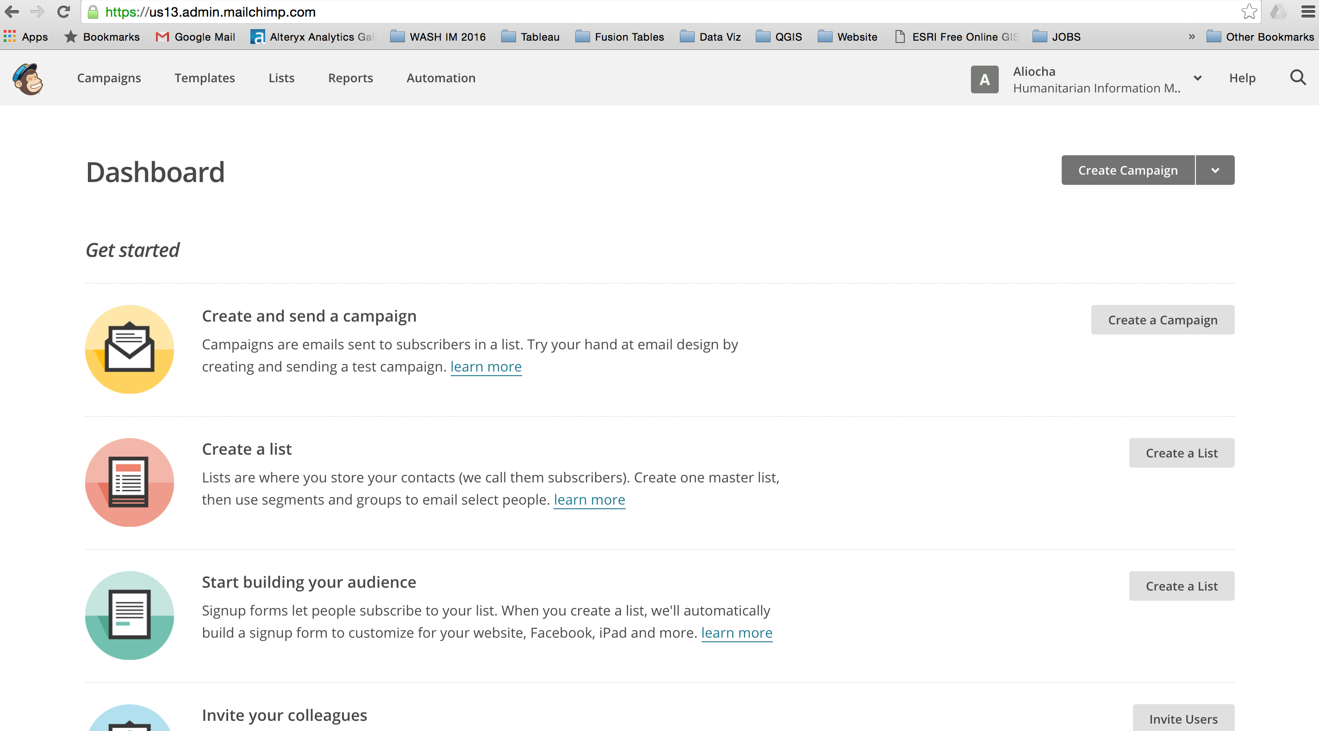

Create lists, add subscribers, groups and sign- up forms
The second thing that you should do is to create your lists. The recommendation is to create a master contact list for MailChimp and then create sub-divisions or sub-lists as required. In order to create a list, click Create a List on the dashboard view.
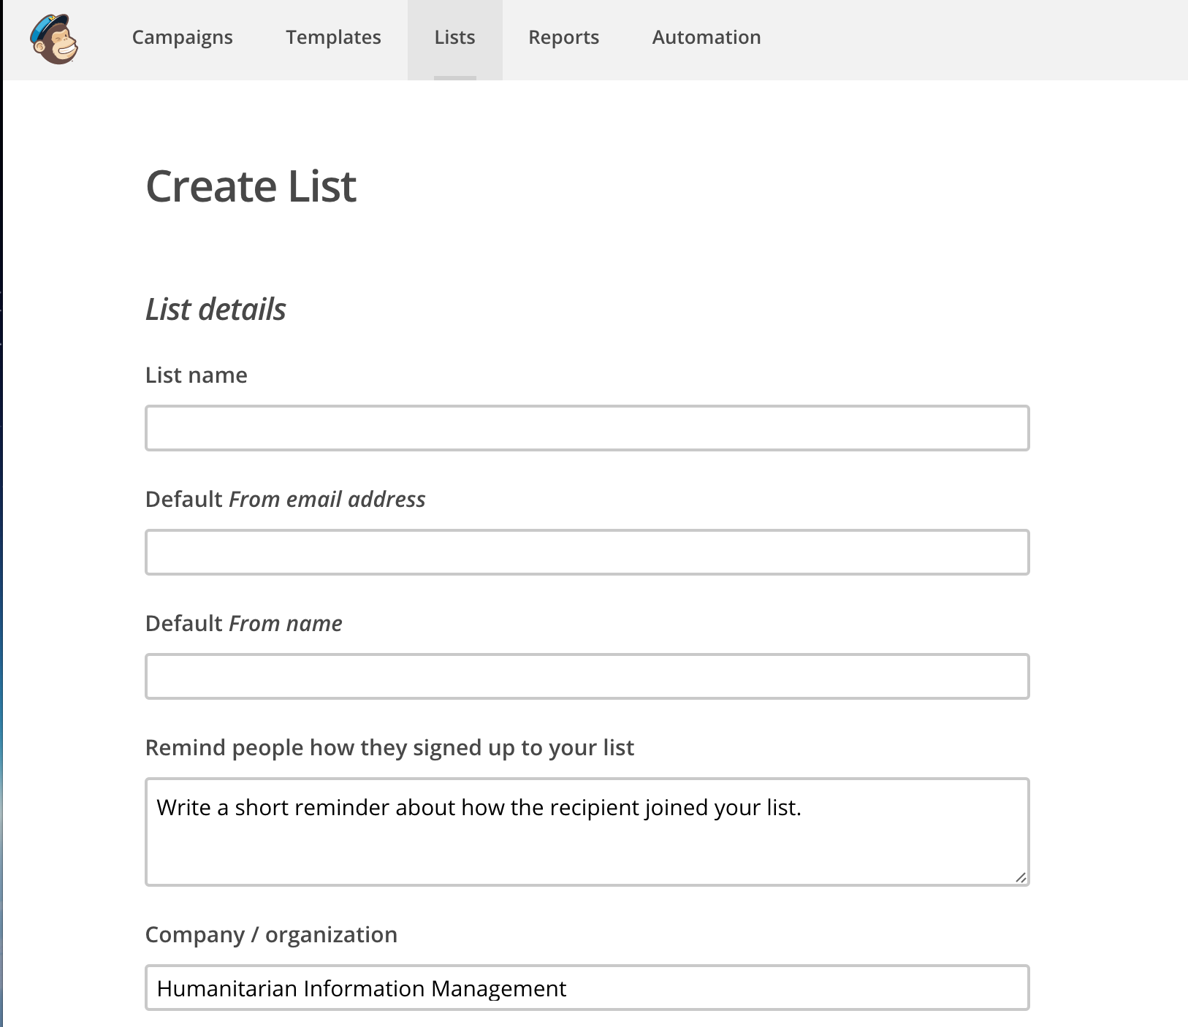
Give the list a name and make sure all fields are filled. It is important that you indicate an email address from which users will receive campaigns or newsletters. Once again, it is preferable that you use a HR.Info or an agency email for this field for best dissemination experience and to avoid server delivery notification failures.
Provide a description reminder for your list, this will enable users to remember how they signed up for the list.
Most of the time, users already have a contact list, whether in excel or through their email contact lists.
Options users have at this stage are:
- either to add users manually, which is time-consuming and not the best suitable option when creatin lists;
- users can import a csv (comma separated value) from an excel contact list. The Global WASH Cluster has created templates to manage contacts in excel. It is advisable to look at the contact list template in the WASH Information Management Toolkit (http:washcluster.net im-toolkitpage/) for best practice. Once you have saved your excel file as csv, you can then import it into Mailchimp.
- Users can also subscribe organically through sign up forms. Sign up forms in Mailchimp can be created from scratch but it is much more efficient to use an already imported contact list with an agreed range of fields to create sign up forms. These forms can be embedded on websites such as humanitarianresponse.info or in emails to get users to provide their details. Whenever users fill in the sign up forms it will then automatically update your master contact list in Mailchimp.
The first step that is recommended here is to import your contact list, even if you don’t have that many contacts, in order to ensure that you have all th required fields for future population of your master contact list in Mailchimp.
- Import your csv file – IMPORTANT: headers need to be the first row; this will ensure that Mailchimp recognizes all the fields in the most comprehensive way.
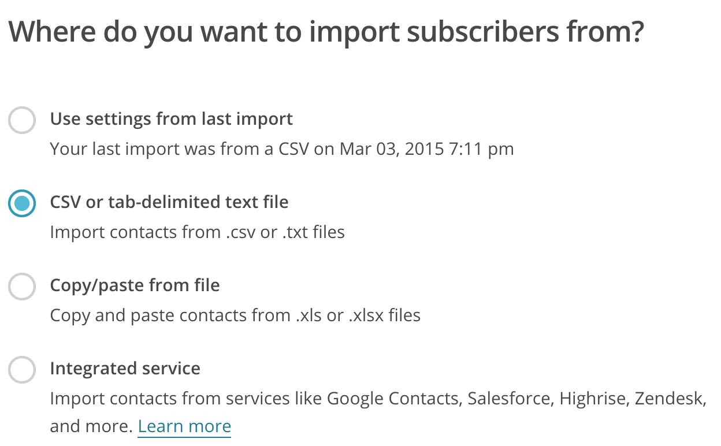
Click on Add subscribers < Import Subscribers.
You will have the option to use the settings from a previous import if you already created a master contact list. Make sure you use the exact same template to augment your existing list with new contacts. In this case, what you will need to do is tick the CSV or tab-delimited text file option and import your CSV accordingly.

- Manage fields
Once you imported your CSV contact list, the next screen should look like this. Mailchimp might highlight some fields for syntax errors and will try to recognize each column name accordingly:
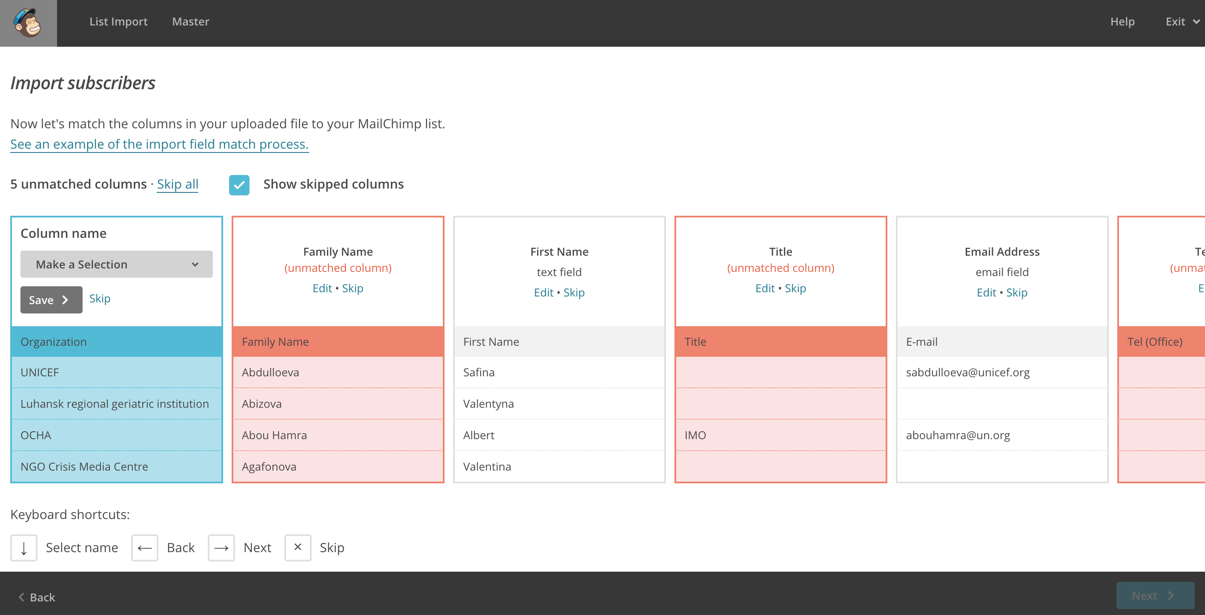
For some columns, you will have to determine the heading and tell Mailchimp what type of heading we are looking at. For Organizations in this case, we will need to create a new column and name it “organization” accordingly. Mailchimp will also ask you which field type it is, in this case (and in many instances except for emails) the field type is text.
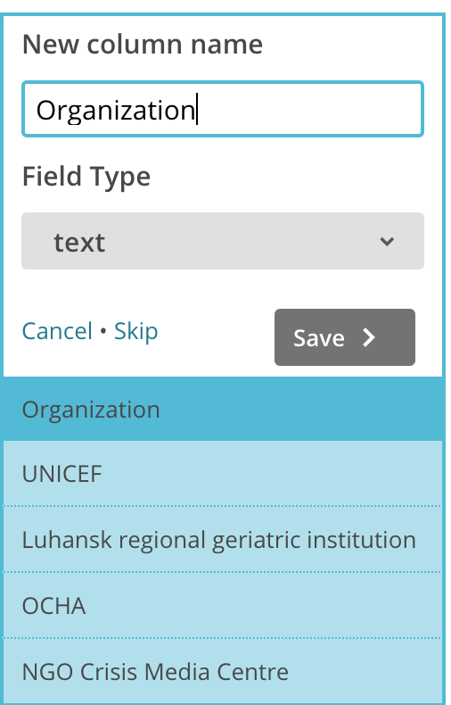
Mailchimp will just ask you to confirm each column header one by one. Since you have imported a CSV with all your required fields you will need to edit each heading. Don’t worry, this will happen once only. You should NOT skip any header even if the rows are empty, for Mailchimp will not include them in your master contact list.
Once all columns are matched, you will be ready for the next steps.
IMPORTANT: This step is crucial in the Mailchimp set up process, make sure you have all the required elements within your imported CSV and that the header (column) names match you CSV headers for future imports for example.

Mailchimp will then ask you to confirm the import method (by columns) and also ask you to confirm that the imported subscribers should be already considered as “subscribed” into Mailchimp, which means that is you were to send a campaign now, all imported contacts would receive it. Usually the answer is yes, assuming that your contacts already want to receive updates from you.
Once you click IMPORT, Mailchimp will create your master contact list and you shall also receive an email notification as confirmation that your list has been created.
- Lists setttings
Your imported master contact list should now look like this:
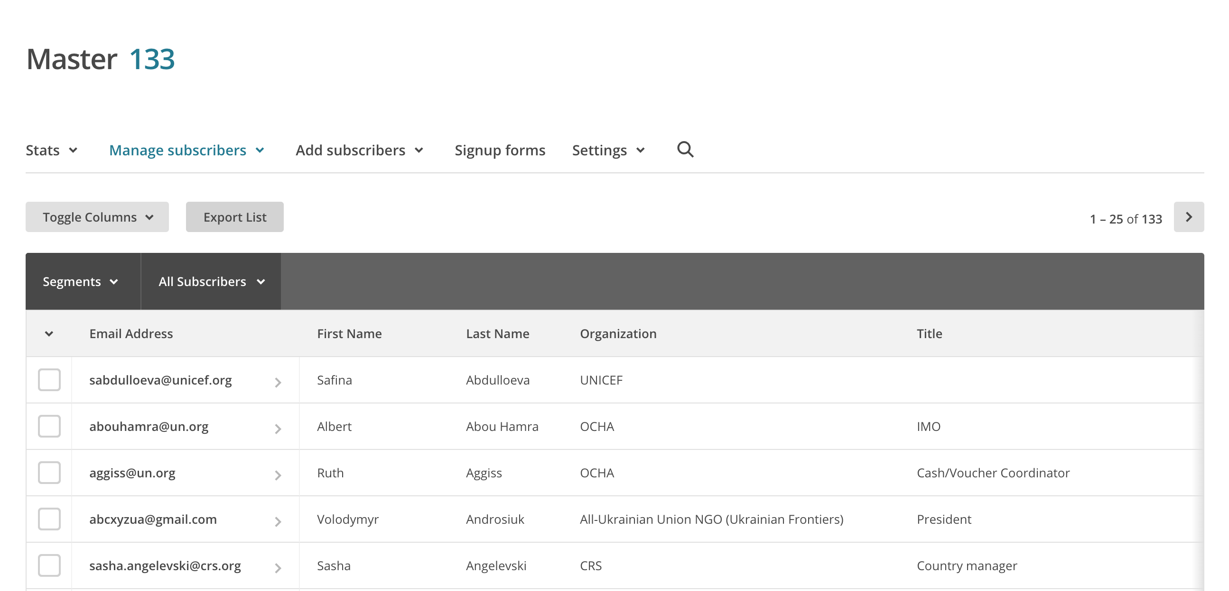
Note that Mailchimp will always put the email addresses as the first column. This is the working principle of the system, you cannot have a contact without an email address. It is therefore an automatically required field for any new subscriber.
You can manage your list names/defaults in Settings. You can also go to settings < List fields and *MERGE* Tags to ensure that a certain number of fields are REQUIRED and not optional whenever you import a contact or whenever a new user subscribes to your list. See below:
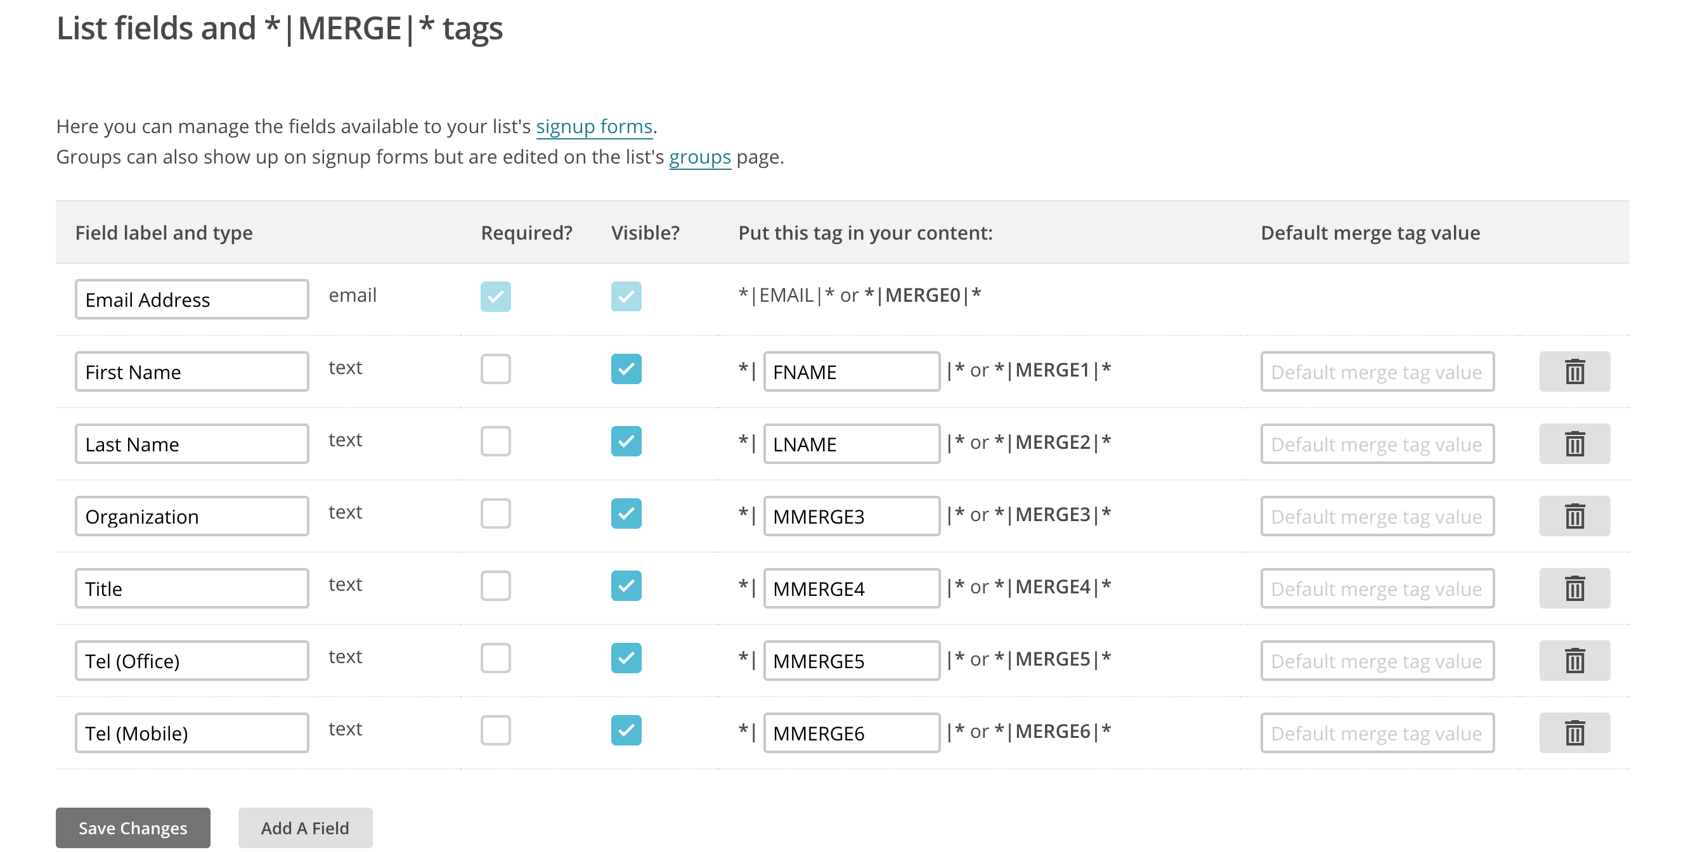
IMPORTANT: it will be useful to determine which fields should be visible or required when you create subscription forms. This will ensure that users who update or create a new subscription fill in the required fields. In some cases, you would like a majority of required fields. Make sure that you do not burden users with too many required fields, but rather keep it to the minimum of important fields to fill in. You could alternately also do some follow up emails for users missing information at later stages YES, Mailchimp will recognize existing users by email addresses, then first and last names and it will allow them to update their contact details automatically.

- Create groups and manage subscribers
Click on Lists. On the right-hand side you should have an arrow that allows you to manage subscribers:
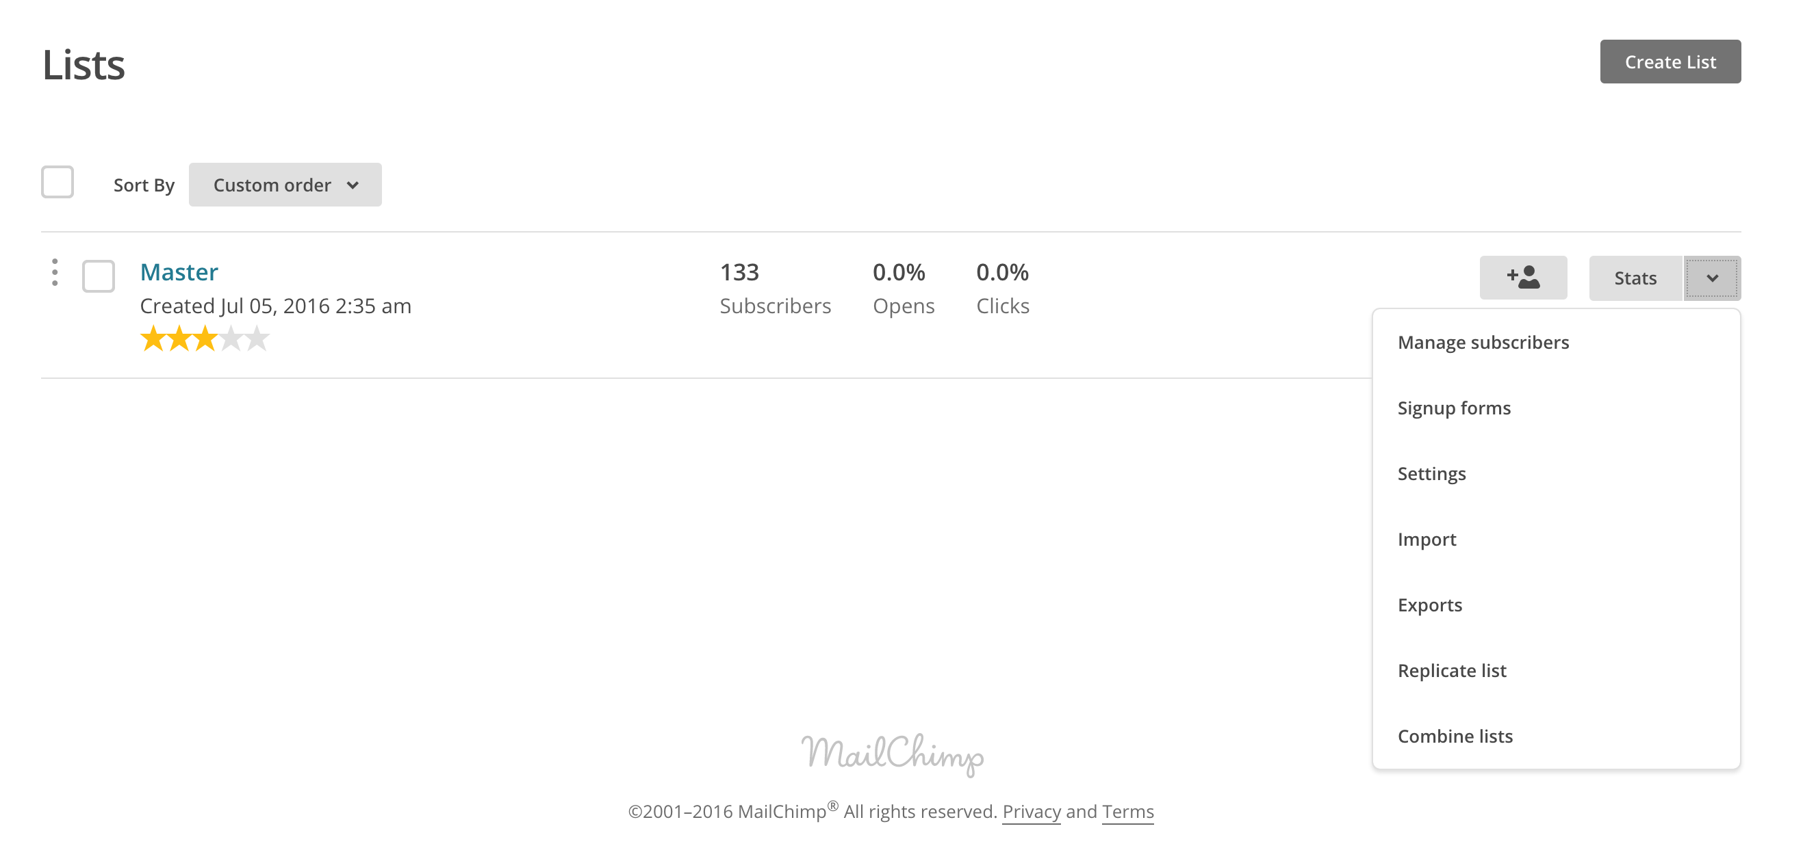
Once you have clicked on manage subscribers, click on Groups and then create groups.
The purpose here is to assign various groups to subscribers and also to create sub-lists for your campaigns or correspondence (i.e: you want to create and IMWG group; a list of persons that can receive updates on IMWG issues). When you create you group, give it a name and a sub-group name (at least one must be entered).
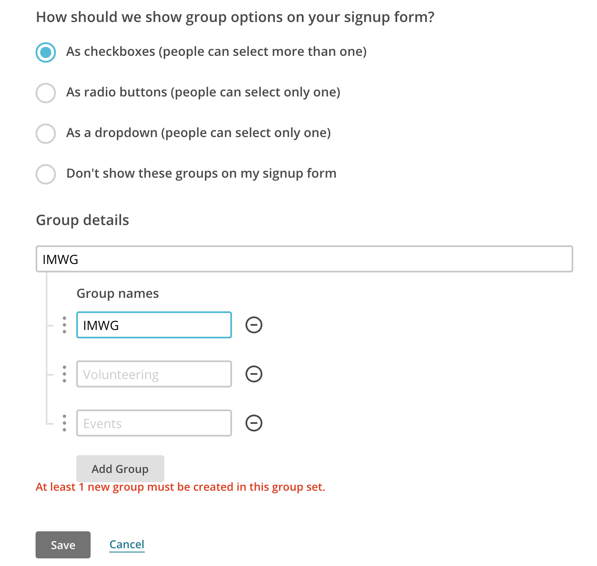
IMPORTANT: Once you have saved your new group, you will see that it now appears as heading in you main contact list. You now have two options; you can either import existing contacts to that group (using the same CSV file and method as above) OR you can now ask future subscribers through forms if they want to be part of that group or not. This will then automatically update your groups and you will be able to send targeted emails to certain members of your contact lists.

- Create sign up forms.
There are many advantages in creating sign up forms. It is recommended that you create a sign up form for your master contact list in the beginning. This will allow you to further manage you contacts in an effective way. You can then send the sign up form by email and ask existing users to update their information, subscribe to groups and much more. Sign up forms are usually sent via email or embedded on websites/social media.
We will first be looking at how to create these forms in an effective manner.
First, go to your master contact list and click on sign up forms.
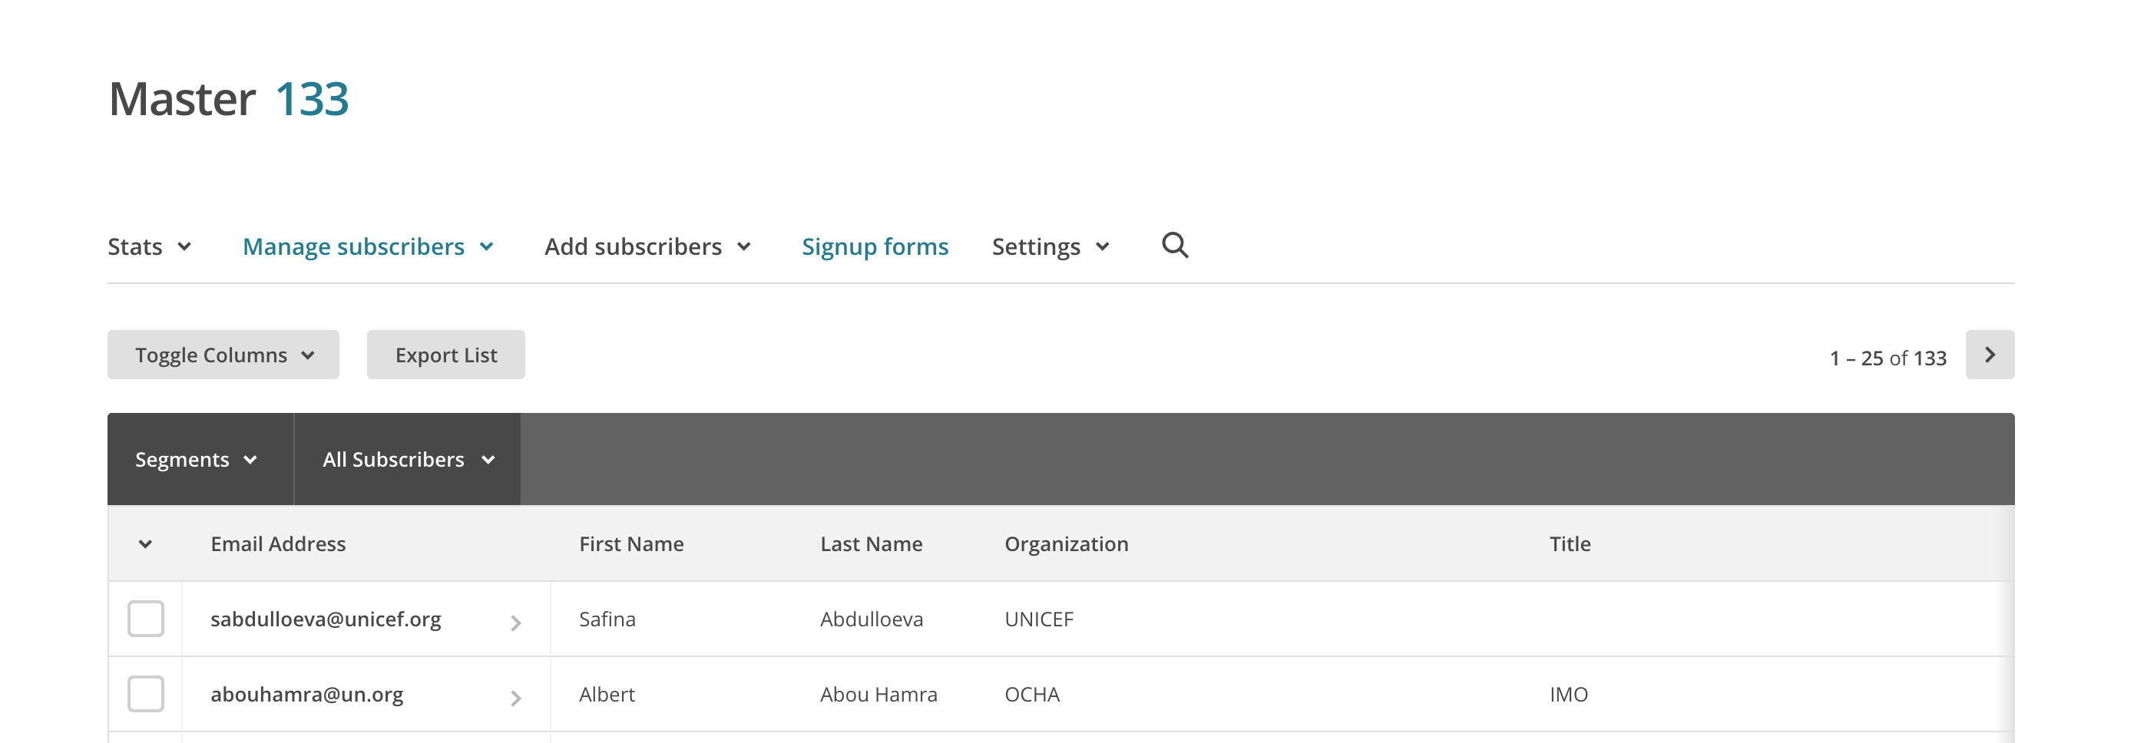
Choose general sign up forms. Select the default sign up form. You will see that there are many pre-built sign up forms that you can select for further and advanced Mailchimp contact management. For this exercise, we will just look at the default version.
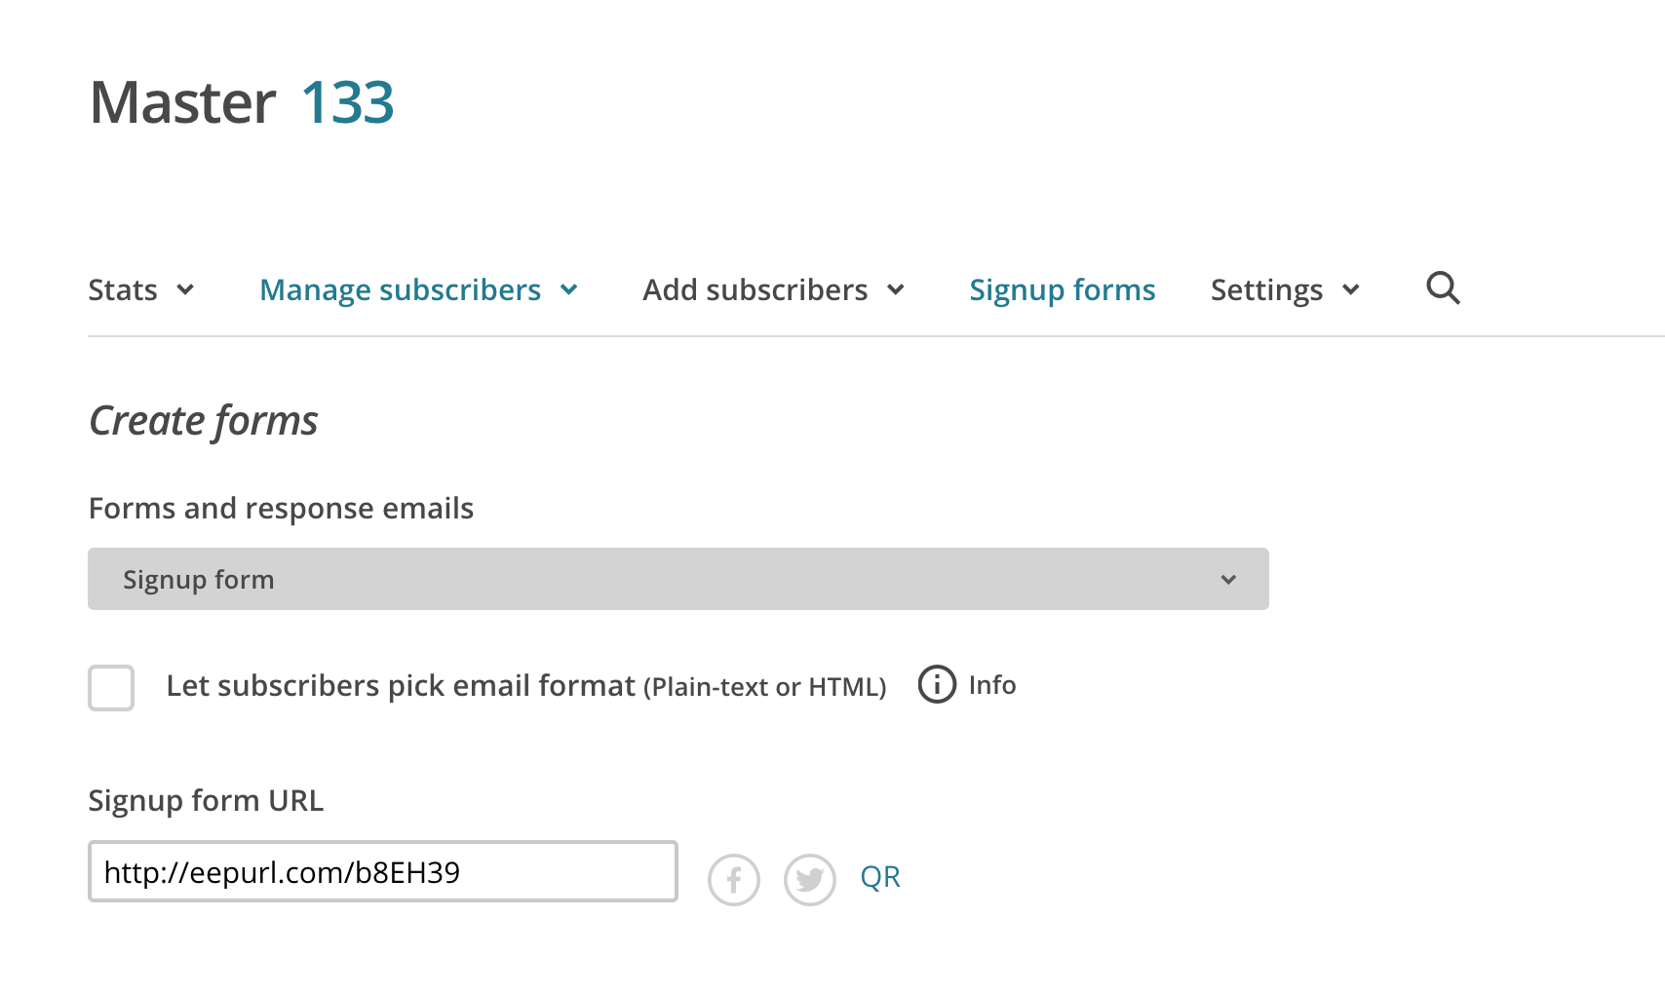
This will automatically generate an URL that will be the address your form will be hosted on.

Secondly, you will need to build your form in the most effective way. In order to keep it simple, you should not add any new fields to the form. However you can define parameters for each field, add descriptions and other items to each existing field. This can be done on the right-hand side of that page.
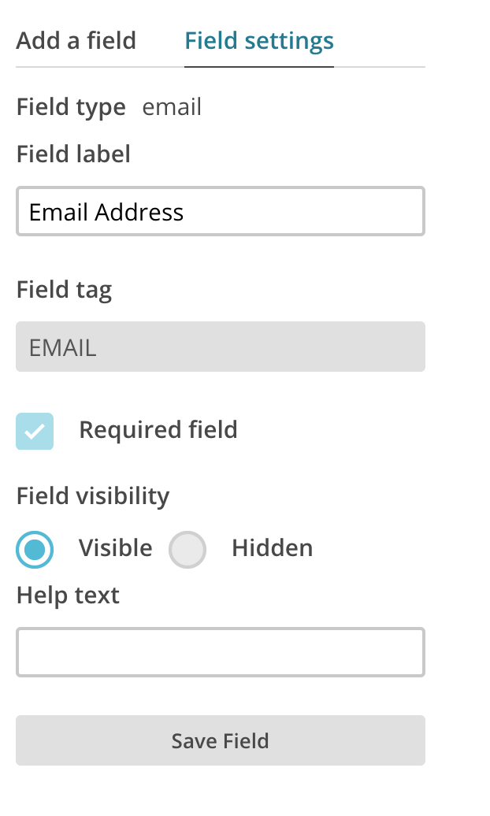
You can set the field to be required or not, visible or hidden and add some help text to it.
It is important to remember that users can fill in the form, whether they are already subscribed or not and that Mailchimp can notify you when users have taken that form.
Most of the time you will have new users who take that form, it is therefore important to give a purpose to your contact list and be as direct as possible when you provide a description to your form.

Thirdly, you can design your form (on the Design it tab) and add headers, footers or eventually pictures to it. In a humanitarian context it is preferable to keep it as simple and light as possible. It is therefore not recommended to insert heavy items such a high definition pictures or other background images, etc… Just keep it simple. You can refer to the useful tutorial links for advanced design tools and tips at the end of this document.
Lastly, Mailchimp offers a Translate it tab that allows your form to be automatically translated (Google type of translation) for other languages. Simply enable the Auto-translate function through the tickbox and it will allow users to select their language and translate the content of the form through their own browsers.
Once you are happy with the design and form settings, you can simply share the URL with your contacts.
IMPORTANT: Sending URL links by email is the preferred approach. Sharing a link is better than embedding your form in your email, especially in humanitarian settings and especially with UN agencies. Some users might be blocking html content and might just not receive your email or some others would not see the embedded content you send by email. Please refer to the embedded forms tips at the end of the document if you wish to create some for your websites or social media.

Creating email templates and sending campaigns
Now that you have your lists and forms ready, you can start creating email, newsletter, broadcast email templates in order to eventually send your campaigns. Creating templates is essential as it will enable you to pre-design every single static element of your emails (headers, footers, unsubscribe buttons, address, logo, disclaimers, etc…). You will then only have to edit the text each time you want to send a new campaign.
IMPORTANT: Campaigns in Mailchimp are essentially emails to a large number of recipients. They are named campaigns mainly because of the powerful monitoring and reporting tools Maichimp offers to track recipients and targeted users. For this specific context, we will not be looking at the marketing aspect of campaigns in details. Please refer to the tips and tutorials at the end of this document for more information on campaigns.
- Create a template
In the same logic and approach that we looked at creating forms, we are going to create one template design. On the top left of your main Mailchimp menu, click templates.

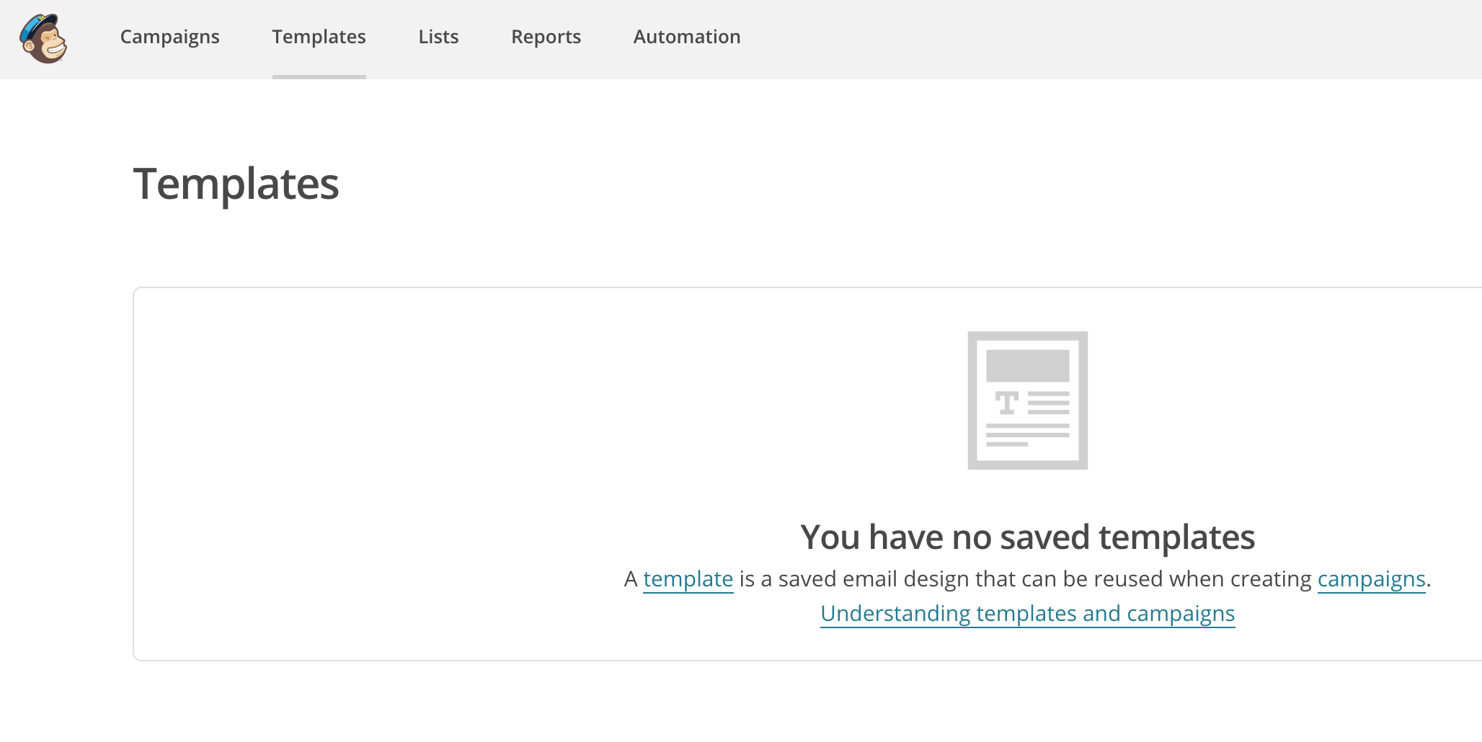
Choose create template and select the appropriate template settings (one column or several). For simplicity purposes, it is advised not to select too crowded templates. It is easier on the reader’s eye to have one column only. Once you have selected your template you will have the options to edit the content or the design.
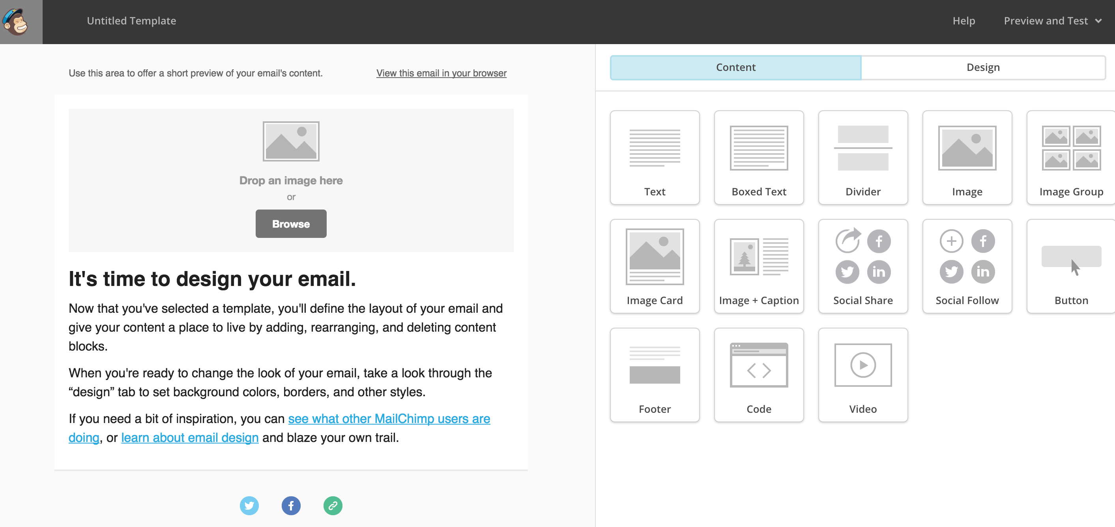The design and content options are self-explanatory, please bear in mind not to overcrowd your template and get to the essentials. One advice is to start with the design, rather than your content which will change over time and campaigns. A simple example would include a header with logo and footer. Remember that the essential content of your future campaign (subject, description, etc..) will be added to your campaign and should not be added to your template
IMPORTANT: The footer that Mailchimp automatically generates is very useful, it picks up attributes from your account and your lists in order to allow users to unsubscribe and see your admin details (email address, postal address, etc..). You can of course amend that and add some additional information there.
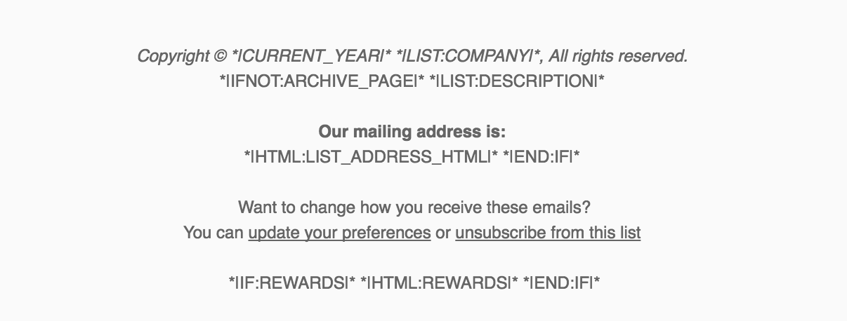
Once your template is ready, you can test it using the preview mode or by sending a test email to yourself for example.
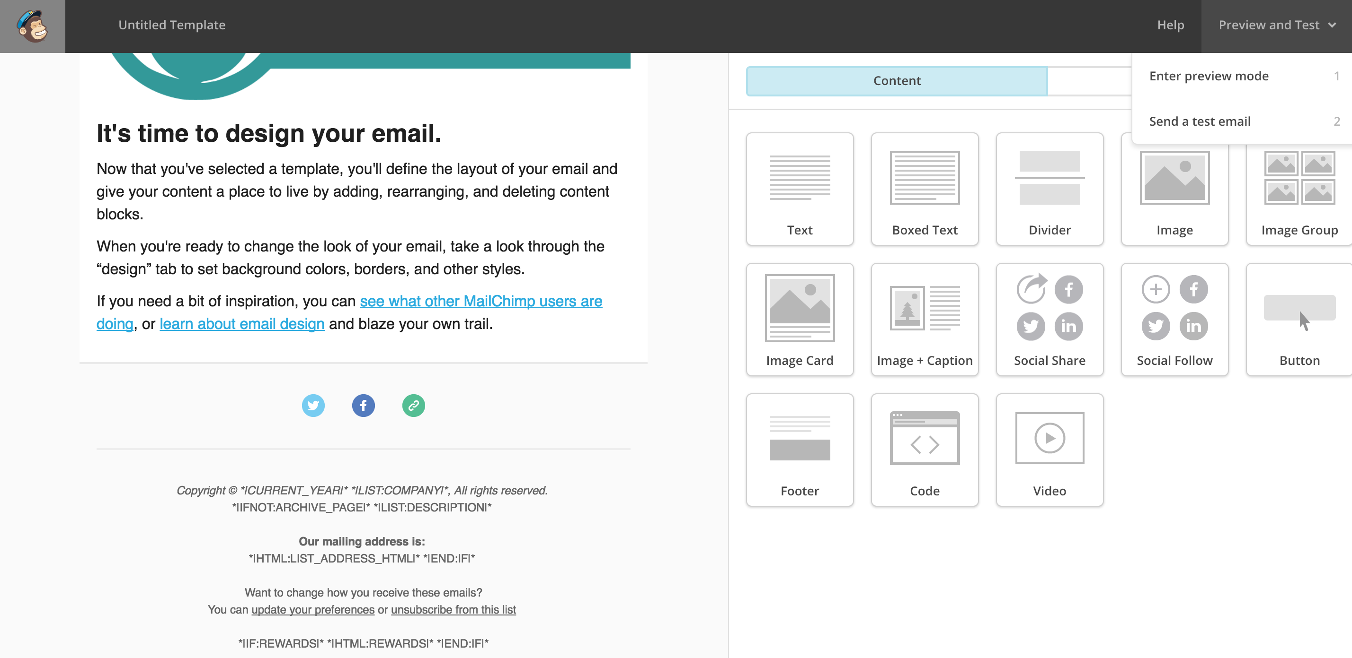
When you are ready with the result of your template, save and exit.
- Create and send your campaign
Now go to Campaigns, create < regular campaign.
First you will be asked to whom you want to send your campaign. Is it the entire master list or groups. Chose the appropriate. Then you will be required to enter the appropriate information about your campaign. You can leave the tracking options ticked, this will also allow you to see who has and who hasn’t read your campaign.
IMPORTANT: The email subject line is very important. The combination of words you are using should be simple and straight to the point. This is the same as in regular emails and correspondence.
You will then be asked to select a template. Go to Saved templates and chose the template you have just created.
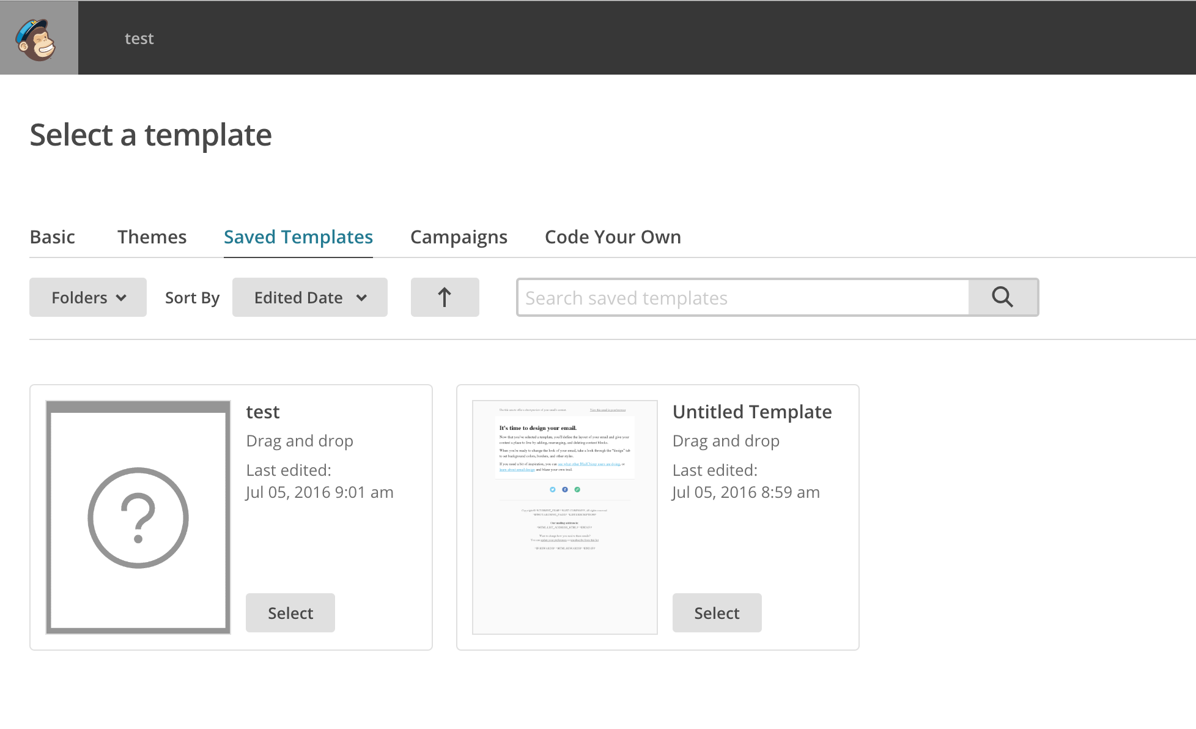
The next step will prompt you to design your campaign, but normally you should not need to, since your template is already designed. The only thing you will do is create the content of your template (subject, description and main content). When this is done click Next.
Done. You are all set. Mailchimp will provide you with a summary of your campaign. Again, you can always test it or send it to yourself using the Preview and Test button on the upper right. Last step, you can press SEND to send it to your list or schedule it for a certain day/time.

Reports and tracking
The reports section of Mailchimp allows you to track recipients of your campaigns and offers other types of basic analytics and correspondence monitoring tools. Just go to the reports section and look at your campaigns criteria of success, opening rates and other stats. For more information on reports and advanced analytics, please refer to the useful links at the end of this document.

Humanitarian ID / HR.Info and Mailchimp
You can embed your contact forms on country cluster websites using HR.info. Please refer to the HR.Info and HID guidance within the Global WASH Cluster Information Management toolkit (http://washcluster.net/imtoolkit-page).

Useful tips and tools for Mailchimp:
General Mailchimp tutorials
Common general Mailchimp mistakes.
Limitations of Mailchimp – Watch for custom content in your emails!
Common HTML mistakes
Bounce back emails troubleshooting:
http://kb.mailchimp.com/accounts/compliance-tips/about-bounces
http://kb.mailchimp.com/delivery/spam-filters/i-know-this-email-address-is-valid-but-it-hard-bounced
http://kb.mailchimp.com/delivery/deliverability-research/soft-vs-hard-bounces
Troubleshooting list imports
Translation with Mailchimp
Mailchimp campaigns

