Contact List : Guidance Note

- After opening the contact list and changing the country name/info, click on the ‘LIST_ORG’ tab.

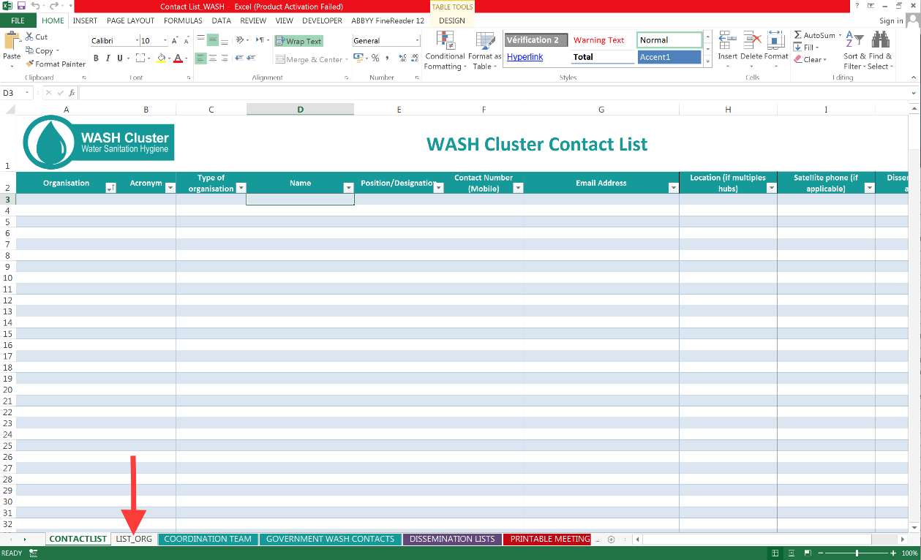

- Edit the list of different types of organizations that you find within your Cluster. If you want to add a term simply type it at the bottom of the list and press Enter or Tab (note: the order of the terms in this table will determine the order they appear on a dropdown list; feel free to sort the column accordingly. Here’s some help on how to sort.
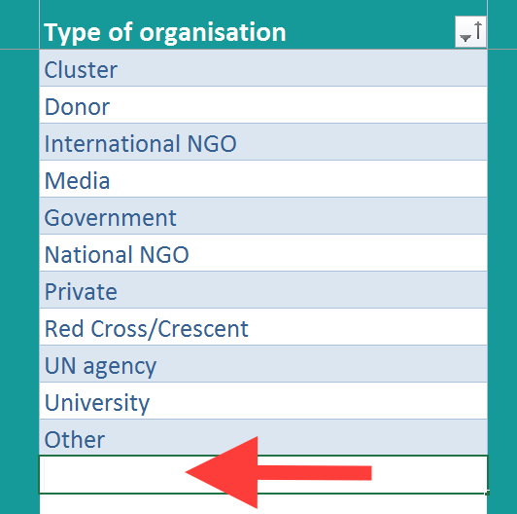

- Still on the LIST_ORG tab, type the names of all Cluster member organizations and their acronyms; select the type of agency that they are from the dropdown list (Note: the terms on this dropdown list are determined by the table in the previous step). If you have an existing contact list, feel free to simply copy and paste the names and acronyms.
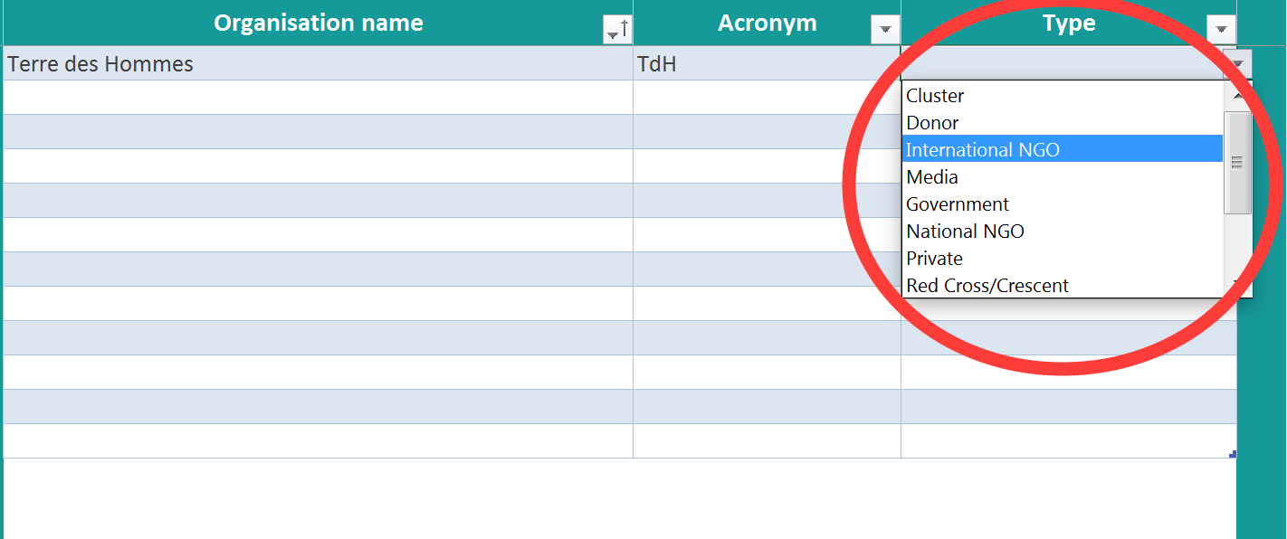
- You are now ready to start populating your contact list: on the CONTACTLIST tab, select the individual’s organization from the dropdown list (the terms on this dropdown are determined by the ‘Organization’ column on the LIST_ORG tab; see the previous step).
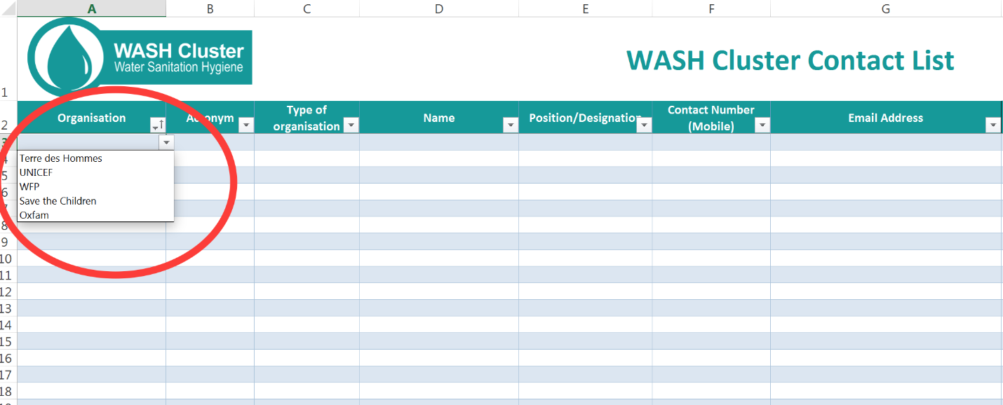
- Once you select the name of the individual’s agency, the ‘Acronym’ and ‘Type of Organisation’ will automatically appear (also determined by the information entered on the LIST_ORG tab). Note: this functions because of formulas that are contained within the cells in these two columns; DO NOT delete these formulas.
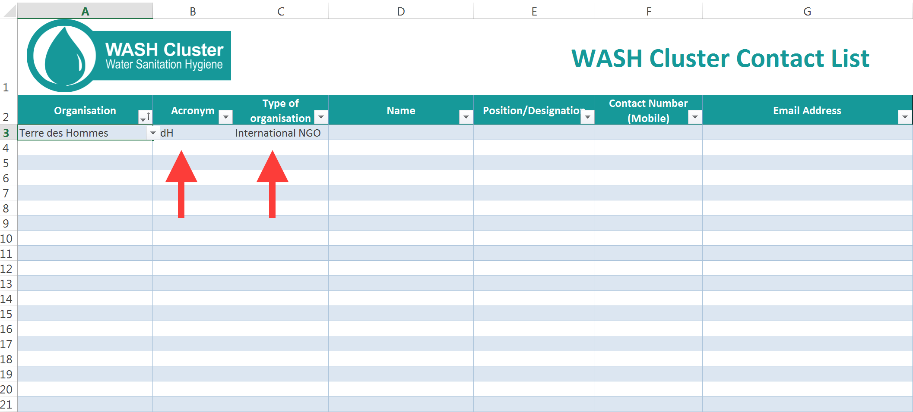
- Now you can add the name, title, email, phone, etc. for the individual whom you are adding to your contact list. Note: feel free to hide columns you do not wish to use or add columns to include additional information about an individual (e.g. the sub-cluster he or she belongs to, etc.). NOTE: If you want to add multiple emails to a single cell, be sure to put a semicolon (;) between them as this will allow you to simply copy and paste into Outlook, Gmail, etc. DO NOT USE COMMAS.
Contact list tips
- As mentioned above, if you put multiple emails for an individual in a single cell, make sure to put a semicolon between them as this will enable you to simply copy and paste into Outlook, Gmail, etc. DO NOT USE COMMAS.
- Print your contact list before meetings (use the printable Meeting list tab) and use it as an attendance list; this not only saves participants time (since they don’t have to write their information at every meeting) but doing so gives you an easy system for having an up-to-date contact list. It’s always good to print several blank rows so that new attendees can write their contact information as well.
- Have a clear and structured system for updating the contact list:
  - When: Update the contact list immediately after every meeting as well as after meeting new people
  - Who: Determine if there should be a single contact list focal point or if the responsibility will be shared. Be very, very clear on how this will be done; otherwise you may get multiple people working on multiple versions of your contact list.
  - Where: determine where will the file be stored and how will updates be shared. You may choose to use something like google sheets/forms or you may choose to have a single focal point email the list each time an update is made.
- Version control, version control, version control! It is good practice to put the date (in reverse order YYYY-MM-DD) at the end of the filename and to change the date every time an update is made. For example: Somalia_WASH_Cluster_ContactList_2016-11-05
This helps keep clear which version is the most recent and to quickly see when the last change was made (and putting the date in reverse orders allows your multiple versions to be organized chronologically).
- When emails bounce back, try calling them to update their information.
- You can filter your main contacts by dissemination lists and copy paste all the email addresses into one cell in your dissemination lists tab (see this tutorial).

