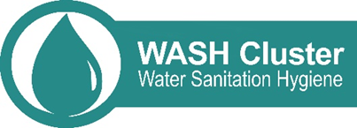

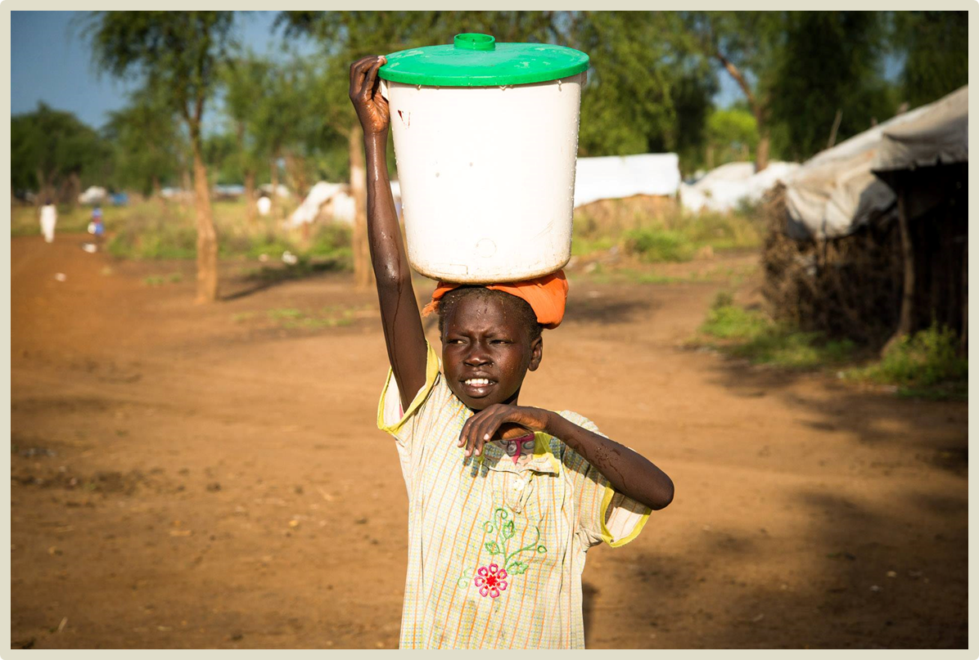

INSERT NAME OF DOCUMENT
INSERT SUBTITLE OR CONTEXT OF PROJECT
TITLE
Area, Country
Date

DD of MM, YYYY

SUMMARY
Normal text Normal text

CONTENTS
SUMMARY 2
CONTENTS 3
LIST OF ACRONYMS 3
GEOGRAPHIC CLASSIFICATION 3
LIST OF FIGURES, TABLES AND MAPS 3
INTRODUCTION 4
METHODOLOGY 4
Objective 4
Preparation 4
Sampling 4
FINDINGS 4
Population profile 4
Livelihoods 4
CONCLUSION 5
ANNEX I: The white page 6

List of acronyms
GWC Global WASH Cluster
WASH Water, Sanitation and Hygiene

Geographic classification
Governorate Highest form of governance below the national level.
District Governorates are divided into districts.

List of figures, tables and maps
Figure 1: Vocational Trainings 4

Table 1: Impact of aid on food security 4

Map 1: Assessed areas 4

Introduction
Normal text Normal text

Methodology

Objective
Normal text Normal text Normal text Normal text Normal text Normal text Normal text Normal text Normal text Normal text Norma Normal text Normal text Normal text Normal text Normal text Normal text Normal text Normal
**Text is justified**

Preparation
Normal text Norma Normal text Normal text Normal text Normal text Normal text Normal text Normal text Normal

Sampling
Describe sampling strategy

Limitations
Present limitations and challenges

Findings
This section outlines the main findings from the assessment, including education, health, food, livelihoods, energy/fuel and water. Data is generally presented at two levels, both in the graphics and the narrative: disaggregated by camp, and generalized at the national level.

Population profile
This sub-section outlines assessment findings related to the assessed population.
Households with specific needs and vulnerabilities
Based on the profile of the assessed population, seven groups were identified as being in a particularly vulnerable position compared to the average refugee household. This section focuses on the impact of that vulnerability, correlating specific demographic characteristics with other indicators.

Livelihoods
This sub-section outlines assessment findings related to the livelihoods of the assessed population.

Main sources of income
Most households rely on sewing (43%), as shown in Figure 1. Normal text Normal text text Normal text Normal text

For more information on data presentation and graph appearance, refer to the GWC Style Guideline.
Figure 1: Vocational Trainings

Map 1: Assessed areas
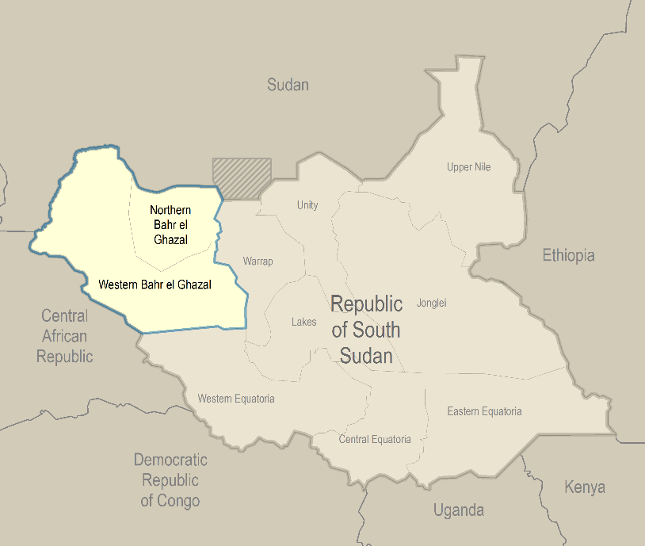

Table 1: Impact of aid on food security
 | Food Secure | Moderately Food Insecure | Severely Food Insecure
Both FFA and GFD | 68% | 31% | 1%
FFA Only | 59% | 40% | 1%
GFD Only | 63% | 30% | 8%
None | 60% | 38% | 2%
Sample Median | 61% | 37% | 2%

Conclusion

ANNEX I: The white page

