Creating static dashboards during emergencies (using Excel and Publisher)
2014

Global WASH Cluster IM Toolkit

Contents
INTRODUCTION 3
What is a Dashboard? 3
What do we need to make Dashboards? 3
Which type of Dashboard to use, static or interactive? 4
Preparing your datasets 4
CREATING STATIC DASHBOARDS (one and two page templates) 5
1. Excel & Publisher 5

INTRODUCTION

What is a Dashboard?
A dashboard seeks to provide a visual display of the most important information needed to make a decision about the response to an emergency, for instance, it can show the progress of a Cluster against targets and needs for a particular intervention.
Strategic level dashboards are produced on a cyclical (often quarterly) basis, highlighting key Humanitarian Response Plan (HRP) indicators and high-level response information. Nonetheless, more operational level dashboards would be useful to produce in tandem with the cycle of 4W submissions by partners (often weekly or monthly) to facilitate the coordination of activities.
As such a dashboard needs to be tailored to the specific decisions or audiences, collecting feedback through several cycles of prototype, testing and adjusting. The regular production of dashboards is useful for a number of reasons:
- It encourages WASH partners to supply 4W information, and how the information is used;
- It helps to identify both gaps and over-provision of interventions in the Cluster; and
- It acts as an advocacy tool for cluster partners.

What do we need to make Dashboards?
Ideally, the dashboard will provide visualisations of both activity tracking and coverage against HRP priorities, and of indicator monitoring against HRP standards. It may also incorporate cluster capacity and caseload information to provide context to the numbers.
Nonetheless, a dashboard should be kept as simple as possible. It should just give a snapshot of where a Cluster is in the response. If there is information of interest to partners beyond what is shown in the dashboard, then the raw data or additional information can be shared by the IMO. Thus, a dashboard should be uncomplicated, avoiding over intricate graphs and lots of text.
A dashboards visualisable content must be easy to read and comprehend - it should:
- Be grouped logically
- Provide context to give meaning to the numbers i.e. highlighting the target, trend or typical values
- Highlight exceptions, gaps and surpluses
- Use appropriate chart types with ‘soft’ consistent colours
It is best to initiate a draft and refine through several iterations, than to spend weeks creating the perfect first version, or sourcing elusive datasets.

Which type of Dashboard to use, static or interactive?
The same dataset can be used to create both static and interactive dashboards. Depending on the emergency, if there is a low level of internet connectivity and low IM resources, it may be better to create a static dashboard. If there is widespread availability of internet and good IM resources, an interactive dashboard may be more appropriate. If resources are low but there is good connectively, a dashboard created less frequently might be useful.

Preparing your datasetsBefore you organise your data (for a static or interactive dashboard) be sure that you know what you want to visualise and for what audience you are creating the visualisation. This will help define the data needed and its format, and the best means of presentation and distribution.

The examples provided in this Section are simple outlines using fictional data. They will need to be adapted and dynamically linked to the source data you have identified.

The datasets supplied as an example in the WASH IM Toolkit contain four simple/general WASH indicators with information for each in ten locations which have longitude and latitude, total beneficiaries in need, targeted, and reached. It is not necessary to have the longitude and latitude, but this enables the creation of maps alongside other visualisations in the interactive dashboard (using Tableau).

CREATING STATIC DASHBOARDS (one and two page templates)

Excel & Publisher
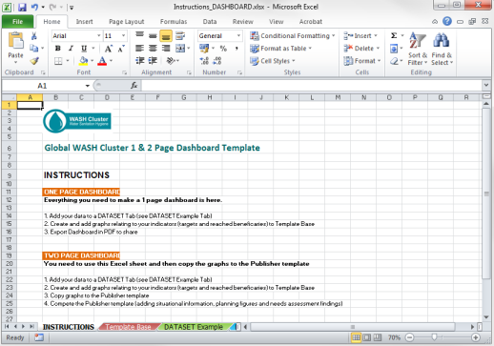
The WASH IM Toolkit (Reporting - WASH Dashboard-Static Dashboard section) contains an Excel spreadsheet template named Instructions_DASHBOARD
This template should be used to make a one page Excel Dashboard or a more extensive two page Publisher Dashboard. The Excel has five TABS
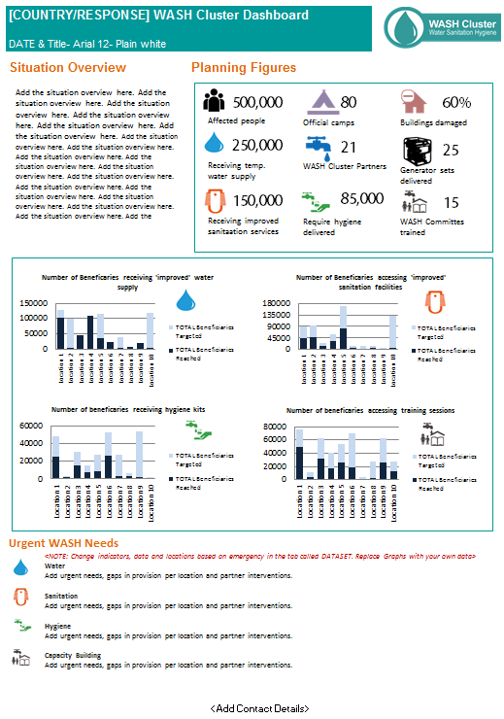
Tab - Instructions
Basic instructions on how to use the template for both one and two pager Dashboard
Tab – Chart Catalogue
Tab contains pre-formatted charts to add to your Dashboard. Copy and paste to your data tabs and re-define the chart source data.
Tab - Icons and Logos
Tab contains additional images to add to your Dashboard. There is a folder of icons in the WASH IM Toolkit that can also be used here.
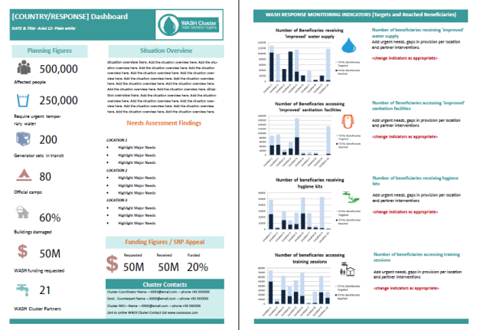
Tab(s) - Dataset Example
Dummy data used to create the graphs in the Template Base

Tab - Template Base(s)
An example template has already been creating using basic indicators and dummy data. You will replace these graphs (indicators) and text with your own graphs.

Follow the instructions (instructions Tab) on how to create either a one pager or two page Dashboard.
Note: Once you are happy with the dashboard, create a PDF and share to partners and other interested agencies and upload to the operational website

