NEEDS-BASED
STRATEGIC PLANNING
AND MONITORING

Process and Outputs
The IASC Transformative Agenda calls for a more evidence-based, strategic and prioritised humanitarian response. It proposes a needs-based strategic planning approach and stronger coordination around the “humanitarian programme cycle” – from assessment and analysis of needs, to planning of the strategic response, resource mobilisation, implementation, monitoring and evaluation of operations.
Planning for the plan: The HC with the HCT are expected to outline the process prior to commencing including establish a vision of needs based strategic response planning; setting a time frame and broad parameters of the process and agreeing on roles & responsibilities.
The programme cycle stipulates that protracted response operations should commence with a Humanitarian Needs Overview (HNO) followed by a Strategic Response Plan (SRP) and regular periodic monitoring reports (PMR) with each step informing the next. All three steps make up a single process with the primary purpose of providing the humanitarian country team (HCT) with decision-making support and a management tool for response.
TRIGGERS  - Event / situation requiring a joint response  - New planning cycle  - Significant change in situation  - When monitoring data suggests corrective actions | ► | Joint  Analysis  HNO | ► | Strategic  Planning  SRP | ► | Response  Monitoring  PMR

HNO: In developing an HNO the humanitarian community collaboratively analyses existing humanitarian information and reaches a shared understanding of which are the priority issues and of the likely evolution of the situation. This process underlies the country team’s strategic response. The HNO document describes the impact of the humanitarian crisis, provides and explains an estimate of the number of those affected, analyses their situation and presents an overview of the operational environment (as an annex). The HNO captures both the current situation as well as the projected evolution of needs during the planning cycle.
SRP: The strategic response plan articulates the shared vision of how to respond to the affected population’s assessed and expressed needs. The strategic response plan is a management tool for response and supports decision-making by the humanitarian country team. It has two interlinked components: a country or context strategy, with strategic objectives and indicators; and cluster plans, with objectives, activities and accompanying projects. Together they detail how the strategy will be implemented and how much funding is required.
PMR: Humanitarian response monitoring is a continuous process that records the aid delivered to an affected population as well as the results achieved against objectives set out in the SRP. The PMR tracks inputs, and outputs resulting from interventions on behalf of affected populations; charts the outcomes of cluster activities; and measures progress towards the strategic and cluster objectives of the SRP, taking into account the diversity of the affected population and their perspectives in relation to the response.
The preparations for response monitoring are integral to the process of developing the SRP and as such carried out at the drafting stage of the SRP. Response monitoring preparations have strong repercussions at three levels of the SRP process:
- strategic level monitoring, when selecting indicators and setting targets for measuring achievement against the strategic objectives;
- cluster level monitoring, when selecting indicators and calculating targets to accompany cluster objectives;
- project level monitoring, when selecting indicators and defining targets for capturing the outputs of cluster member activities.
The agreements on each level serve as basis for all monitoring efforts and reporting throughout the HPC cycle
The chart below illustrates the key information elements pertaining to all three steps: joint needs analysis, strategic planning and response monitoring. It conceptualises how the operational element informs strategic information, starting with assessment data and reports expose the primary needs and shape strategic objectives, and progressing to how these subsequently inform cluster objectives, activities and projects, matched by corresponding levels of monitoring.

Information elements for needs analysis, strategic planning and monitoring
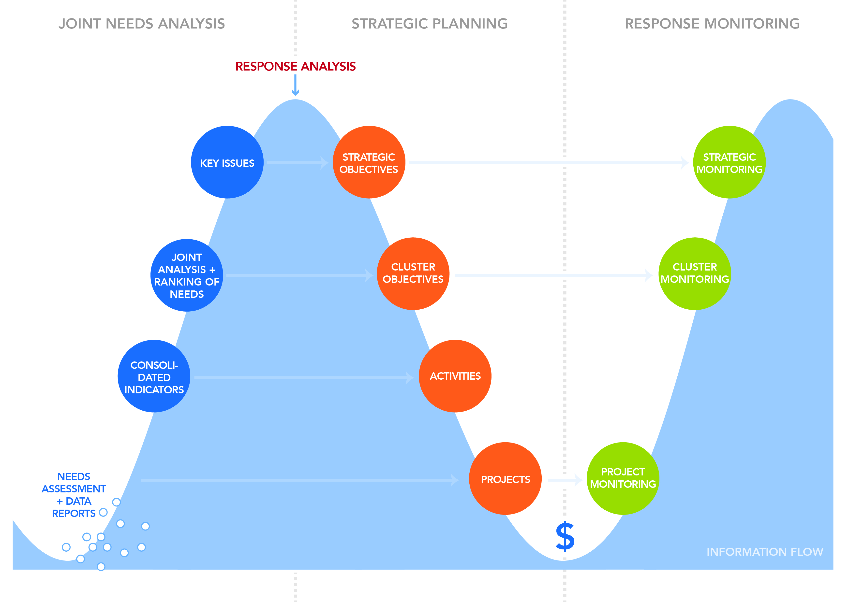

From Needs Analysis to Strategic Planning
and Response Monitoring
- Linking the HNO to the SRP, the response analysis is perceived as the core of needs based strategic response planning. A response analysis follows the review, validation and analysis of the needs. It means deciding what to do, once the HC/ HCT has an understanding of needs and of the operational context within which they are working. It also requires an analysis of the causes of the problem, the “why”, in order to decide on an appropriate response.

- Consider undertaking response analysis during the strategic planning workshop. The response analysis helps establish boundaries such as time, geographical focus and assumptions, based on the feasibility of different response options, which in turn form the basis for development of strategic objectives and indicators for a country strategy.
- In line with the country strategy, the clusters are responsible for developing cluster plans including a log frame for implementation and for subsequent monitoring.

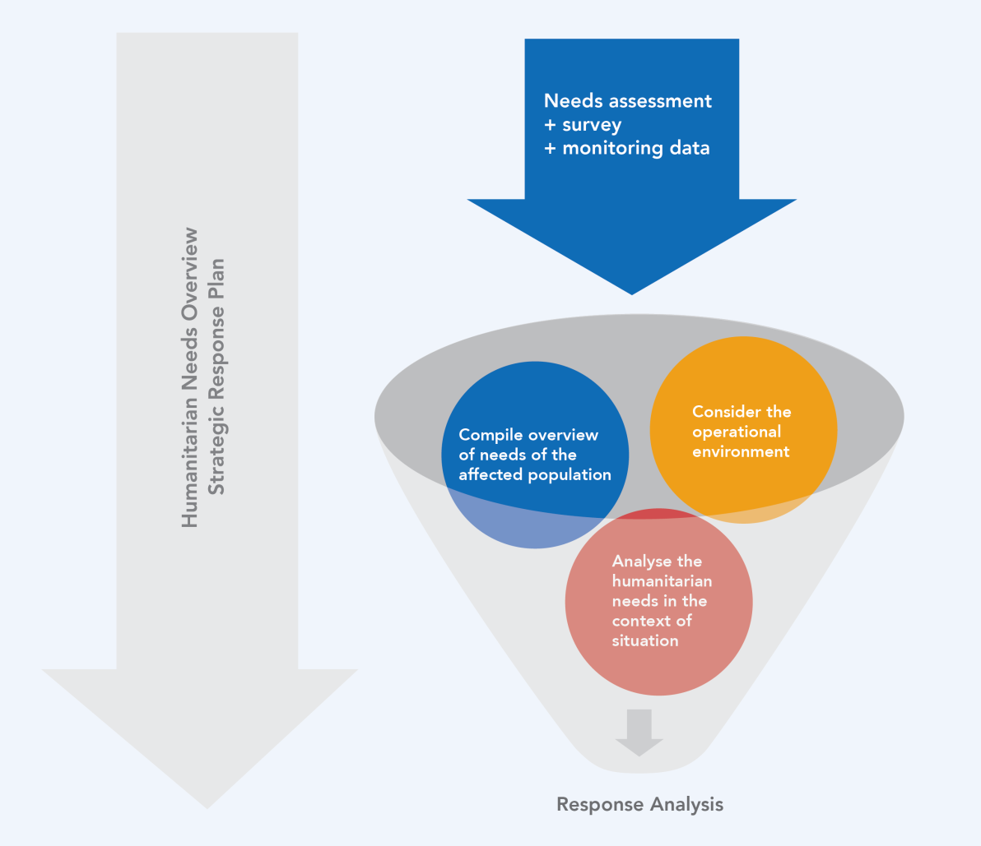

Roles and Responsibilities
MAIN  STEPS | Preparation/  pre-planning | Needs Analysis | Strategic Planning |  |  | Response Monitoring
 |  | Humanitarian Needs Overview | Response Analysis | Country strategy | Cluster Plans | Periodic Monitoring Report
Content | - Planning for a needs based strategic response planning including time frame  - Establishing the broad parameters of the process  - Considering options for consulting the affected population  - Agreeing on roles & responsibilities | Joint needs analysis/overview  - Key problem statements  - Impact of the following on the crisis:  - Drivers/underlying factors  - Scope/scale and demographic profile  - Population status – including livelihood analysis  - Impact of the crisis on critical markets  - Information gaps (assessment planning in SRP)  Annex: Operational environment | Components for response analysis:  1. Needs analysis (HNO)  2. Operational environment:  - Capacity (local, national, international, HCT)  - Community concerns  - Access constraints  - Security constraints  - Political considerations  - Seasonal cycles  - Market capacity  - Country specifics | Country strategy  - Parameters: boundaries; assumptions;  results of response analysis  - Strategic objectives  - Strategic indicators, baselines and targets  - Assessment planning | Cluster strategies  - Cluster objectives  Log frames  - Cluster activities, locations, indicators, baselines and targets | Overview  - Changes in context  - Needs analysis  - Response capacity  Strategic Objectives  - Achievements to date  Analysis  - Funding analysis  - Cluster Performance and achievements  - Challenges  - Contingency/Preparedness Plans  Recommendations
Modalities | HCT planning meeting in consultation with the Inter-Cluster Coordination Group | Analysis team, supported by OCHA, responsible for the development of humanitarian needs overview | Response analysis during strategic planning workshop based on needs analysis and operational environment | Workshop  Wider consultations/reviews  Validation by HCT | Intra-cluster work  validation by HCT | Through processes, responsibilities and reporting format outlined in monitoring framework
Main actors | Humanitarian Coordinator (HC)/HCT/ICCG | HCT/ ICCG, Clusters, OCHA  analysis team assigned by HCT/ICCG comprising cluster representatives and technical experts | HCT  ICCG  Humanitarian stakeholders | HC/HCT  ICCG | Cluster coordinators and members | Clusters, ICCG, HC/HCT
Roles + responsi-bilities | - HC/HCT: Decision on the overall process from joint needs analysis to strategic response planning  - Cluster coordinators: Planning in consultation with the ICCG | - HC/HCT: custodians of the process, responsible for initiating and validating joint analysis  - Analysis team: Conducts consultations and develops humanitarian needs overview  - OCHA: Convenes analysis team and supports data compilation, consultations, caseload estimation, joint analysis, production of needs overview document and dissemination as appropriate, maintains assessment registry of Common Operational Datasets (CODs) and Fundamental Operational Datasets (FODs)  - Cluster coordinators: coordinate member inputs, participate in consultations identification of needs and gaps, validate findings  - NGOs, agencies: participate in consultations, provide expert inputs, validate findings | - HC/HCT: custodians of the process  - Analysis team: present and ensure availability of needs overview  - Cluster coordinators: prepare and ensure availability of information for response analysis  - OCHA: facilitates response analysis process and discussion  - NGOs, agencies: participate in consultations, provide expert inputs | - HC/HCT: Leads planning process, defines overall vision  - Cluster coordinators: participate in planning, engage with cluster members, provide HCT with inputs for the strategy, ensure cross-sectoral collaboration  - OCHA: Facilitates planning process, coordinates caseload planning, prepares draft country strategy, finalises response plan  - NGOs, agencies: participate in consultations, provide expert inputs | - Cluster coordinators: Prepare internal division of labour and establish peer review panel for projects  - Cluster members  Contribute to cluster plans, elaborate projects including requirements in line with cluster objectives | - Cluster: reviews compiled core and supplemental information and synthesises challenges faced in reaching objectives and making recommendations for cluster/HCT action  - OCHA: facilitates compilation of core and supplemental information for inter-cluster analysis and reporting  - ICCG: analyses compiled information and synthesises challenges faced in reaching objectives, makes recommendations for HCT  - HC/HCT: deliberates on findings and recommendations makes evidence-based decisions to address major constraints. Optionally, endorses report for public release
Timeline | A meeting ahead of the start of the process | 4-6 weeks before SRP development | One meeting /session  (ideally at SRP workshop) | 4 weeks including workshop | 4 weeks | As agreed in the Monitoring Framework

In the case of a sudden onset level 3 emergency, a secondary data analysis will be the first step in analyzing the affected populations’ needs and based on the information gaps informed, a Multi Cluster/Sector Initial Rapid Assessment (MIRA) will be organized, its findings informing the strategic plan.
See Strategic Response Plan guidance for more information on country strategy, cluster plans and monitoring.

