Discussion Paper
Strategic Response Planning
A possible guidance to engage cluster coordinators in a systematic intercluster approach
GB (Nutrition) – FB (WASH), 12/11/2012
Introduction
Audience
This paper provides to the GCU a framework to discuss a possible approach for intercluster programming at country level. It aims at generating a first discussion at the cluster unit in EMOPS/Unicef, before broaden it to the relevant IASC working groups if there is an interest / significance to do so.
Current Challenge
The interest of intercluster cooperation / coordination is well understood. However, encouraging it remains a challenging task for the HC. The transformative agenda brings the elements to enhance intercluster cooperation, but a systematical approach remains to be proposed to ensure that it goes beyond the strategic planning and is included in the projects presented by the cluster partners.
Scope and Objective
A systematic and step-by-step approach is proposed to help cluster coordinators (CC) to guide partners and systematically consider intercluster programmatic needs when developing a strategic response plan for their clusters. The approach is consistent with the planning process of the transformative agenda.
Proposal to enhance intercluster programming
Assumptions
The programming process follows the subsequent logic:
- Identification of the humanitarian response goal (impact)
- Identification and formulation of key intercluster strategic objectives (strategic outcomes) of the humanitarian response by the HC/HCT. This phase is by essence intercluster.
- Definition of the cluster objectives by each cluster (cluster outcomes), which can contain intercluster elements, but not necessarily
- Identification cluster outputs (most generally the cluster projects of the partners), which should necessarily contain all the intercluster elements to achieve the strategic objectives of the humanitarian response. This is where the cluster coordinator needs to bring guidance to the partners and where the proposed approach can add value

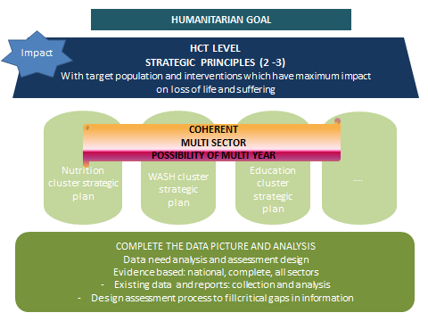
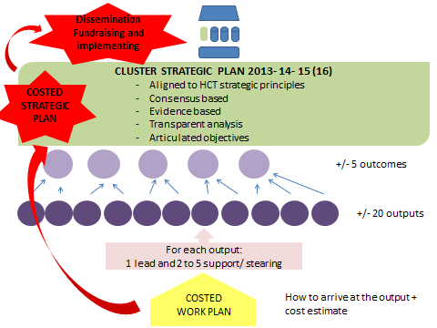

The Approach
Phase 1: definition of the cooperation needs among cluster
This step is led by the HC and the HCT who formally address intercluster cooperation needs based on the strategic objectives identified. They are summarized in a simple cluster/cluster matrix, which serves for the CCs to identify with which clusters they are to cooperation in priority.

Identification of key area of cooperation between clusters:
 |  | WASH Cluster | Nutrition Cluster | Protection Cluster | Education Cluster | Shelter Cluster | Cluster….
What can this cluster provide to others? | WASH Cluster |  | ex.: distribution of hygiene kits  Safe water at nutrition center  Access to water for communities
 | Nutrition Cluster | ex.: Sensitization messages (C4D) |  | ex.: Food rations | ex.: Integrate nutrition in school curriculums  School feeding
 | Protection Cluster |  | ex.: Focus group discussions at nutrition center with caretakers  Support to orphans or isolated children
 | Education Cluster
 | Shelter Cluster
 | Cluster …

Phase 2: identification of input needed for each cluster (request mode)
This step is led by the cluster coordinator. While defining the cluster objectives, the coordinator of a X cluster identifies, for each of the cluster ouputs, the necessary activities the other clusters need to be engaged in to make sure they contribute to the achievement of the X cluster objectives. The activities can be summarized in an input / output cluster matrix for the X cluster, which expresses the needs for he X cluster X. Each cluster is engaged in this process simultaneously. At the end of the process, each CC has expressed the needs of input for other clusters for his/her cluster. All matrices are exchanged between all CCs, who therefore know the request for inputs by the other CCs.

Matrix of Intercluster Input
(X Cluster – input needed from other clusters)
IDENTIFICATION OF INPUTS FROM OTHER CLUSTER TO THE NUTRITION CLUSTER
 | Output 1  ex.: management of Severe Acute Malnutrition | Output 2  Access to safe water and hygiene in nutrition centres | Output 3  Detection of malnutrition cases | Output 4  Prevention of malnutrition at community level | Output 5 | Synthesis of needs per cluster
WASH Cluster | 0 | 20 000 hygiene kits  build 50 latrines boys/girls in 50 nutrition centres | 0 | Rehabilitation of 20 wells and 10 boreholes  200 copies of Hygiene promotion- C4D material | 0 | 20 000 hygiene kits  Rehabilitation of 20 wells and 10 boreholes  200 copies of Hygiene promotion- C4D material
Nutrition Cluster
Protection Cluster
Education Cluster
Shelter Cluster
Cluster …

IDENTIFICATION OF INPUTS FROM OTHER CLUSTER TO THE PROTECTION CLUSTER
 | Output 1 | Output 2 | Output 3 | Output 4 | Output 5 | Synthesis of needs per cluster
Cluster WASH
Cluster Nutrition
Cluster protection
Cluster Education
Cluster Shelter
Cluster …
IDENTIFICATION OF INPUTS FROM OTHER CLUSTER TO THE EDUCATION CLUSTER
 | Output 1 | Output 2 | Output 3 | Output 4 | Output 5 | Synthesis of needs per cluster
Cluster WASH
Cluster Nutrition
Cluster protection
Cluster Education
Cluster Shelter
Cluster …

Phase 3: identification of output needed from each cluster (service delivery mode)
This step is also led by the cluster coordinator. Once having all the matrices of intercluster input from the other clusters, the coordinator of the X cluster can easily identify the activities that need to be developed in the projects presented by the cluster partners. S/He can provide a one line matrix for his/her cluster to compile all the outputs that the projects of the partners need to contain to support the objectives of the other clusters.
Matrix of Intercluster Output
(X Cluster – outputs to be achieved for other clusters)
 | Nutrition | Protection | Education | Shelter | …
WASH

Phase 4: ranking of cluster project based on intercluster criteria
The projects proposed by the partners in the X cluster can be ranked according to the number of outputs that are in lined with the input needs of the other clusters, using a simple 0 and 1 code. It provide to the CCs a good view of which cluster the cooperation is active or not.
Cluster Project Ranking
(X Cluster – intercluster cooperation criteria)
WASH | Nutrition | Protection | Education | Shelter | … | Rating by partner/project
Partner A |  |  |  |  |  | 5
Project 1 | 1 | 0 | 1 | 0 |  | 2
Project 2 | 0 | 1 | 1 | 0 |  | 2
Project 3 | 1 | 0 | 0 | 0 |  | 1
Partner B |  |  |  |  |  | 4
Project 1 | 1 | 0 | 0 | 1 |  | 2
Project 2 | 1 | 0 | 1 | 0 |  | 2
Project 3 | 0 | 0 | 0 | 0 |  | 0
…
Rating by Cluster | 4 | 1 | 3 | 1 |  | 9
Notation: Cluster integrated into project = 1/ Cluster not integrated = 0
Limits and Advantages
(+) Systematic process that forces the CCs to go through a systematic review of their intercluster cooperation needs in term of request and offers; A way to take into consideration intercluster cooperation needs in the ranking of projects with objectives criteria
(-) Formalized process that requires time.

Next step
Discuss within GCCU/EMOPS/UNICEF the interest of systematizing such an approach and going further.

