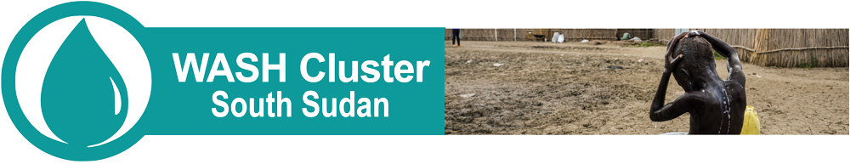
PARTNER BRIEFING SHEET
0. Partner Briefings
Partners are welcome for induction briefings at the WASH Cluster office in UNICEF in Juba (see address here) on
Thursdays from 10AM to 12PM. Kindly make sure you notify the team beforehand. at: wash.information@gmail.com

1. How do I get on the WASH Cluster mailing list?
Subscribe to the main WASH Cluster Partner Contact list by clicking HERE
If relevant you can also ask to be added to one of the groups below writing directly to: wash.information@gmail.com
- List of the South Sudan WASH Cluster sub-groups:
Terms of Reference (ToR) available in the annexes of the Strategic Operational Framework (SOF)
WASH Cluster core groups open to the elected members only:  - Strategic Advisory Group (SAG) for middle/long-term strategic issues  - Emergency Preparedness and Response (EP&R) Working Group for mobile teams deployments  - Steering Committee (SC) = “SAG + EP&R + 2 donors” for operational and structural short-term issues | WASH Cluster Technical Working Group (TWiG) open to all interested and active members:  - Accountability for Affected Population (AAP) TWiG  - AAP / Gender Based Violence (GBV) sub TWiG  - Cholera Technical TWiG  - Urban WASH TWiG  - Monitoring and Evaluation (M&E) TWiG  - Drilling/Boreholes/Handpumps (DBH) TWiG
2. How do I find contact details of others?
You can access the main contact list of existing members and partners of the Cluster here: https://goo.gl/EapZyE
3. Where can I find Maps, Meeting calendar, Minutes, Sitreps, assessment reports?
- All the key information of the Cluster is available on the WASH cluster South Sudan website:
https://www.humanitarianresponse.info/en/operations/south-sudan/water-sanitation-hygiene
- You will find additional information for partners on the WASH Cluster full share drive here:
https://drive.google.com/drive/folders/1b_A88cPnPT0lXYgvK78kJiVzo85UpnBh?usp=sharing
- You can also request access for uploading information directly to: wash.information@gmail.com
4. How can I find where WASH partners are working?
You can find out where other partners are working on the operational presence map produced monthly. Access to the folder here: https://goo.gl/8FHjN3
You can also query and download the latest 5W data (Who does What Where When and for Whom) here: https://goo.gl/AKrLhY
5. What are the core documents of the Cluster?
The core documents of the Cluster are the following; the Strategic Operating Framework, the Humanitarian Response Plan WASH section, the Humanitarian Needs Overview for WASH, the Core Pipeline Toolkit and the EP&R Strategy. You can access all these core documents here: https://goo.gl/qWvgyN
6. How do I know when and where the next Cluster meetings take place?
WASH Cluster monthly meeting (forum open to all partners) per default each last Friday of the month from 10:00 am – 11:00 am at OCHA Office – Juba
, you can access the calendar of events here: https://goo.gl/sMJgLL
In order to see all Cluster and Inter Agency Events for South Sudan click here:https://goo.gl/VHn9Y3
7. Where can I find additional information?
Useful additional links:
South Sudan on ReliefWeb
Global WASH Cluster Website

Cluster team contacts
Frederic Patigny  UNICEF  WASH Cluster Coordinator  fpatigny@unicef.org  +211 (0) 920 873 960 (Mobile) | Rana Sarmad Sardar  NRC  WASH Cluster Coordinator  sarmad.sardar@nrc.no  +211 (0) 922 761 673 (Mobile) | Olivia Pearson  WASH Cluster IMS  UNICEF  Information Manager  wash.information@gmail.com

