Guidelines on Coordinating Integrated Nutrition-in-WASH Interventions in Emergencies

The impact of water, sanitation and hygiene (WASH) interventions on nutrition and - ultimately - health outcomes is well-documented. Inadequate access to clean water and unsafe sanitation and hygiene practices increase the risk of severe infectious diseases that can contribute to undernutrition (Black R et al. 2013). Studies have shown that improved WASH interventions can reduce diarrhoea, parasitic intestinal infections, and environmental enteric dysfunction, which inhibit the absorption of calories and nutrients and generally impact nutritional status (Pruss-Ustun, 2006; Humphrey J. 2009). Emerging evidence also suggests that stunting cannot be addressed without focusing on WASH interventions (Cochrane, 2013). The framework below illustrates the main WASH-related routes to undernutrition:

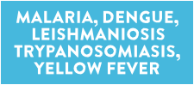

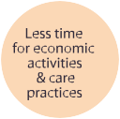

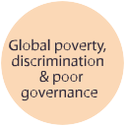

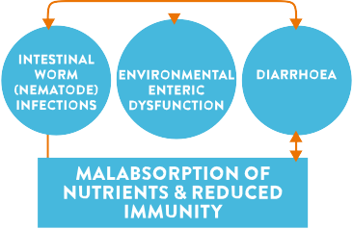

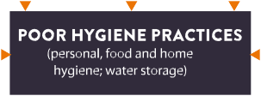

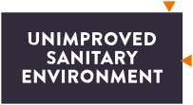

Source: Dangour at.al (2013), adapted by Lapegue J., ACF (2014) “WASH and nutrition factsheet”

Over the years, numerous efforts have been made to integrate WASH in Nutrition programmes especially in food insecure contexts. Most of these efforts are programmatic with little documentation of effective coordination models of nutrition-sensitive WASH interventions. Pulling on these field experiences therefore, the Global WASH Cluster has developed a checklist to provide guidance to WASH coordination platforms and practitioners on quick actions required to operationalize integrated Nutrition-in-WASH interventions for positive health outcomes. This checklist will supplement the Inter-cluster matrix (GWC, 2008) which clarifies accountabilities and areas of responsibilities for WASH, Nutrition and Health.

Areas of Integration | Checklist of Proposed Actions
Emergency Preparedness | - Have you involved the government and national WASH institutions in promoting safe WASH practices as part of the efforts to curb malnutrition?  - Have you held joint consultations and collated information on integrated programming as part of your preparedness/ contingency planning?  - Have you conducted joint coordination/ cluster approach trainings?  - Have you shared information with cluster partners for a common understanding on the link between WASH and the causes of malnutrition?  - Have efforts been taken to analyze cluster partner scale-up capacities for a nutrition-sensitive WASH response?
Coordination Arrangements | - Do you encourage participation in WASH-Nutrition cluster meetings?  - Have you incorporated Nutrition-in-WASH integration in the TORs for Cluster Coordination roles at national and sub-national levels?  - Have you mapped the areas of operations for partners involved in integrated Nutrition and WASH interventions?  - Do you have representation in relevant Technical working groups in both clusters?
Information Management | - Do you jointly collect, analyze and share information on nutrition needs for evidence-based WASH programming?  - Do you document and share lessons learnt on nutrition-sensitive WASH interventions and the impact of integrated programmes?
Needs Analysis | - Have you made efforts to conduct joint assessments and gap analysis?  - Do you support WASH assessment in communities where malnutrition is of concern to generate the evidence base for an integrated programme?  - Have you included nutrition indicators (perception based) in WASH assessment questionnaires?
Strategic Planning | - Do you contribute to joint WASH-Nutrition cluster strategic plans?  - Do you reinforce the WASH-in-Nutrition concept in project proposals?  - design incentives through reporting or evaluation criteria for the WASH and nutrition sectors to work in collaboration toward common goals, objectives, and targets
Response Implementation | - Are there efforts to promote joint cash-based programming as part of nutrition-sensitive WASH interventions?  - Do the WASH sector activities target and/or prioritize malnourished individuals/ households/ communities?
Resource Mobilization | - Do you produce joint funding proposals?  - Do you advocate for integrated funding streams for nutrition-sensitive WASH programmes?
Monitoring and Evaluation | - Do you encourage partners to do joint monitoring of nutrition-sensitive WASH responses?  - Do you monitor trends in hygiene and water related illness at nutrition rehabilitation/feeding centres, health facilities and at the community level (where malnutrition is of concern)?

Undernutrition is defined as the outcome of insufficient food intake and repeated infectious diseases. It includes being underweight for one’s age, too short for one’s age (stunted), dangerously thin for one’s height (wasted) and deficient in vitamins and minerals
Stunting is defined as low height for age

