Communication in Context

The Humanitarian Programme Cycle (HPC)

The Humanitarian Programme Cycle (HPC)

The HPC is a comprehensive and single strategic process consisting of six sequential elements and two key ‘enablers’. It can be used as a leadership tool since it covers the whole humanitarian cycle. It can be applied to all humanitarian crises and the process, timeline, tools and documents can be used flexibly.

Information on HPC is found in ‘IASC Reference Module for the Implementation of the Humanitarian Programme Cycle’ (2015), published by the Inter-Agency Standing Committee (IASC). This reference module is one of 8 protocols developed to support implementation of the IASC Transformative Agenda.

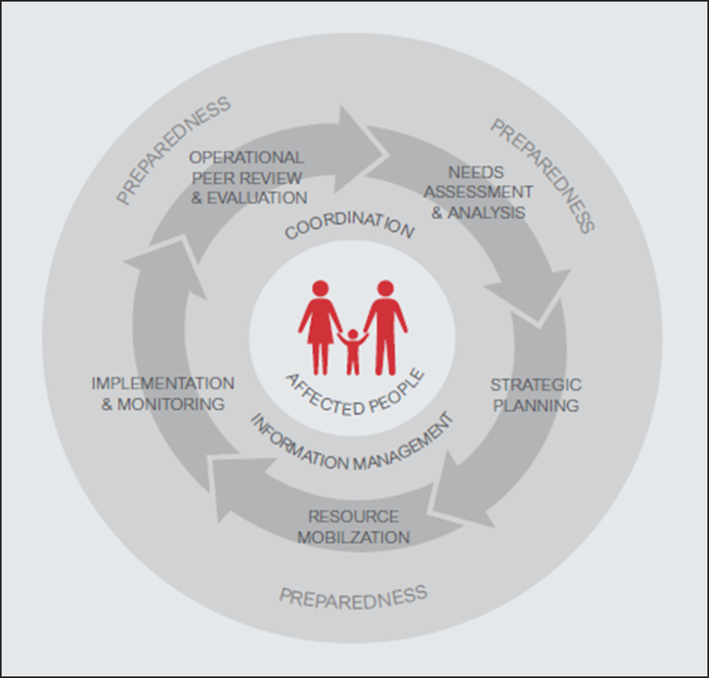

As shown in the diagram above (IASC, 2015), the cycle has affected people at its centre. The cycle itself comprises six sequential elements and two key ‘enablers’. The six key elements are:
- Emergency Response Preparedness.
- Needs Assessment and Analysis.
- Strategic Response Planning.
- Implementation and Monitoring.
- Resource Mobilization.
- Operational Peer Review and Evaluation.

The two key enablers are coordination and information management.

Using the HPC

Applying the HPC should be an inter-agency process which is:
- Led by a Humanitarian Coordinator (HC).
- Managed by a Humanitarian Country Team (HCT).
- Supported by an inter-cluster/sector coordination group and clusters.
- Inclusive of a broad range of actors, including at the sub-national levels.
- In support of the national authorities, who have primary responsibility to affected people.
- With the participation of the people affected by the crisis.

The HPC can be applied flexibly to/guide planning steps in:
- Sudden onset crises.
- Sudden escalations in an existing crisis.
- Annual planning cycle of a protracted crisis.

As shown on the diagram below (AISC, 2015), the HPC gives guidelines on timelines and triggers. At each stage, the HPC defines what needs to be done, when and by whom.

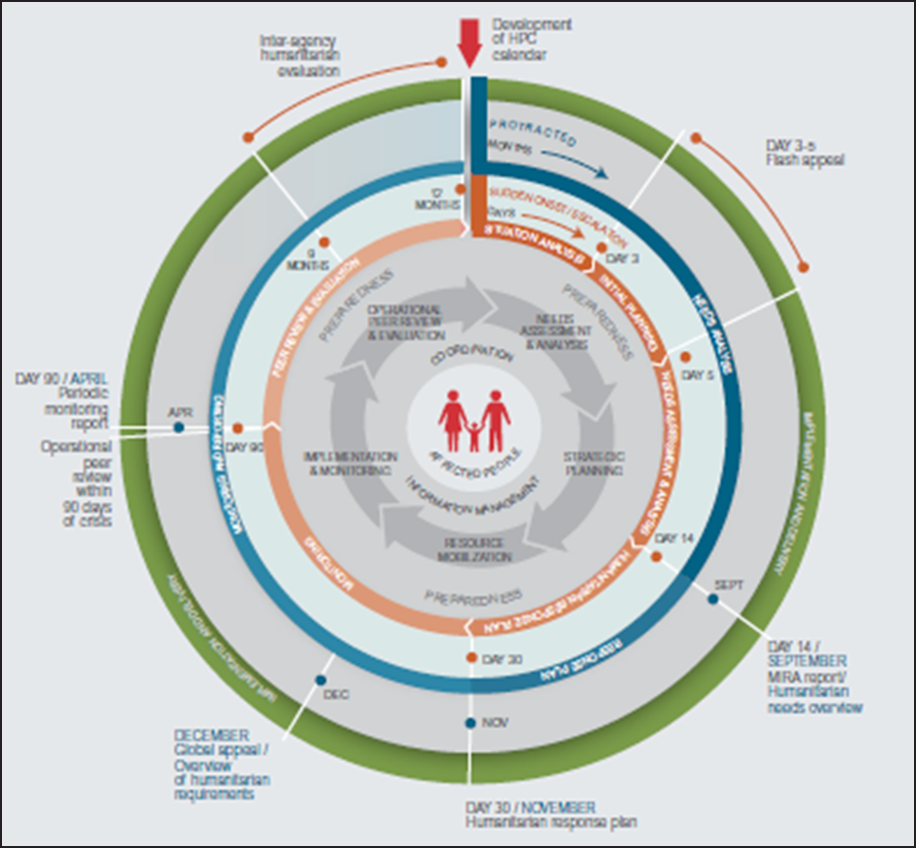

Each stage has recommended tools and guidance (e.g. Needs Assessment, the tool is Multi-Cluster/Sector Initial Rapid Assessment – MIRA). In the actual report, these tools are linked to website addresses so that the actual pdf versions of reports, forms and templates can be easily accessed.

- Preparedness
The response to a crisis is more timely, more appropriate and can even be more cost effective if preparedness measures are taken beforehand. As the HPC states; ‘Emergency response preparedness (ERP) involves anticipating emergencies that are likely to occur and putting in place key components of the response in advance.’ (IASC, 2015: 5). It is something that should be done continuously, and involves:
- Risk analysis and monitoring.
- Minimum preparedness actions – steps that need to be taken so that other elements of the HPC can be implemented in the event of a crisis.
- Contingency planning and advanced preparedness actions.

The HC, working with the HCT and clusters/sectors is responsible for leading preparedness actions. Clusters/sectors are to use the country risk profile to identify relevant clusters and what risks are likely to affect their activities; to put in place minimum preparedness actions; and to assist the HCT to prepare and provide technical support as needed.

Tools/guidance:
- Emergency Response Preparedness Guidance
- Inter-Agency Emergency Simulation Facilitator Guide
- IASC Handbook for RCs and HCs on Emergency Preparedness and Response.

- Needs assessment and analysis

Needs assessments provide the evidence base for humanitarian response. When a crisis happens, they provide the necessary information to define the strategic objectives, and later for operational planning, staffing and resourcing. Assessments need to be coordinated (done jointly, harmonised) to enable inter-agency and inter-sectoral planning,

The Multi-Cluster/Sector Initial Rapid Assessment (MIRA) is a joint needs assessment tool that can be used in sudden onset emergencies. It should be initiated as soon as possible after a sudden onset crisis, and the initial secondary data analysis should be completed within 72 hours to inform the flash appeal (if applicable). A MIRA should be finalized within 14 days to inform the humanitarian response plan. The HC and HCT decide, in close coordination with the inter-cluster coordination group, on the appropriate timings.

The needs assessment data collection tool should be chosen based on the information gaps identified through the secondary data analysis. The community should be involved, appropriate sampling approaches used, age, gender, diversity considerations taken into account, and representation of the perceived needs of those affected.

The analysis, in consultation with government (as appropriate), should be disseminated to the HC/HCT and sectors/clusters, to inform the humanitarian response plan, cluster/sector planning and the programmes of individual organisations.

Tools/guidance:
- IASC Operational Guidance for Coordinated Assessments in Humanitarian Crises.
- Multi-Cluster/Sector Initial Rapid Assessment Guidance.
- Humanitarian Needs Overview Guidance and Template.

A Humanitarian Needs Overview also needs to be undertaken, which consolidates and analyses information on the needs, vulnerabilities and capacities of affected people. It is based on existing information (secondary data). It is done as the first step in the implementation of the HPC in a protracted crisis and is done ahead of strategic response planning. Its application (or revision) in a new slow onset crisis or escalating protracted crisis should be determined by the HC and HCT based on operational requirements. It may also be used in the later stages of a sudden onset crisis.

- Strategic response planning

Humanitarian response planning helps ensure a more effective response by focusing activities and resources, ensuring that organisations are working toward the same goals, and assessing and adjusting the humanitarian community’s response to a changing environment. It is strategic ‘because it involves being clear about the overall objectives, being aware of the resources and capacity, and incorporating both into being responsive to a dynamic environment’ (IASC, 2015: 8). It involves setting strategic objectives and how they will be achieved, and clarifying roles and responsibilities – it guides the collective response.

For sudden-onset OR significant and unforeseen escalation in protracted crises, a flash appeal is conducted 3-5 days after onset. This includes a concise, top-line analysis of the scope and severity of the humanitarian crisis and sets out priority actions and preliminary requirements for the response.

A humanitarian response plan communicates the strategy to respond to the assessed needs, and serves as the basis for implementing and monitoring the collective response. It consists of two parts: a country strategy and cluster/sector response plans.

Since one of its purposes is to indicate each cluster/sector’s contribution toward meeting the strategic objectives, it involves holding cluster/sector meetings to determine cluster/sector objectives and key activities.

Tools/guidance:
- Flash Appeal Guidance and Template.
- Humanitarian Response Plan Guidance and Template.

- Humanitarian response monitoring

Humanitarian response monitoring tracks progress against strategic and cluster objectives; provides an evidence base for taking decisions about the future direction of the response; and supports resource mobilization. It is done continuously, the frequency of data collection and reporting determined by the HC and HCT based on needs and capacities. For sudden onset and/or protracted crises with a sudden/unexpected escalation in the crisis, it is recommended that the first monitoring report is prepared 60 days after the response plan.

The final stage in humanitarian response monitoring is the reporting. The aims to answer: ‘has the humanitarian community done what it committed to doing in the response plan, and, if not why, and what should be done to address those shortcomings. (AISC, 2015: 10).

Response monitoring has three stages:
- Preparation: during the strategic planning process, the clusters and inter-cluster coordination group agree monitoring plans.
- Monitoring – apply the response monitoring framework continuously throughout the response.
- Reporting – using the data collected on the collective response in the periodic monitoring report.

Clusters and the inter-cluster coordination prepare the response monitoring framework and aggregate data and compare actual results to targets set for cluster and strategic objectives based on that framework.

Tools/guidance
- Humanitarian Indicators Registry.
- Humanitarian Response Monitoring Guidance.
- Periodic Monitoring Report Guidance and Template.

- Resource mobilization

Resource mobilization is about fundraising for the humanitarian response, as outlined in the flash appeal and/or humanitarian response plans. It can happen at any point in the humanitarian programme cycle. However, the top humanitarian donors tend to make their main decisions during the last quarter of the calendar year for disbursement early in the next calendar year and within 72 hours for sudden onset emergencies.

Resource mobilization activities at the field level are led by the HC, coordinated by OCHA and supported by the HCT, inter-cluster coordination group and clusters/sectors. National authorities should be consulted and included in the process as appropriate.

Clusters play an important role in facilitating funding allocations from pooled funds to cluster partners; they may wish to approach donors for resources to fulfil their cluster response plan.

Tools/guidance:
Resource Mobilization Template.

- Operational peer review and evaluation

An operational peer review is an internal, inter-agency peer support tool, which helps determine whether any adjustments need to be made to the collective humanitarian response. It is light, brief, collaborative and forward-looking, and undertaken by peers. It is not a real-time evaluation. It is conducted within the first 90 days of an L3 Response. For other responses, an operational peer review may be triggered by a request from the HC/HCT, the IASC Emergency Directors Group or the IASC Principals.

An inter-agency humanitarian evaluation (IAHE) is an independent assessment of results of the collective humanitarian response by IASC partners to a specific crisis. IAHEs may be triggered after activation of an L3 Response and final reports are expected 12-15 months after the L3 Response activation.

Tools/guidance:
Operational Peer Review Guidance
IAHE (Inter-Agency Humanitarian Evaluation) Guidelines.

Essential enabler: Coordination

Effective coordination underpins all elements of the HPC, enabling identification and meeting of priority needs, addressing of gaps and reduction of duplication. It makes the whole implementation a joint effort using available resources and capacities.

The HCT provides a forum for strategic discussion and decision-making by the country directors of humanitarian organisations. This includes setting the direction of the humanitarian response and development of the overall humanitarian strategy, under the leadership of the HC.

The inter-cluster coordination group brings cluster/sector coordinators and representatives of cross-cutting issues together at the national and sub-national levels to coordinate operations and the implementation of the programme cycle. Clusters coordinate action among humanitarian partners within their sectoral area of responsibility. Collaboration, two-way flow of communication, timely meeting documentation, and clear roles and responsibilities among the various coordination structures are essential to support the implementation of the cycle

Tools/guidance:
IASC Reference Module for Cluster Coordination at the Country Level.

Essential enabler: Information management

Humanitarian information management is the systematic process of collecting, collating, storing, processing, verifying, and analysing data and information, and disseminating it to humanitarian stakeholders. Information management underpins each element of the HPC and helps connect them by carrying information from one to another

Tools/guidance:
IASC Operational Guidance on Responsibilities of Cluster-Sector Leads.

Supporting information
IASC Reference Module for the Implementation of the Humanitarian Programme Cycle. Version 2. July 2015, Inter-Agency Standing Committee.

