# ASSESSMENT FRAMEWORK – MOZAMBIQUE

Contents

Purpose of document 2

Assessment diagnosis 2

Data collection modalities 2

Assessment Planning 4

When 4

Where 5

Who 5

Who and How 6

Pilot 7

Data collection logistical planning 7

ANNEX 1: Briefing sheets for assessment tools 8

Mozambique Area Level Assessment Briefing Sheet 8

Mozambique Household Level Assessment Briefing Sheet 10

Mozambique Infrastructure Assessment Briefing Sheet 14

## Purpose of document

This document and supporting tools is produced with the intent of strengthening the assessment mechanisms for the Mozambique WASH cluster and to ensure data is available to identify needs (who, where, what, how many) and to inform response planning accordingly. It will present the existing data environment in Mozambique, present data collection tools for WASH partners and outline key steps in coordinating and planning assessments.

## Assessment diagnosis

The data environment in Mozambique is generally poor, with little coordination and comparability between assessments. While there are a few initiatives providing regular data on WASH indicators, the extent to which these can sufficiently inform an effective WASH response remains limited.

#### Existing initiatives with WASH components

|  |  |  |  |  |  |
| --- | --- | --- | --- | --- | --- |
| Agency | Name | Meth | Coverage | Frequency | Sector |
| IOM-DTM | Multi-Sector Location Assessment (MSLA) | FGD, KII, Observation | All IDP sites | Bi-Monthly | Multi-sectoral |
| IOM-DTM | Baseline | FGD, KII, Observation | Host localities | Bi-Monthly | Multi-sectoral |
| INGD | Ficha de Avaliação Rápida de Necessidades – 72h Moçambique | KII, Observation | Where there has been a shock | Ad-hoc | Multi-sectoral |
| SetSan/WFP | FSN | Household? | ? | ? | Food security and livelihoods |
| SINAS |  |  |  |  |  |

Data from IOM-DTM in IDP site (MSLA) and at locality level (Baseline) can provide some general information on the WASH situation on a regular basis. However, outside of IDP sites, the data does not provide sufficient levels of granularity and coverage. Other data sources are not always readily available, are conducted on a more ad-hoc basis and not WASH specific, hence key information relevant to partners is lacking.

In order to fill these information gaps, the WASH Cluster have created a set of tools that can be used to develop an evidence-base of WASH data to improve coordination, monitoring and planning. It’s important to note that data collection activities needs to be carefully coordinated, with WASH partners as well as external actors, to ensure there is no duplication of efforts which can lead to assessment fatigue of the population and conflicting information.

## Data collection modalities

Below is a set of tools developed for various scenarios and information needs that can be used by WASH cluster partners:

**1. Rapid Area Level WASH Assessment**

***Objective***: To capture key WASH needs of populations following a sudden shock. Information from the assessment should feed into the early response of WASH actors.

***Data collection method:*** Key informant

***When***: To be deployed following a sudden shock (e.g. cyclone, flooding, displacement). It can be conducted after an initial multi-sectoral rapid need assessment (MRNA) or instead of, if no MRNA is conducted.

**2. Comprehensive Area Level WASH Assessment**

**Objective:** To provide an in-depth understanding of key WASH needs of all relevant population groups (IDPs in sites, IDPs living in host communities, and non-displaced population) to better inform the WASH response.

***Data collection method:*** Key informant

**When:** The tool can be used for the following situations: 1) to develop a baseline of WASH needs, 2) to capture change following an event if no baseline exists, 3) for regular needs monitoring. It should be implemented when there are no sufficient resources for a household level survey (which takes time, resources, and requires additional coordination)

**3. Household Level WASH Assessment**

**Objective**: To provide an in-depth understanding of household-level WASH needs and access to services of populations to inform WASH response in sites and host communities.

***Data collection method:*** Household surveys

**When:** The tool can be used for the following situations: 1) to develop a household-level baseline of WASH needs, 2) to capture change following an event if no baseline exists, 3) for more regular needs monitoring.

When the assessment is implemented correctly, i.e. the sampling frame is adhered to, the data produced will be representative at a given administrative level. Hence, the assessment will result in a more granular understanding of WASH needs and can therefore be used to better inform the WASH response.

**4. Infrastructure Assessment**

**Objective**: To identify/tag all key wash infrastructure (water points, sanitation facilities, hand-washing facilities, bathing facilities, water tanks, and solid waste management systems) in a given area, assess their characteristics and functionality in order to establish a comprehensive overview of available infrastructure and to monitor functionality over time to understand needs and access to services.

***Data collection method:*** Observations

**When:** The tool can be used for the following situations: 1) to develop a baseline of WASH infrastructure, 2) to monitor change over time or following a sudden change in context. The tool will collect information on type of facility, functionality, technical characteristics, adherence to gender and disability standards, and quality (e.g. water quality testing) through observations.

All tools can be downloaded on XXXX

## Assessment Planning

### When

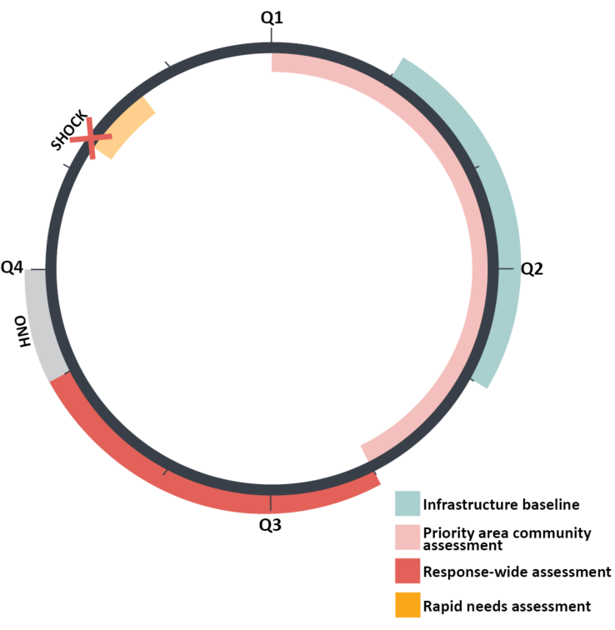WASH needs assessments should be done to feed into response planning and analysis events such as the HNO/HRP, to focus in on priority areas, and to provide updated information following a sudden-onset crisis (e.g. cyclone, violence etc.).

The above image illustrates the suggested timeline of the assessments and how they feed into response planning.

1. From the start of the year, conduct assessment in high-priority areas (where needs are known to be high, response is poor and/or there is limited to no information), using household tool (if resources and capacity allows) or comprehensive area level (key informant) tool.
2. Starting in February, plan to conduct a full sweep of all key WASH infrastructure using the infrastructure tool. The following should be taken into consideration when preparing the assessment:
   1. Coordinate with other actors:
      1. CCCM and IOM-DTM for IDP sites as they are already doing basic infrastructure monitoring,
      2. Coordinate with the government in non-IDP sites.
      3. Ensure that WASH Cluster partners cover areas not targeted by other actors and that tools are aligned.
   2. Main data gaps for infrastructure is in non-IDP areas. Hence, these should be prioritised
3. Prior to the HNO, ensure there is up-to-date WASH data that can feed into the analysis. A few considerations to take into account:
   1. If there is a response wide, joint multi-sectoral needs assessment (MSNA) conducted covering all sectors core indicators, there is no need for an additional WASH specific assessment. Instead, cluster partners could conduct focus group discussions with various population groups to add additional qualitative information to the analysis, or highlight additional indicators needed for the analysis and do a brief key informant assessment.
   2. If there is no MSNA planned, WASH cluster partners should conduct a response wide WASH assessment using the household tool (if resources and capacity allows) or comprehensive area level (key informant) tool. Note, the assessment needs to be coordinated with other actors to ensure there is no duplication of efforts.

The timeline of assessments should be adjusted to inform other response planning and monitoring, e.g. AQA, and be aligned with seasonal information needs.

Finally, use the assessment registry (ADD LINK) to keep track of past and upcoming assessments.

### Where

Data collection should be conducted at the lowest admin level needed for the response. Data informing the HNO needs to be aligned with OCHA determined administrative level (normally Admin 2). However, time and available resources needs to be taken into consideration. For community level interviews, it is recommended that one key informant is interviewed per Locality. For household level interviews, time and resources will increase the lower the admin level. For example, if you conduct household interviews representative at Locality level, in a district with 10 Localities, you will end up with approximately 3,700 surveys. However, if your conduct the same survey representative at the District level, your sample size (number of surveys) could be around 300-1000, depending on the population size. The time required varies vastly, as does the costs and manpower needed to execute the data collection. If you need the data to be representative at different population groups (which is recommended for Mozambique given the context), for example IDPs in sites, IDPs living with host community and non-displaced populations, then the sample size will increase even more.

Priority areas for data collection and geographical coverage should be agreed with Cluster partners and other key stakeholders.

### Who and How

Assessment planning should never take place in isolation. It is important to coordinate and discuss within the cluster and with other actors to ensure there is no overlap of exercises and to ensure the population is not over-assessed, leading to assessment fatigue. Below outlines key stakeholders to involve, when and how:

#### Assessment Coordination Architecture

|  |  |  |
| --- | --- | --- |
| **Who** | **When** | **How** |
| IMWG | Throughout the year | The IMWG should be informed of any planned WASH specific assessment. This could also be the forum to learn of assessments planned by other actors, and where WASH indicators included, WASH cluster should engage to ensure harmonization. |
| SAG (if any) | Prior to any assessment | The SAG should be involved in assessment planning and design. They should also be part of validating assessment results and findings. |
| Cluster partners | Prior to any assessment | Cluster partners should be involved in identifying or highlighting priority areas, for example they could raise issues with information gaps in their area of operation that could trigger an assessment.  They will also be involved in the data collection, both coordinating at the field level and to collect data where needed.  Analysis and findings should be shared with partners for validation and input. |

During joint needs assessments there will be one actor responsible for the overall coordination, ensuring tools are agreed on and harmonised with existing standards and tools, that data collection is going smoothly, covers all target areas and delivers in quality, and who oversees analysis.

For Cluster led assessments, there will be an agreement internally on who is responsible for what. Below table provides an example of how the roles and responsibilities could look like:

#### Roles and responsibilities during data collection for cluster led assessments

|  |  |  |
| --- | --- | --- |
| **Task** | **Responsible** | **Comment** |
| Overseeing the assessment process | WASH Cluster IMO or CC | This could be any other designated person. The point is that there is someone having responsibility of the overall process. |
| Training of partner focal points | WASH Cluster IMO or CC | See training package |
| Supervising data collection | Partner focal points | One focal point needs to be identified per target location. In some circumstances, one partner could cover several target locations and would then send one focal point for the given areas. |
| Conducting data collection | Enumerators | Enumerators could be identified in the communities or be partner staff. Enumerators need to show proficiency with mobile data collection (if used) and understanding of how to conduct interviews. |
| Daily data cleaning | WASH Cluster IMO or CC  & Partner focal points | Each day, the data needs to be checked for inconsistencies. The one overseeing the assessment will be checking the incoming data and provide feedback to the partner focal points who in turn checks with the enumerators on any corrections that needs to be made. |
| Data analysis | WASH Cluster IMO or CC | See training package for analysis |
| Output production (information sheets, reports, etc.) | WASH Cluster IMO or CC |  |

Further explanations of the step-by-step of assessments for each of the tools can be found in Annex 2.

### Pilot

Each assessment needs to be piloted. This could be the first day of data collection after which you will review the tools and coordination of the field activities and make any necessary adjustments to the process before continuing with the rest of the data collection.

### Data collection logistical planning

There are various logistical components of any assessment. Here is a checklist that can be used as a starting point:

* **Training venue** to be hired/arranged both for training of focal points and training of enumerators.
  + Focal point training can take place at a central location, where all focal points in a given area gather. Transportation and accommodation need to be planned for them if they are not based in the training location.
  + Enumerator training often takes place in the area they are based/where the data collection takes place.
  + Food and refreshments should be arranged during the training days.
* **Enumerator payment** needs to be arranged and decided who will pay them and when or if it is provided in-kind by partners
* **Cars** to get enumerators around during data collection. This could be provided in-kind by partners or rented
* **Tablets/ or phones for data collection** if assessment is done through mobile data collection (recommended).

## ANNEX 1: Briefing sheets for assessment tools

# Mozambique Area Level Assessment Briefing Sheet

**Assessment Overview**

There are two types of area level assessment tools developed for Mozambique using Key Informant (KI) interviews at the community or site-level covering all population groups (IDPs in sites, IDPs living in host communities, and non-displaced populations). The tools can be combined with an infrastructure assessment (add link) and focus group discussions with men/adolescence boys, women/adolescence girls, elderly and persons with disabilities.

1. **Rapid Area Level WASH Assessment** (add link)

**Objective**: To capture key WASH needs of populations following a sudden shock. Information from the assessment should feed into the early response of WASH actors.

**When:** To be deployed following a sudden shock (e.g. cyclone, flooding, displacement). It can be conducted after an initial multi-sectoral rapid need assessment (MRNA) or instead of if no MRNA is conducted.

1. **Comprehensive Area Level WASH Assessment** (add link)

**Objective**: To provide an in-depth understanding of key WASH needs of populations to better inform from the WASH response.

**When:** The tools can be used for the following situations: 1) to develop a baseline of WASH needs, 2) to capture change following an event if no baseline exists, 3) for regular needs monitoring

**Methodology**

1. **Identify Key Informants**
   * KIs are people that have specific knowledge about certain aspects of a community, a population, the specific location, or the emergency. In this case, the KI will need to have information on the population’s access to, use of, and experience with WASH services.
   * If possible, make pre-arranged meetings with the KIs so they can have the relevant information ready, for example on numbers of people affected (disaggregated by age / sex), number of displaced populations etc.
2. **Conduct interviews using KoBo**

* Before starting the interview:
  + Introduce yourself and present the purpose of the assessment.
    - Ensure the KI understand that the interview will help plan the response and there is no incentive provided.
    - Use the instructions in the tool to obtain verbal consent. If consent is not provided, end the interview and delete the form.
  + You should complete one form per location if possible. However, if there are multiple KIs with different pieces of knowledge (e.g. a District Water Focal Point with knowledge specifically on water services, and a Camp Manager with general information about the population in the location), fill one form per KI with all the information that they provide.
    - When you analyse the data, you will have to merge the various KI forms together so that you have just one row per location.
  + Familiarise yourself carefully with the tool before the interview, so that you know all the response options and understand every single question.
  + Ask every single question in the Kobo form as they come up
  + If the KI cannot answer a question or is not comfortable answering, do not guess the answer- enter ‘Don’t know’ or for number questions, enter ‘999’.
  + Note that taking a photo is optional. If you take a photo, first ensure that the KI is comfortable with you doing so and ask for verbal permission first. Ensure that there are NO faces of people in the photo. The photo should be of the infrastructure and the environment as relevant to WASH.

1. **Submit all data** to the KoBo server once you return to a location with internet access.

# Mozambique Household Level Assessment Briefing Sheet

**Assessment Overview**

**Objective**: To understand household level WASH needs and access to services of populations in in Mozambique to inform WASH response in sites and host communities.

**What:** Household interviews with all relevant population groups (IDPs in sites, IDPs living in host communities, and non-displaced populations) in Mozambique. When the assessment is implemented correctly, i.e. the sampling frame is adhered to, the data produced will be representative at a given administrative level. Hence, the assessment will result in a more granular understanding of WASH needs and can therefore be used to better inform the WASH response.

**When:** The tool can be used for the following situations: 1) to develop a household-level baseline of WASH needs, 2) to capture change following an event if no baseline exists, 3) for more regular needs monitoring

**Methodology**

1. **Identifying households (sampling)**

* Household level data collection is often based on a sample of the total population (as compared to a full census) to reduce costs, limit collection time and resources. If the collected household data is going to be able to speak to, and estimate characteristics and prevalence of the wider population (i.e. being generalizable and representative), a sampling strategy needs to be developed and followed. The main requirement of sampling[1] is that each household in the location needs to have an equal probability of being selected for the survey. To ensure this you must follow the following steps from the planning stage to implementation:
  + ***Define the geographical areas and population of interest***– For example, you might want to focus on certain provinces only, look only at IDPs in sites or all population groups including IDPs in host communities and non-displaced populations
  + ***Define the unit of measurement* –** i.e. should the assessment look at district level, posto, or locality? The unit of measurement will impact the amount of time and resources needed for the data collection. It will also define the depth and scope of your analysis. For example, if you focus on a lower admin level you will have to collect more surveys (increasing time and resources needed) but will have more granular data in return.
  + ***Prepare sampling frame and sampling size***– List all units of measurement and the population size (disaggregated by population group, e.g. IDP in site, host, etc.). Enter the population size in [the sample calculation tool](https://www.calculator.net/sample-size-calculator.html)[2] to know how many household interviews needs to be conducted by location.
  + ***Implement randomisation of household in the field locations during data collection*** – see ‘Sampling guidance’ below for further instructions.

1. **Conduct household level interviews using KoBo**

* Before starting the interview:
  + Introduce yourself and present the purpose of the assessment.
  + Ask to speak to the head of the household. If the head of the household is not present, ask if there is anyone else who can speak on behalf of the whole household.
  + Ask for the age of the respondent
    - The person being interviewed needs to be 18 years old or older
  + Match, to the extent possible, the gender of the enumerator conducting the interview with the gender of the respondent
  + Ensure the respondent understand that the interview will help plan the response and there is no incentive provided.
  + Use the instructions in the tool to obtain verbal consent. If consent is not provided, end the interview and delete the form.
  + Familiarise yourself carefully with the tool before the interview, so that you know all the response options and understand every single question.
  + Ask every single question in the Kobo form as they come up
  + If the respondent cannot answer a question or is not comfortable answering, do not guess the answer- enter ‘Don’t know’ or for number questions, enter ‘999’.
  + Note that taking a photo is optional. If you take a photo, first ensure that the respondent is comfortable with you doing so and ask for verbal permission first. Ensure that there are NO faces of people in the photo. The photo should be of the infrastructure and the environment around the household shelter as relevant to WASH.

1. **Submit all data** to the KoBo server once you return to a location with internet access.

## Sampling guidance

* **Randomisation of research participants is key i.e. ensuring a everyone has an equal chance of being selected based on the criteria set (e.g. location, population group etc.)**
* **Any bias introduced will compromise the probability of the sample i.e. the extent to which findings are truly representative of the population of interest**
* **There are three possible options for random selection of research participants:**

|  |  |
| --- | --- |
|  | **Pre-requisites** |
| **List-based sampling** | * List of all units (i.e houseold) in your population of interest * List contains required details e.g. location points, contact details, etc. |
| **GIS sampling** | * Admin boundaries shape files * Data on the distribution of the population and population density across the targeted area * Well-trained data collection teams that have the capacity to use navigation software e.g. maps.me to locate the households |
| **Systematic sampling** | * Accurate understanding of the layout of the area to be targeted (for e.g. boundaries of sites/ settlements) * Area is of a manageable size to implement systematic sampling 🡪 broken down into sub-areas (for e.g. camp blocks or city neighbourhoods) |

**List-based sampling**

1. 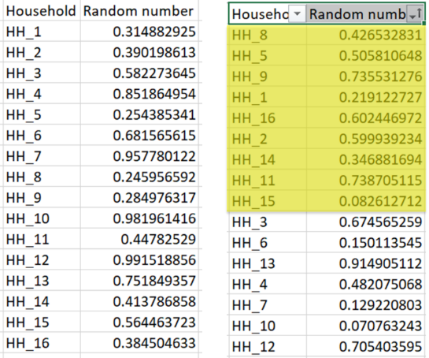List of all the units (households) in your population of interest. This could be a list of all houses in the area, beneficiary lists of all IDP households in a relocation site, etc. Something which gives a unique determinant of all the households in an area
2. The list needs to contain information that helps you locate the household. For example location points, contact details, etc.
3. In excel, next to each unit add the formula =RAND()
4. Sort the random number column and select the top households that equal the sample size (e.g. 384)

**Randomized GIS sampling**

1. Generate random GPS points on a map of the area
2. Interview household nearest to each sampled GPS point

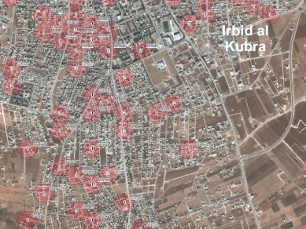

**Systematic sampling on site**

If the site is as structured as the image on the right, enumerators would start at one end and interview the households based on a randomized number. E.g. the first household would be household number 4 from the start, the second one would be household number 12 after the first household and so on….

**A possible alternative** as this is not always the reality:

* Enumerators meet at the center of the village/ site/ settlement
* Spin a pen and start walking towards the edge of the location as shown by the pen
* On way to the edge, count either the # of households passed or the time taken to reach the edge
* Once at the edge, determine the threshold for which household to interview based on: # of HHs in the route or time taken to reach the edge / the target # of HHs to be interviewed per enumerator
* Start walking back towards the center and assesses every x’th household (with x as determined above)

# Mozambique Infrastructure Assessment Briefing Sheet

**Assessment Overview**

**Objective**: To identify/tag all key wash infrastructure in a given area, assess their characteristics and functionality in order to establish a comprehensive overview of available infrastructure and to monitor functionality over time to understand needs and access to services overtime and if there are changes in context

**What:** Sweep of all available communal wash infrastructure including water points, sanitation facilities, hand-washing facilities, bathing facilities, water tanks, and solid waste management systems within a geographical location. The tool will collect information on type of facility, functionality, technical characteristics, adherence to gender and disability standards, and quality (e.g. water quality testing) though observations.

**When:** The tool can be used for the following situations: 1) to develop a baseline of WASH infrastructure, 2) to monitor change over time or following a sudden change in context. The tool can be used together with the rapid area level assessment and comprehensive WASH assessment (area and household level).

**Methodology**

1. **Preparations**

* Define the geographical area for the assessment
* Enumerators should have a WASH background or a good understanding of WASH infrastructure, e.g. NGO WASH Officers, Local Authority WASH focal point, WASH engineer etc.
* Divide the area up in divisions and allocate one enumerator per division.
  + If the area is unknown to the team (i.e. locations of all infrastructure is unavailable), divide each division up into smaller 1*1km squares. The enumerator should then search through each of the squares and mark it empty if no WASH infrastructure is found. Also identify a local guide who is familiar with the area and can direct the enumerator to all the infrastructure points.
  + If the area is known to the team or gps points for all infrastructure is available, the enumerators can navigate the areas assigned to them.
* Ensure enumerators are well versed in the tool, knows the questions and response options and is aware of the different types of infrastructure facilities.
* Enumerators should (if available) carry measuring tape to measure size of infrastructure and water quality testing kits.
* Maps of the area and the designated divisions should be printed so the enumerator can navigate the area and make sure all infrastructure is covered.

1. **Conduct infrastructure survey using KoBo**

* One survey should be conducted per infrastructure.
* Enumerators will use direct observations to answer the survey question about the infrastructure.
* Sanitation and bathing facilities can be assessed individually or as a block and there is a question in the survey to determine which one you will do. If an individual unit is assessed, you will be asked about the characteristics, functionality etc. of that specific unit. If a block is assessed (i.e. with several individual units), you will be asked to respond whether all latrines in the block or only some fulfil the question criteria. For example, if the question is: “Is the inside of the latrine/the latrines in this block well lit?” – for a single unit you will respond yes or no. For a block you will respond yes or only some.
* Ask every single question in the Kobo form as they come up
* If you cannot answer a question, do not guess the answer- enter ‘Don’t know’ or for number questions, enter ‘999’.
* You will be asked to take a photo of the infrastructure but first ensure that there are NO faces of people in the photo. The photo should be of the infrastructure and the environment around it.

1. **Submit all data** to the KoBo server once you return to a location with internet access.

1. There are various forms of probability sampling. For this assessment we will follow the methods of simple random sampling.
2. Confidence level and margin of error should be either 95%/5% respectively or 90%/10%.