How to add a new sector page with custom margin and footer for different pages
- On the top menu bar, go to ‘Page layout’ tab > Breaks > click on ‘Next Page’
- When on the new page, right click on the header and click on ‘Edit Header’ option (see image below)

- Deselect the option ‘Link to Previous’ (see image below)

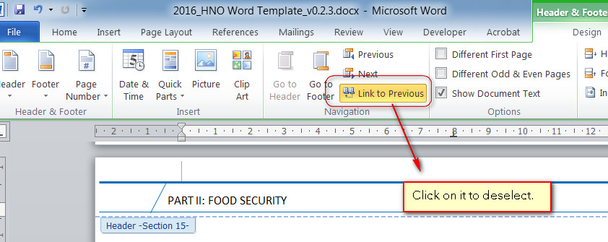

- Type in the new cluster name in the header and click ‘Close Header and Footer’ (see image below)

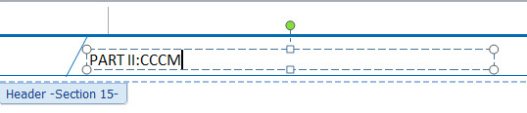

- Copy all the contents from previous cluster page (see image below) , by selecting everything on the page, and paste it on the new CCCM page.
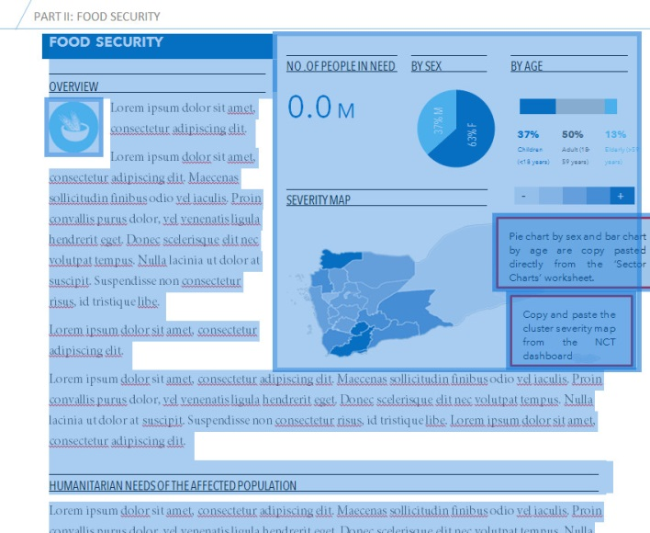

- Copy and paste the relevant pie chart and bar graph from the ‘Sector Chart’ worksheet of ‘HNO charts.xlsx’ workbook.

How to place graph and charts in the footer section of CCCM cluster page
- Go to ‘Page Layout’ tab > click on ‘Margins’ and select ‘Custom Margins…’
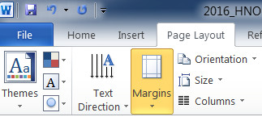

- On the “Page setup’ dialog box, type ‘8’ cm for the bottom margin value and hit OK.

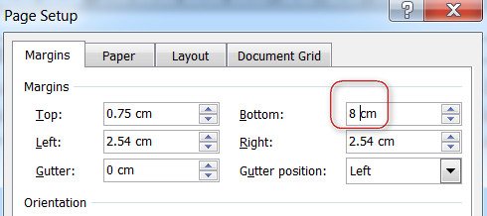

- You will notice that the margin from bottom is increased (by 8 cm). Double click on the footer to open it (or go to ‘Insert’ tab, click on ‘Footer’ and > Edit Footer), in order to place our charts and graphs.
- Deselect the option ‘Link to Previous’ (see image below)

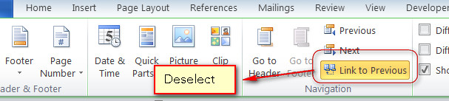

- Insert a textbox from the ‘Insert’ tab. Give it a background color of Blue. Copy paste the relevant chart(s) and graph(s) from the ‘HNO charts.xlsx’ workbook. Adjust the size of text for axis and legend of the chart. Hit on the ‘Close Header and footer’ button, once happy with the settings.
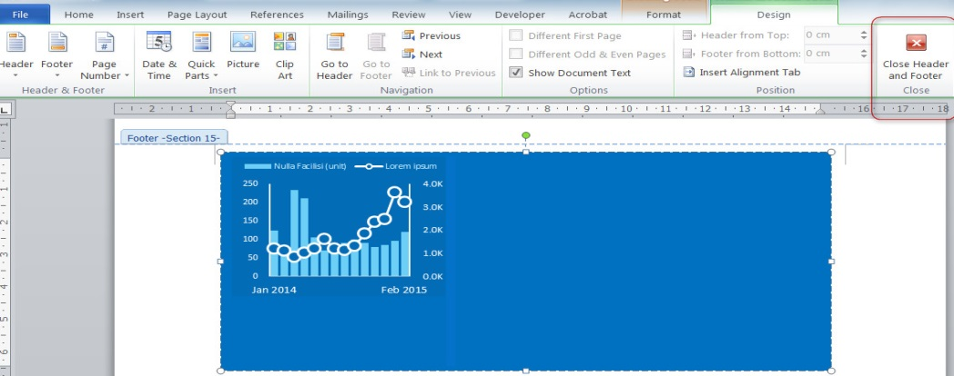
- Incase if the text on ‘Overview’ and ‘Humanitarian Needs of the Affected Population’ flows on to the second page and you don’t want to put more charts or infogprahs in the footer, then we can adjust the bottom margin for second page. To adjust the margin, first you will have to put a ‘Section break’ on the page.
- Put the cursor at the end of first page (see image below)
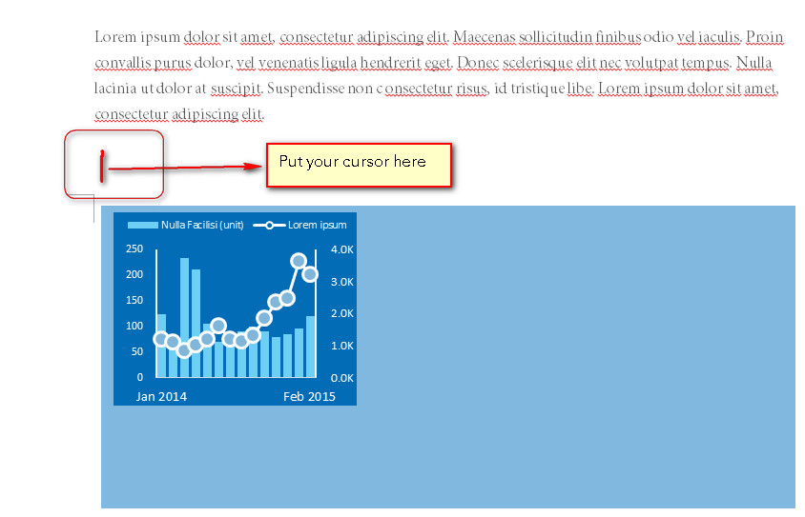
- Go to ‘Page Layout’ tab > Breaks > Section Breaks and select ‘Next Page’. You will notice that the cursor will start blinking on the first line of the next page (which is our second page). This means the section break was inserted successfully and we can now reduce the bottom margin of our second page (with affecting our first page margin).
- Double click on the footer (of second page) to open it (or go to ‘Insert’ tab, click on ‘Footer’ and > Edit Footer). Deselect the option ‘Link to Previous’ and remove the textbox and charts which were copied from our first page. Close the footer and header section.
- Go to ‘Page Layout’ tab > click on ‘Margins’ and select ‘Custom Margins…’
- Set the ‘Bottom’ margin to 2.54 cm (see image below) and hit OK.

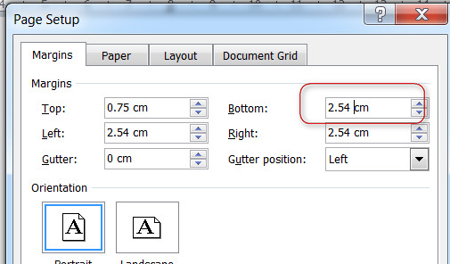

- The same process can be repeated in the ‘Impact of the Crisis’ section to add charts and adjust footer margin on different pages.
How to restore the broken link to ‘linked Microsoft Excel object’
- When on a double click, if the linked Microsoft object doesn’t open the ‘HNO charts.xlsx’ workbook, first delete the linked object from MS Word template.
- Open ‘HNO charts.xlsx’ and go to the relevant worksheet from where you want to copy the charts or figures.
- Highlight the cells in excel (in our example below, we are copying the Humanitarian Key Figures from ‘PN Caseload‘ worksheet)
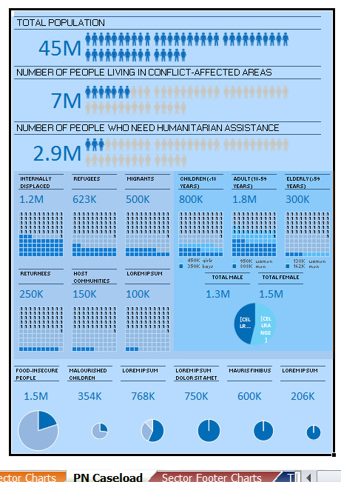
- Ctrl + C to copy the highlighted cells from excel workbook. Place the cursor on the relevant page in MS Word template, where you want to put the charts or figures, go to Paste > Paste Special… (See image below)

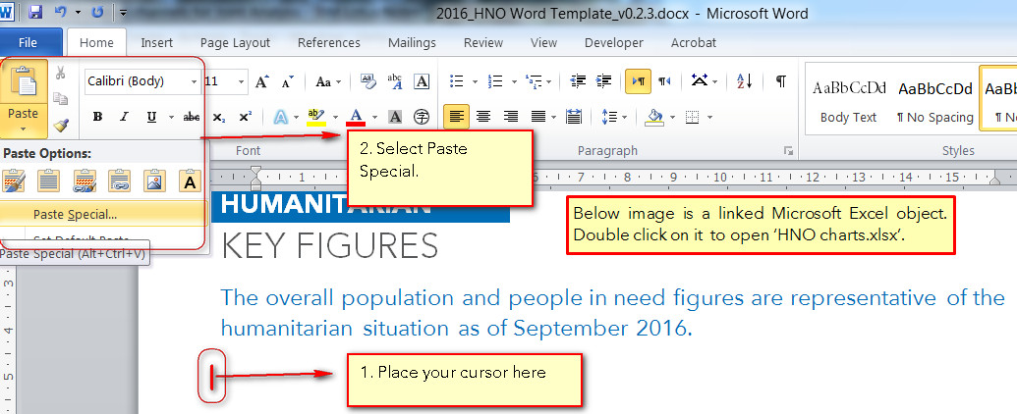

- Click on Paste Link > Microsoft Excel Worksheet Object and hit OK ( see the image below). Adjust the size of the image to fit on page.
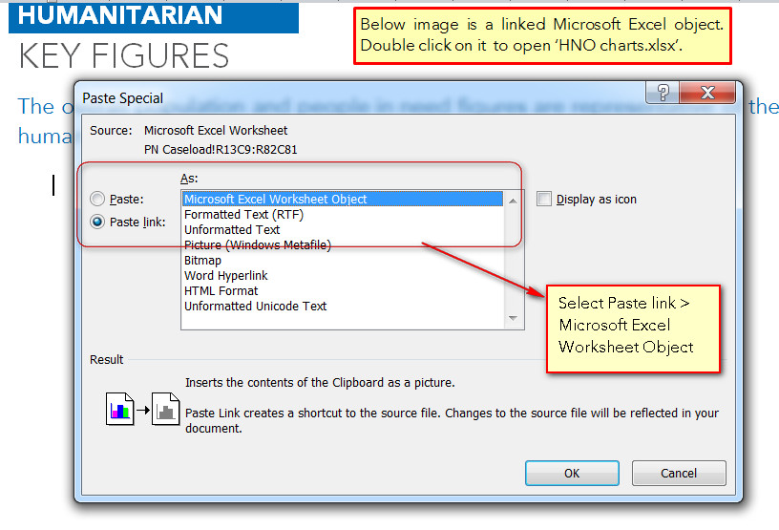

How to update the labels for ‘BY AGE’ bar chart on sector overview page

- The numbers in label for the bar chart ‘By Age’ are copied from the ‘Sector Charts’ Worksheet.

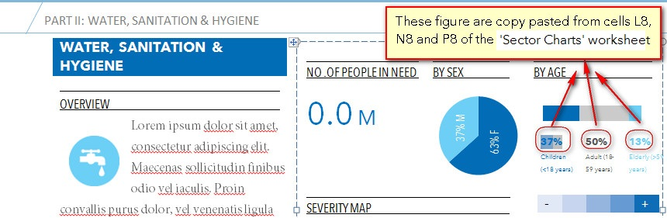

- To copy and paste (special) the numbers from excel, click on cell L8 in the “Sector Charts’ worksheet. Press Ctrl+C.
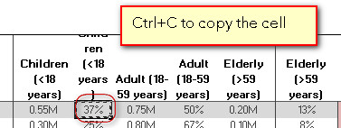

- On the MS Word template, place the cursor in the position where you want to paste the excel cell contents (above the Children (<18 years) label).
- Go to Paste > Paste Special… From the ‘Paste Special’ Dialog box, click on ‘Paste Link’ and ‘Unformatted Text’. Hit OK.

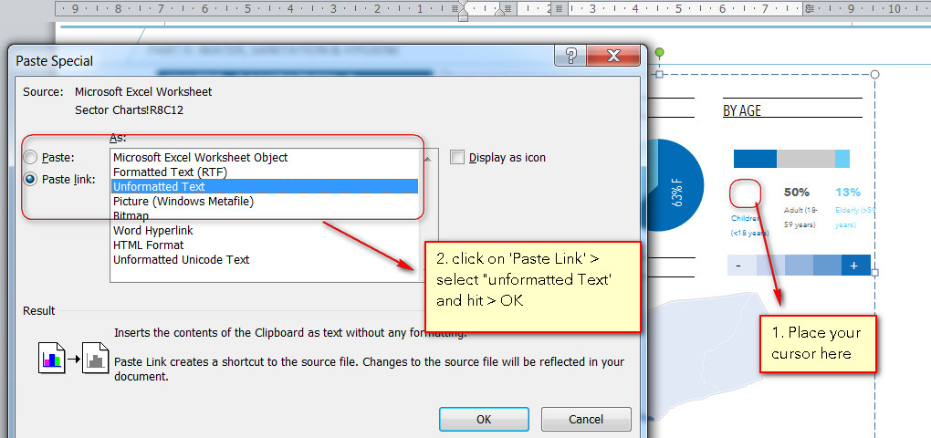

- Change the formatting of the inserted text as desired.
- Repeat the same process, for Adult (18-59 years) and Elderly (> 59 years) labels.
- Please note that figures ‘1’ and ‘5’, in the sector footer charts, are copy pasted (special) from ‘Sector Footer Charts’ worksheet ( see image below).

