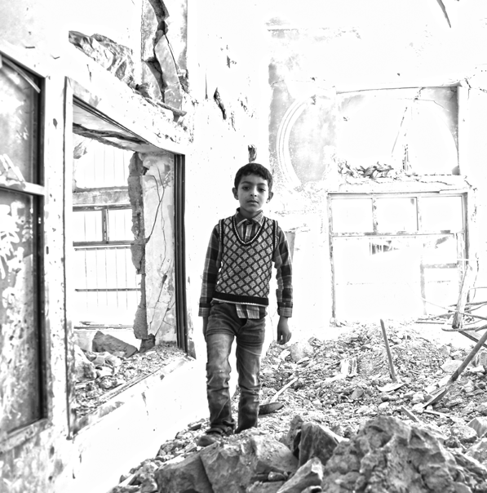

PHOTO CREDIT

**2017**

PEOPLE IN NEED

0.0 M

OCT 2016

**COUNTRY NAME**

HUMANITARIAN

**NEEDS**

OVERVIEW

agn

Right click on the picture and select ‘change picture‘ to insert a new picture

This document is produced on behalf of the Humanitarian Country Team and partners.

This document provides the Humanitarian Country Team’s shared understanding of the crisis, including the most pressing humanitarian need and the estimated number of people who need assistance. It represents a consolidated evidence base and helps inform joint strategic response planning.

The designations employed and the presentation of material in the report do not imply the expression of any opinion whatsoever on the part of the Secretariat of the United Nations concerning the legal status of any country, territory, city or area or of its authorities, or concerning the delimitation of its frontiers or boundaries.

[www.unocha.org/yemen](http://www.unocha.org/yemen)

[www.humanitarianresponse.info/en/operations/yemen](http://www.humanitarianresponse.info/en/operations/yemen)

@OCHAYemen

Humanitarian needs & key figures

Impact of the crisis

Breakdown of people in need

Severity of need

**PART I:**

**SUMMARY**

PEOPLE IN NEED

Right click on the picture and select ‘change picture… ‘to insert a new PiN map

This map should be more than a simple baseline map. It should be overlaid with available needs data and show:

* the number of people in need
* geographical locations of need
* other data can be overlaid if helpful such as displacement, specific hotspots such as food security, excessive damage etc)

The map should also show neighboring countries to help the reader gain a quick understanding of the spatial characteristics of the emergency.

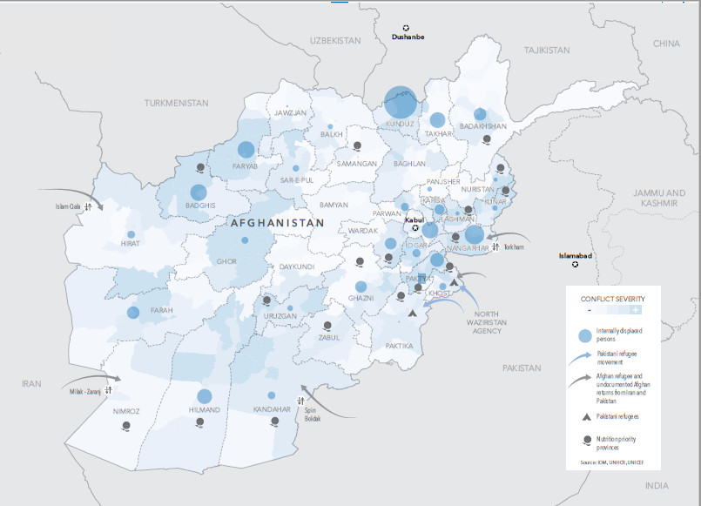

0.0M

**HUMANITARIAN**

Humanitarian icons can be downloaded from the following links:

<http://reliefweb.int/report/world/world-humanitarian-and-country-icons-2012>

**or**

<https://thenounproject.com/ochaavmu/collection/ocha-humanitarian-icons/>

* This section summarizes the most critical humanitarian needs the affected population is facing
* Avoid listing simply sectors and be careful not to describe response requirements (such as need for more funding, need to truck water, need to expand voucher programme, etc.). Instead develop an inter-sectoral perspective focusing on the most urgent problems faced by the most vulnerable population groups to ensure their survival and meet their essential livelihood requirements.
* Keep this overview short and succinct.

NEEDS &

KEY FIGURES



Text for an example of 4 humanitarian needs is organized in textboxes. Please click on the textbox to edit text.

HUMANITARIAN NEEDS

**2**

**Acute Malnutrition**

Lorem ipsum dolor sit amet, consectetur adipiscing elit, sed do eiusmod tempor incididunt ut labore et dolore magna aliqua. Ut enim ad minim veniam, quis nostrud exercitation ullamco laboris nisi ut aliquip ex ea commodo consequat. Duis aute irure dolor in reprehenderit in voluptate velit esse cillum dolore eu fugiat nulla pariatur.

**Shelter**

Lorem ipsum dolor sit amet, consectetur adipiscing elit, sed do eiusmod tempor incididunt ut labore et dolore magna aliqua. Ut enim ad minim veniam, quis nostrud exercitation ullamco laboris nisi ut aliquip ex ea commodo consequat. Duis aute irure dolor in reprehenderit in voluptate velit esse cillum dolore eu fugiat nulla pariatur.

**Protection of civilians**

Lorem ipsum dolor sit amet, consectetur adipiscing elit, sed do eiusmod tempor incididunt ut labore et dolore magna aliqua. Ut enim ad minim veniam, quis nostrud exercitation ullamco laboris nisi ut aliquip ex ea commodo consequat. Duis aute irure dolor in reprehenderit in voluptate velit esse cillum dolore eu fugiat nulla pariatur.

**Conflict displacement**

Lorem ipsum dolor sit amet, consectetur adipiscing elit, sed do eiusmod tempor incididunt ut labore et dolore magna aliqua. Ut enim ad minim veniam, quis nostrud exercitation ullamco laboris nisi ut aliquip ex ea commodo consequat. Duis aute irure dolor in reprehenderit in voluptate velit esse cillum dolore eu fugiat nulla pariatur.

**4**

**3**

**1**

Afghanistan’s civilian population continues to bear the brunt of a conflict growing in intensity and geographic scope. The September battle for the provincial capital, Kunduz, shows how fighting in 2015 has moved closer to towns and cities. The increased impact of the conflict on Afghan life is seen in the number of civilian casualties, heightened fear and uncertainty, and recurrent displacement. Widespread conflict affects the lives of at least 6.3 million Afghans and by September had contributed to 197,000 people fleeing their homes - a 64% increase from 2014.

|  |  |
| --- | --- |
| **HUMANITARIAN** | Below image is a linked Microsoft Excel object. Double click on it to open ‘HNO charts.xlsx’.  Ensure that the charts are sourced and that the population figures are explained in the chapter ‘breakdown of people in need.  Check carefully for consistency between the figures, and between the charts and the text/narrative. |
| KEY FIGURES | |
| The overall population and people in need figures are representative of the humanitarian situation as of September 2016. | |



Text in this section is free flowing and organized without textboxes.

* In 2-3 pages, develop an inter-sectoral narrative and tell a compelling story highlighting the plight of affected people and how the crisis has evolved.
* Start with a people-centered approach, so that problems and needs are ‘anchored’ on people rather than sectors. Depending on the context, different groups of people or even individuals may be identified, based on facts and expected consequences of the crisis on their lives (how do they affect their survival) and livelihoods (how do they affect their capacity to meet their requirements for food, health, shelter, education, and productive and income-earning activities). Avoid multiplying the number of groups if they mostly (or are likely to) present the same difficulties and needs. Each group becomes the center of the inter-sectoral analysis.
* Adopt an holistic approach to describe problems faced by people for their lives and livelihoods (current and forecasted) rather than as a simple succession of separate issues, with an emphasis on how the problems inter-relate: for example, eating poorly and getting malnourished can be associated to lack of income itself that prevents people to purchase sufficient food and to pay for health treatment; a problem with education because children are missing out school may be due to security threats along the way to school; etc.
* Highlight and be specific on the main factors or causes of the problems for lives and livelihoods and needs, from the most direct or proximate ones (e.g. disease and lack of food are directly contributing to acute malnutrition), to the more indirect/underlying and basic ones (e.g. the political stalemate fuels the conflict which is at the origin of people’s displacement and loss of income). Factors contributing to several problems at once should be identified, as they will guide decisions on strategic planning and response.
* If appropriate, highlight a key/defining characteristic of the crisis in a box (e.g. protection).
* Use bold text / colouring to highlight key information to the reader. Ensure key info is at the beginning of the para.

**IMPACT OF THE**

CRISIS

Afghanistan remains one of the poorest and least developed countries in the world. Despite the past decade of international assistance severe poverty, inequality and instability remain entrenched. Approximately 70% of Afghans live on less than two dollars a day and struggle to meet their basic requirements resulting in chronic malnutrition, severe food insecurity, and one of the highest infant and maternal mortality rates globally.

Sub-heading

Lorem ipsum dolor sit amet, consectetur adipiscing elit, sed do eiusmod tempor incididunt ut labore et dolore magna aliqua. Ut enim ad minim veniam, quis nostrud exercitation ullamco laboris nisi ut aliquip ex ea commodo consequat. Duis aute irure dolor in reprehenderit in voluptate velit esse cillum dolore eu fugiat nulla pariatur.

Use of improvised explosive devices (IED) and indiscriminate tactics remain. However the intensified fighting is now characterised by more armed clashes and a substantial increase in attacks on district centres, hitting at the heart of communities and prompting widespread fear and uncertainty. With the increasing proximity of fighting to population centres, the impact on civilians has escalated. Destruction of property, violence and intimidation is common, and boys and girls have been forcibly recruite into armed opposition groups and militias. World Bank studies on mental health in Afghanistan note associated trauma and psychosocial distress in half the Afghan population over 15 years old. population centres, the impact on civilians has escalated. Destruction of property, violence and intimidation is common, and boys and girls have been forcibly recruite into armed opposition groups and militias. World Bank studies on mental health in Afghanistan note associated trauma and psychosocial distress in half the Afghan population over 15 years old.

48% of assessed displaced are women and 57% children; almost 20% are below five years of age.

Sub-heading

Lorem ipsum dolor sit amet, consectetur adipiscing elit, sed do eiusmod tempor incididunt ut labore et dolore magna aliqua. Ut enim ad minim veniam, quis nostrud exercitation ullamco laboris nisi ut aliquip ex ea commodo consequat. Duis aute irure dolor

Below charts are placed in the footer of the page.

Ensure that the chart are explained and that the narrative makes reference to them. Carefully check consistency between figures in the charts and figures in the narrative.

in reprehenderit in voluptate velit esse cillum dolore eu fugiat nulla pariatur.

**Key questions to help make this section analytical:**

* What are the main drivers/root causes of the crisis (underlying socio-political, climatic and/or economic factors)? How are the main drivers likely to change in the short, medium and long term?
* What are displacement trends and what causes displacement?
* As explained in previous annotation, what are the problems faced by specific groups of people (and individuals) to ensure their survival (mortality, morbidity) and meet their basic livelihood requirements (e.g. sufficient food, health treatment if sick, housing/shelter, education for children, productive and income-generating activities to pay for these various associated costs, safe access to markets etc.)?
* What are the main factors associated to these problems? In particular, how has the population’s access to, and utilization of, basic services and goods been affected (which sectors and groups are most affected)? And why?
* How has access to, and functioning of markets of different parts of the population been affected?
* How has the access to natural resources ,including water, timber, firewood, agricultural land for fuel, food, livelihoods and shelter been affected by the crisis per population group (e.g. displaced, women, children, men, older people etc.)?
* How have these problems and factors changed compared to pre-crisis?
* What were the pre-crisis vulnerabilities, including those associated with gender/age/diversity and environment contributed to the crisis? Have these been worsened by the crisis and if yes, how?
* What are the underlying *environmental* drivers and causes of the crisis (e.g. conflict over natural resources (e.g. water, land or grazing), impacts of climate change, natural hazards) and how do they relate to the humanitarian programming?

Include a **protection analysis** encompassing age, gender and diversity. **Examples of pertinent questions are:**

* What is disrupting social cohesion in communities? And what are the coping mechanisms of the affected population?
* Are specific groups facing discrimination (ethnic/religious minorities; disabled, elderly, LGBTI); by whom and why? Are female and male populations from various age groups (young children, adolescents, adults and older people) and social groups (LGBTI, disabled, minorities etc.) affected differently? How do they cope with the emergency situation?
* How do existing gender inequalities contribute to the social and economic vulnerability of the population? Does the crisis exacerbate existing gender and age based discriminations?
* How do the status and roles of women, girls, boys, men and older people in families and communities determine their experience of the crisis? Are different age and gender groups respected and supported in families and communities?
* Who faces barriers in accessing services? What are the barriers? What causes them? Are there specific groups facing discrimination?
* For more information on how to develop a gender, diversity and age sensitive HNO, please refer to Annex II of the HNO guidance

Use of improvised explosive devices (IED) and indiscriminate tactics remain. However the intensified fighting is now characterised by more armed clashes and a substantial increase in attacks on district centres, hitting at the heart of communities and prompting widespread fear and uncertainty. With the increasing proximity of fighting to population centres, the impact on civilians has esc alated. Destruction of property, violence and intimidation is common, and boys and girls have been forcibly recruite into armed opposition groups and militias. World Bank studies on mental health in Afghanistan note associated trauma and psychosocial distress in half the Afghan p opulation over 15 years old. population centres, the impact on civilians has escalated. Destruction of property, violence and intimidation is common, and boys and girls have been forcibly recruite into armed opposition groups and militias. World Bank studies on mental health in Afghanistan note associated trauma and psychosocial distress in half the Afghan population over 15 years old.

48% of assessed displaced are women and 57% children; almost 20% are below five years of age.

Use of improvised explosive devices (IED) and indiscriminate tactics remain. However the intensified fighting is now characterised by more armed clashes and a substantial increase in attacks on district centres, hitting at the heart of communities and prompting widespread fear and uncertainty. With the increasing proximity of fighting to population centres, the impact on civilians has escalated. Destruction of property, violence and intimidation is common, and boys and girls have been forcibly recruite into armed opposition groups and militias. World Bank studies on mental health in Afghanistan note associated trauma and psychosocial distress in half the Afghan population over 15 years old. population centres, the impact on civilians has escalated. Destruction of property, violence and intimidation is common, and boys and girls have been forcibly recruite into armed opposition groups and militias. World Bank studies on mental health in Afghanistan note associated trauma and psychosocial distress in half the Afghan population over 15 years old.

Sub-heading

Lorem ipsum dolor sit amet, consectetur adipiscing elit, sed do eiusmod tempor incididunt ut labore et dolore magna aliqua. Ut enim ad minim veniam, quis nostrud exercitation ullamco laboris nisi ut aliquip ex ea commodo consequat. Duis aute irure dolor in reprehenderit in voluptate velit esse cillum dolore eu fugiat nulla pariatur.

Intensified fighting and growing fear caused by insecurity and intimidation has displaced thousands of people throughout Afghanistan. Twenty-one of thirty four provinces had recorded some level of forced displacement in the summer of 2015. Constrained humanitarian access hinders assessments, thus preventing verification of the full extent of displacement and undermining the provision of assistance and services.

Displacement affects all individuals differently with needs, vulnerabilities and protection risks evolving over time due to exhaustion of coping mechanisms and only basic emergency assistance provided following initial displacement. Inadequate shelter, food insecurity, insufficient access to sanitation and health facilities, as well as a lack of

Timeline of events is a linked Microsoft Excel object and placed in footer of the page. Double click on it to open ‘HNO charts.xlsx’.

protection, often result in precarious living conditions.

The continued conflict is also prompting an exodus of refugees. Afghans make up 16% of asylum seekers currently arriving in Turkey and Europe. Over 122,000 Afghans applied for asylum in 44 countries between January and August, more than twice the number in 2014.

Afghanistan is prone to earthquakes, flooding, drought, landslides, and avalanches. Over three decades of conflict, coupled with environmental degradation, and insufficient investment in disaster risk reduction strategies, have contributed to increasing vulnerability of the Afghan people to cope with the sudden shock of natural disasters. On average such disasters affect 200,000 people every year.

XX is a country beset by

natural disasters.

Outlook for 2016: continued

intensification of conflict and growing

humanitarian needs.

For 2015 this number will be even greater owing to the 7.5 magnitude earthquake which hit north eastern Afghanistan in October. The earthquake affected 15 of the country’s provinces and left more than 127,000 people in need of some form of humanitarian assistance.

Despite positive preparations towards an Afghan peace process, the intensifying conflict signals a concerning yet realistic trend towards increased uncertainty and violence. The September battle for Kunduz heralded the first fall of a provincial capital to Taliban control since 2001. Continued strategic attacks on multiple fronts serve to highlight the fragile reality of a country menaced by unending conflict and piecemeal fragmentation. On such a trajectory, the need for humanitarian support will only increase.

years old.

Sub-heading

Lorem ipsum dolor sit amet, consectetur adipiscing elit, sed do eiusmod tempor incididunt ut labore et dolore magna aliqua. Ut enim ad minim veniam, quis nostrud exercitation ullamco laboris nisi ut aliquip ex ea commodo consequat. Duis aute irure dolor in reprehenderit in voluptate velit esse cillum dolore eu fugiat nulla pariatur.

Intensified fighting and growing fear caused by insecurity and intimidation has displaced thousands of people throughout Afghanistan. Twenty-one of thirty four provinces had recorded some level of forced displacement in the summer of 2015. Constrained humanitarian access hinders assessments, thus preventing verification of the full extent of displacement and undermining the provision of assistance and services.

Intensified fighting and growing fear caused by insecurity and intimidation has displaced thousands of people throughout Afghanistan. Twenty-one of thirty four provinces had recorded some level of forced displacement in the summer of 2015. Constrained humanitarian access hinders assessments, thus preventing verification of the full extent of displacement and undermining the provision of assistance and services.

|  |  |  |
| --- | --- | --- |
| **BREAKDOWN OF** |  | |
| PEOPLE IN NEED | | |
| Lorem ipsum dolor sit amet, consectetur adipiscing elit, sed do eiusmod tempor incididunt ut labore et dolore magna aliqua. Ut enim ad minim veniam, quis nostrud exercitation ullamco laboris nisi ut aliquip ex ea commodo consequat. | | |
| Lorem ipsum dolor sit amet, consectetur adipiscing elit. Maecenas sollicitudin finibus odio vel iaculis. Proin convallis purus dolor, vel venenatis ligula hendrerit eget. Donec scelerisque elit nec volutpat tempus. Nulla lacinia ut dolor at suscipit. Suspendisse non consectetur risus, id tristique libero. | | NO .OF PEOPLE IN NEED |
| 0.0 M |
| NO .OF PEOPLE IN NEED BY SECTOR | | |

|  |
| --- |
| Below image and the one on next page are linked Microsoft Excel objects. Double click, to open the source in ‘HNO charts.xlsx’.  This section should provide a detailed breakdown of people in need and identify the most vulnerable groups.   * Apply a consistent terminology * Humanitarian population figures need to be **explained** with a brief narrative. Estimates should be described as transparent as possible. If they are taken from a specific source it should be explained why that source was considered most appropriate or reliable. Challenges around double counting and lack of information should be highlighted. * A full **break down** of the overall number of people in need, and if possible by province or district, is recommended – see tables. * Carefully check the figures, and the consistency with previous charts in the document and with the text/narrative. * For further guidance please consult HR.info: <https://www.humanitarianresponse.info/en/system/files/documents/files/humanitarianprofilesupportguidance_final_may2016.pdf> |

|  |
| --- |
| The people of Afghanistan are caught in a protracted crisis; poverty levels  remain stubbornly high despite a decade of extraordinary levels of aid.  Nearly half the government’s $1.8 billion revenue is spent on national security, a level unmatched by any other country in the  world. Spending on development projects and basic services, such as health and education, is therefore minimal. In parallel with  a crisis of unemployment, the Afghan state is left unable to adequately meet the needs of its people.  In an uncertain security environment anticipated in the coming year, there is a need for increased levels of rapidly available  humanitarian assistance to respond quickly to the humanitarian consequences of the conflict. A sudden drop in overall levels  of development aid will adversely affect an already vulnerable population, and increase demand for emergency shelter and food  for those displaced with little ability to withstand new shocks. A careful watch will need to be maintained on the agricultural  growing season in 2016 as a semi-arid Afghanistan is heavily dependent on variable precipitation for a successful wheat harvest. |
|  |

Copy and paste the overall severity map from the NCT dashboard or the heatmap of the lowest admin level used in NCT.

Do not include a severity map without explanations on which indicators were used and combined. Ideally provide a link to the composite index so readers can understand the indicators behind it. Make sure to indicate if there were important issues (for example if. some sectors were left out of the severity mapping due to lack of proper indicators or misleading results – e.g. protection, education). The role played by such sectors in defining the severity of the situation should then be explained in the narrative (e.g., security threats affecting the whole country at different times of the year and with varying intensity, making it difficult to visualize in a map per administrative areas).

Lorem ipsum dolor sit amet, consectetur adipiscing elit. Maecenas sollicitudin finibus odio vel iaculis. Proin convallis purus dolor, vel venenatis ligula hendrerit eget. Donec scelerisque elit nec volutpat tempus. Nulla lacinia ut dolor at suscipit. Suspendisse non consectetur risus, id tristique libero.

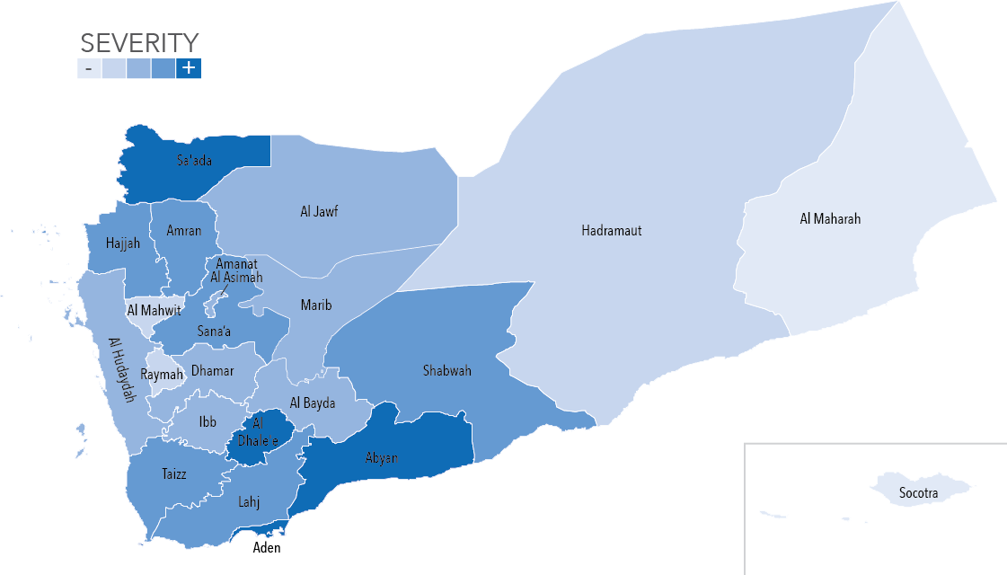

NEED

Lorem ipsum dolor sit amet, consectetur adipiscing elit, sed do eiusmod tempor incididunt ut labore et dolore magna aliqua. Ut enim ad minim veniam, quis nostrud exercitation ullamco laboris nisi ut aliquip ex ea commodo consequat.

**SEVERITY OF**

**Emergency Telecommunications**

**Camp Coordination & Camp Management**

**Water, Sanitation & Hygiene**





















INFORMATION GAPS AND

ASSESSMENT PLANNING

INFORMATION BY SECTOR

**Shelter**

**Nutrition**

Early Recovery

Logistics

Education

Health

Protection

**Food security**

**BY SECTOR**

**NEEDS OVERVIEWS**

**PART II:**

|  |
| --- |
| **FOOD SECURITY** |
| OVERVIEW |

Lorem ipsum dolor sit amet, consectetur adipiscing elit.

Pie chart by sex and bar chart by age are copy pasted directly from the ‘Sector Charts’ worksheet.

|  |  |  |  |
| --- | --- | --- | --- |
| NO .OF PEOPLE IN NEED | BY SEX | | BY AGE |
| 0.0 M |  | | |  |  |  | | --- | --- | --- | | **37%** Children (<18 years) | **50%**  Adult (18-59 years) | **13%** Elderly (>59  years) | |
| SEVERITY MAP | | |  |  |  |  |  | | --- | --- | --- | --- | --- | | - |  |  |  | + | | |
|  | | | |

Lorem ipsum dolor sit amet, consectetur adipiscing elit. Maecenas sollicitudin finibus odio vel iaculis. Proin convallis purus dolor, vel venenatis ligula hendrerit eget. Donec scelerisque elit nec volutpat tempus. Nulla lacinia ut dolor at suscipit. Suspendisse non consectetur risus, id tristique libe.

**Table Properties**

Alignment: Left

Text Wrapping: Around

Copy and paste the cluster severity map from the NCT dashboard and include an explanation of indicators and thresholds of severity used

Lorem ipsum dolor sit amet, consectetur adipiscing elit.

Lorem ipsum dolor sit amet, consectetur adipiscing elit. Maecenas sollicitudin finibus odio vel iaculis. Proin convallis purus dolor, vel venenatis ligula hendrerit eget. Donec scelerisque elit nec volutpat tempus. Nulla lacinia ut dolor at suscipit. Suspendisse non consectetur risus, id tristique libe. Lorem ipsum dolor sit amet, consectetur adipiscing elit.

|  |
| --- |
| HUMANITARIAN NEEDS OF THE AFFECTED POPULATION |

Lorem ipsum dolor sit amet, consectetur adipiscing elit. Maecenas sollicitudin finibus odio vel iaculis. Proin convallis purus dolor, vel venenatis ligula hendrerit eget. Donec scelerisque elit nec volutpat tempus. Nulla lacinia ut dolor at suscipit. Suspendisse non c onsectetur risus, id tristique libe. Lorem ipsum dolor sit amet, consectetur adipiscing elit.

Lorem ipsum dolor sit amet, consectetur adipiscing elit. Maecenas sollicitudin finibus odio vel iaculis. Proin convallis purus dolor, vel venenatis ligula hendrerit eget. Donec scelerisque elit nec volutpat tempus. Nulla lacinia ut dolor at suscipit. Suspendisse non consectetur risus, id tristique libe.

Lorem ipsum dolor sit amet, consectetur adipiscing elit. Maecenas sollicitudin finibus odio vel iaculis. Proin fgflacinia ut dolor at suscipit. Suspendisse non consectetur risus, id tristique libe fgfgfg fgf gfg fdg fdgfdgfgfgfgfgfgfgfgffffff convallis purus dolor, vel venenatis ligula hendrerit eget. Donec scelerisque elit nec volutpat tempus. Nulla fgfgfg fg fg fgflacinia ut dolor at suscipit. Suspendisse non consectetur risus, id tristique .

Below charts are placed in the footer of the page.

Ensure the charts are sourced, explained and referenced in the narrative above.

Lorem ipsum dolor sit amet, consectetur adipiscing elit. Maecenas sollicitudin finibus odio vel iaculis. Proin convallis purus dolor, vel venenatis ligula hendrerit eget. Donec scelerisque elit nec volutpat tempus. Nulla lacinia ut dolor at suscipit. Suspendisse non consectetur risus, id tristique libe.

Lorem ipsum dolor sit amet, consectetur adipiscing elit.

Lorem ipsum dolor sit amet, consectetur adipiscing elit. Maecenas sollicitudin finibus odio vel iaculis. Proin convallis purus dolor, vel venenatis ligula hendrerit eget. Donec scelerisque elit nec volutpat tempus. Nulla lacinia ut dolor at suscipit. Suspendisse non consectetur risus, id tristique libe. Lorem ipsum dolor sit amet, consectetur adipiscing elit.

Lorem ipsum dolor sit amet, consectetur adipiscing elit. Maecenas sollicitudin finibus odio vel iaculis. Proin convallis purus dolor, vel venenatis ligula hendrerit eget. Donec scelerisque elit nec volutpat tempus. Nulla lacinia ut dolor at suscipit. Suspendisse non consectetur risus, id tristique libe.

Lorem ipsum dolor sit amet, consectetur adipiscing elit.

Lorem ipsum dolor sit amet, consectetur adipiscing elit. Maecenas sollicitudin finibus odio vel iaculis. Proin convallis purus dolor, vel venenatis ligula hendrerit eget. Donec scelerisque elit nec volutpat tempus. Nulla lacinia ut dolor at suscipit. Suspendisse non consectetur risus, id tristique libe. Lorem ipsum dolor sit amet, consectetur adipiscing elit.

|  |
| --- |
| **CCCM** |
| OVERVIEW |

Lorem ipsum dolor sit amet, consectetur adipiscing elit.

|  |  |  |  |
| --- | --- | --- | --- |
| NO .OF PEOPLE IN NEED | BY SEX | | BY AGE |
| 0.0 M |  | | |  |  |  | | --- | --- | --- | | **37%** Children (<18 years) | **50%**  Adult (18-59 years) | **13%** Elderly (>59  years) | |
| SEVERITY MAP | | |  |  |  |  |  | | --- | --- | --- | --- | --- | | - |  |  |  | + | | |
|  | | | |

Lorem ipsum dolor sit amet, consectetur adipiscing elit. Maecenas sollicitudin finibus odio vel iaculis. Proin convallis purus dolor, vel venenatis ligula hendrerit eget. Donec scelerisque elit nec volutpat tempus. Nulla lacinia ut dolor at suscipit. Suspendisse non consectetur risus, id tristique libe.

Lorem ipsum dolor sit amet, consectetur adipiscing elit.

Lorem ipsum dolor sit amet, consectetur adipiscing elit. Maecenas sollicitudin finibus odio vel iaculis. Proin convallis purus dolor, vel venenatis ligula hendrerit eget. Donec scelerisque elit nec volutpat tempus. Nulla lacinia ut dolor at suscipit. Suspendisse non consectetur risus, id tristique libe. Lorem ipsum dolor sit amet, consectetur adipiscing elit.

|  |
| --- |
| HUMANITARIAN NEEDS OF THE AFFECTED POPULATION |

Lorem ipsum dolor sit amet, consectetur adipiscing elit. Maecenas sollicitudin finibus odio vel iaculis. Proin convallis purus dolor, vel venenatis ligula hendrerit eget. Donec scelerisque elit nec volutpat tempus. Nulla lacinia ut dolor at suscipit. Suspendisse non c onsectetur risus, id tristique libe. Lorem ipsum dolor sit amet, consectetur adipiscing elit.

Lorem ipsum dolor sit amet, consectetur adipiscing elit. Maecenas sollicitudin finibus odio vel iaculis. Proin convallis purus dolor, vel venenatis ligula hendrerit eget. Donec scelerisque elit nec volutpat tempus. Nulla lacinia ut dolor at suscipit. Suspendisse non c onsectetur risus, id tristique libe. Lorem ipsum dolor sit amet, consectetur adipiscing elit.

Lorem ipsum dolor sit amet, consectetur adipiscing elit. Maecenas sollicitudin finibus odio vel iaculis. Proin convallis purus dolor, vel venenatis ligula hendrerit eget. Donec scelerisque elit nec volutpat tempus. Nulla lacinia ut dolor at suscipit. Suspendisse non c onsectetur risus, id tristique libe. Lorem ipsum dolor sit amet, consectetur adipiscing elit.

Lorem ipsum dolor sit amet, consectetur adipiscing elit. Maecenas sollicitudin finibus odio vel iaculis. Proin convallis purus dolor, vel venenatis ligula hendrerit eget. Donec scelerisque elit nec volutpat tempus. Nulla lacinia ut dolor at suscipit. Suspendisse non c onsectetur risus, id tristique libe. Lorem ipsum dolor sit amet, consectetur adipiscing elit.

Lorem ipsum dolor sit amet, consectetur adipiscing elit. Maecenas sollicitudin finibus odio vel iaculis. Proin convallis purus dolor, vel venenatis ligula hendrerit eget. Donec scelerisque elit nec volutpat tempus. Nulla lacinia ut dolor at suscipit. Suspendisse non c onsectetur risus, id tristique libe. Lorem ipsum dolor sit amet, consectetur adipiscing elit.

|  |
| --- |
| **WATER, SANITATION & HYGIENE** |
| OVERVIEW |

Lorem ipsum dolor sit amet, consectetur adipiscing elit. Maecenas sollicitudin finibus odio vel iaculis. Proin convallis purus dolor, vel venenatis ligula hendrerit eget. Donec scelerisque elit nec volutpat tempus. Nulla lacinia ut dolor at suscipit. Suspendisse non consectetur risus, id tristique libe.

|  |  |  |  |
| --- | --- | --- | --- |
| NO .OF PEOPLE IN NEED | BY SEX | | BY AGE |
| 0.0 M |  | | |  |  |  | | --- | --- | --- | | **37%** Children (<18 years) | **50%**  Adult (18-59 years) | **13%** Elderly (>59  years) | |
| SEVERITY MAP | | |  |  |  |  |  | | --- | --- | --- | --- | --- | | - |  |  |  | + | | |
|  | | | |

Lorem ipsum dolor sit amet, consectetur adipiscing elit.

Lorem ipsum dolor sit amet, consectetur adipiscing elit. Maecenas sollicitudin finibus odio vel iaculis. Proin convallis purus dolor, vel venenatis ligula hendrerit eget. Donec scelerisque elit nec volutpat tempus. Nulla lacinia ut dolor at suscipit. Suspendisse non consectetur risus, id tristique libe. Lorem ipsum dolor sit amet, consectetur adipiscing elit.

|  |
| --- |
| HUMANITARIAN NEEDS OF THE AFFECTED POPULATION |

Lorem ipsum dolor sit amet, consectetur adipiscing elit. Maecenas sollicitudin finibus odio vel iaculis. Proin convallis purus dolor, vel venenatis ligula hendrerit eget. Donec scelerisque elit nec volutpat tempus. Nulla lacinia ut dolor at suscipit. Suspendisse non c onsectetur risus, id tristique libe. Lorem ipsum dolor sit amet, consectetur adipiscing elit.

Lorem ipsum dolor sit amet, consectetur adipiscing elit. Maecenas sollicitudin finibus odio vel iaculis. Proin convallis purus dolor, vel venenatis ligula hendrerit eget. Donec scelerisque elit nec volutpat tempus. Nulla lacinia ut dolor at suscipit. Suspendisse non consectetur risus, id tristique libe.

|  |
| --- |
| **INFORMATION GAPS AND ASSESSMENT PLANNING** |

Lorem ipsum dolor sit amet, consectetur adipiscing elit. Maecenas sollicitudin finibus odio vel iaculis. Proin convallis purus dolor, vel venenatis ligula hendrerit eget. Donec scelerisque elit nec volutpat tempus. Nulla lacinia ut dolor at suscipit. Suspendisse non consectetur risus, id tristique libe.

Lorem ipsum dolor sit amet, consectetur adipiscing elit. Maecenas sollicitudin finibus odio vel iaculis. Proin convallis purus dolor, vel venenatis ligula hendrerit eget. Donec scelerisque elit nec volutpat tempus. Nulla lacinia ut dolor at suscipit. Suspendisse non consectetur risus, id tristique libe. Lorem ipsum dolor sit amet, consectetur adipiscing elit.

|  |  |  |  |
| --- | --- | --- | --- |
| FOOD SECURITY | WASH | CCCM | HEALTH |
|  |  |  |  |
| SHELTER & NFIs | MULTI-SECTOR | NUTRITION | EMERGENCY TELECOM. |
|  |  |  |  |
| PROTECTION | EARLY RECOVERY | EDUCATION | RAPID ASSESSMENTS |
|  |  |  |  |
|  |  | |  |  |  |  |  |  | | --- | --- | --- | --- | --- | --- | |  |  |  |  |  |  | | 1 | 2 | 4 | 6 | 8 | >10 | | |

|  |  |
| --- | --- |
| NUMBER OF ASSESSMENTS |  |
| 000 |
| NUMBER OF PARTNERS |
| 000 |
| PLANNED NEEDS ASSESSMENTS |
| 000 |

* Copy the large map from the ‘dashboard’ worksheet of ‘Planned_Completed_assessments.xlsm’ workbook.
* Likewise, copy paste (below) the small sector / cluster assessment maps from the same worksheet.

|  |
| --- |
| * Copy the table from the ‘Assessments by sector’ worksheet of ‘Planned_Completed_assessments.xlsm’ workbook. * Place the cursor at the top of the page, go to Paste > Paste Special… * Click on Paste Link > Microsoft Excel Worksheet Object and hit OK. Adjust the size of the image to fit on page. |

|  |  |  |  |  |  |
| --- | --- | --- | --- | --- | --- |
| PLANNED NEEDS ASSESSMENTS | | | | | |
|  | | | |  |  |
| CLUSTER/SECTOR | LOCATION | TARGETED PEOPLE | LEAD AGENCY | PLANNED DATE | SUBJECT |
|  |  |  |  |  |  |
|  |  |  |  |  |  |
|  |  |  |  |  |  |
|  |  |  |  |  |  |
|  |  |  |  |  |  |

|  |  |
| --- | --- |
| ACRONYMS | |
|  |  |
|  |  |
|  |  |
|  |  |
|  |  |
|  |  |
|  |  |
|  |  |
|  |  |
|  |  |
|  |  |
|  |  |
|  |  |

|  |
| --- |
| NCT METHODOLOGY / INDICATORS |
|  |
| PEOPLE IN NEED (PiN) METHODOLOGY |
|  |