JOINT INTERSECTORAL ANALYSIS: WHAT IT CONSISTS OF AND HOW IT CAN BE DONE
GUIDANCE FOR OCHA

Draft, 22 September 2016
This internal guidance for OCHA clarifies the responsibilities of OCHA in supporting joint inter-sectoral analysis of needs, as part of the Humanitarian Needs Overview (HNO) exercise as well as for other types of inter-sectoral assessments, and indicates how this can be done in practice. It describes the steps that can be followed to facilitate discussions across agencies, sectors/clusters and other stakeholders, and to organize the data and information. The inter-sectoral analysis should result in a common understanding of the variety and combination of needs that people face, and the factors that are associated with these needs. They feed in the subsequent response analysis conducted for response planning and programming.
The guidance has not yet been applied in the field and will need to be adjusted as lessons are learned with its usage. The Coordinated Assessment Support Section (CASS) stands ready to provide assistance as required by Country Offices.

I - OCHA’s RESPONSIBILITIES IN JOINT INTER-SECTORAL ANALYSIS
OCHA’s mandate tasks the organization (among other things) to coordinate assessments of the humanitarian situation and needs. Depending on the contexts, this entails facilitating the conduct of joint multi-sectoral assessments (for example the Multi-Sector Initial Rapid Assessment – MIRA), or the compilation of agency and sectoral assessments to produce a consolidated inter-sectoral analysis. In principle, OCHA is not responsible for undertaking directly data collection and analysis. Instead, agencies or clusters either carry out these tasks themselves, or they contract another agency for this such as a local organization or consortiums such as the Assessment Capacities Project (ACAPS), the REACH Initiative, or the Joint IDP Profiling Service (JIPS). The outputs are then used by OCHA to produce an inter-sectoral needs assessment report, for example the annual Humanitarian Needs Overview (HNO).
OCHA may sometimes play a more direct role to collect and/or to analyse data, including gathering secondary data, processing directly data and information, conducting inter-sectoral analysis, and writing up the multi-sector assessment report. This happens especially when agencies or clusters have limited assessment and analysis capacities, and when no other agencies can be mobilized (and funded) to undertake assessments and analysis. OCHA then takes a lead role in the multi-sectoral assessment, with agencies or clusters reviewing data collection material and draft analysis outputs.
OCHA needs solid capacities to conduct multi-sectoral assessment and joint analysis when it is directly implementing these exercises. A sound understanding of what joint analysis consists of, is also essential in all cases for OCHA to properly facilitate the process when other agencies or clusters are in the lead.

II - PURPOSE AND OUTPUTS OF JOINT INTER-SECTORAL ANALYSIS

2.1 – Purpose of joint inter-sectoral analysis
Assessments of the humanitarian situation and needs are typically organized around sectoral topics, such as health, food security, shelter, education, protection etc. Even when these topics are combined in a single multi-sectoral assessment exercise (‘joint’ assessment), questions are generally asked along sectors and answers are analysed accordingly. People interviewed may provide information on their overall needs and priorities, but these tend to be compiled according to each sector they relate to, rather than be considered in their combination and interactions. Consequently, most assessment reports describe the situation, needs and factors associated with these needs sector by sector, with no or limited insights on the relationships between needs across sectors.
Inter-sectoral analysis seeks to understand the extent to which the various sectoral needs coexist within the same population groups and/or the same geographic areas. It also enables to explain how the sectoral needs and associated factors relate between each other, thereby aggravating (or compensating) the problem.
Inter-sectoral analysis enables us to understand the humanitarian situation and needs in a much more comprehensive manner. This contrasts with sectoral analysis which can hide the critical fact that problems and needs almost never exist in isolation: people face a variety of them simultaneously or one subsequent to the other: for example, the lack of income preventing to send children to school and to consume an adequate diet.
The outputs of inter-sectoral analysis not only describe the combination of needs in a same location or for certain people, but also the common factors that cause or are associated with the needs. This information, in turn, is essential to inform decision-making on strategic priorities and responses. As much as possible, to achieve the best results and synergies, responses should address the multiple needs that people face concomitantly and seek to influence the factors that contribute to various needs at once.
Inter-sectoral analysis also informs on which needs should be addressed first, inasmuch as they provoke or aggravate other needs. For example, treating acute malnutrition without solving first or simultaneously the water problem that contributes to it, will not achieve the best or sustainable results.
Very few agencies have the range of technical expertise required in each sector to undertake an inter-sectoral analysis. Hence the importance to conduct this analysis jointly, putting together the shared data and results from sectoral assessments or results.

2.2 – Expected output of joint inter-sectoral analysis
The main output of a joint inter-sectoral analysis is a convincing narrative of people’s combination of needs and associated factors, disaggregated by geographical area and other relevant characteristics such as displacement status, gender, livelihood occupation etc. Depending on the context and if situations and needs are highly diverse, several narratives may be needed according to the type of population group (i.e. IDPs versus the residents) and location (e.g. at the epicenter of a disaster versus more distant).
The narrative should explain people’s various survival and maintenance needs (current and forecasted) comprehensively rather than as a simple succession of separate issues. The emphasis should also be on how they inter-relate: for example, eating poorly and becoming malnourished are associated with lack of income, which is itself linked to the inability to purchase sufficient food and to pay for health treatment; children are missing out school because of security threats along the way to school; etc.
The narrative should highlight the main factors or causes of the lives and livelihood needs, from the most direct or proximate ones (e.g. disease and lack of food are directly contributing to acute malnutrition), to the more indirect/underlying and basic ones (e.g. the political stalemate fuels the conflict which is at the origin of people’s displacement and loss of livelihoods). Factors contributing to several problems at once should be identified, as they will guide decisions on strategic planning and response.
The number of persons in need within the population groups should be estimated as well as the severity of their needs. An attempt should also be made to project how the needs and numbers are likely to evolve during the forthcoming planning period.

These various elements are all necessary to inform the subsequent stage of inter-sectoral response analysis for planning. During the response analysis, the type of needs (across and by sector), number of persons presenting them and severity are considered alongside operational considerations.

2.3 - OCHA’s main role in facilitating inter-sectoral analysis
As a non-operational agency, OCHA can play a critical role to facilitate joint inter-sectoral analysis that transcends sectoral interests. Its main role is to:

- Help agencies, sectors/clusters and other stakeholders to reach a common understanding of the population groups and individuals of most concern and their humanitarian situation, needs, and associated factors. Based on the steps described in Section III below, OCHA’s facilitation should assist with the identification of common or overlapping needs and inter-relations for these population groups.

- Verify that hypotheses and evidence are transparently disclosed. There will be gaps of information that should be made known together with their implications. Any contradictory results that cannot be resolved should be mentioned and, as much as possible, explained (e.g. results corresponding to different timing, sources of information etc.).

- Make sure that the ‘narrative’ is self-explanatory for the subsequent stage of response analysis. People’s combination of needs, associated factors and their inter-relations should be considered together with other operational and resource considerations. The clearer the assessment results are, the more likely it is that they will be used for deciding on strategic response planning.

III- MAIN STEPS TO CONDUCT AND FACILITATE JOINT INTER-SECTORAL ANALYSIS

3.1 – Overview of the approach for inter-sectoral analysis
Acknowledging complexity
Undertaking an inter-sectoral analysis jointly with different agencies, sectors/clusters and other stakeholders is a complex matter. Humanitarian situations are typically difficult due to the diversity of events contributing to a crisis, multiple actors and population groups, different political, social, economic, environmental conditions etc., and frequent volatility. In addition, sectoral analysis requires specialized technical expertise, while combining sectoral outputs for a comprehensive inter-sectoral analysis adds another layer of complexity.
The aim is to achieve a common understanding and agreement among the various stakeholders on the analysis, acknowledging that information is imperfect. The analysis should also not be static and results have to be constantly updated. In fact, more flexible and continuous joint inter-sectoral analyses that build on changes or new data will make the undertaking easier. This approach should be encouraged rather than relying on annual one-off exercises.

People-centered and area-based approach
The cornerstone of inter-sectoral analysis is a people-centered approach, so that needs are ‘anchored’ on people rather than sectors. Depending on the context, different groups of people and types of individuals may be identified, based on hypotheses on their needs. Each group is considered separately for the inter-sectoral analysis, but it is possible to “combine” some of them as the analysis proceeds and similarities are observed.
In the Humanitarian Needs Overview, this translates in the ‘Humanitarian Profile’ that distinguishes specific groups and/or individuals e.g. according to displacement status, proximity to conflict or disaster-affected areas, socio-economic or other vulnerability characteristic etc.
In some cases, the lack of data at the desired population level requires an area-based approach whereby people’s needs are generalized within certain areas. While this is one step away from people, it has programmatic benefits (geographic concentration of responses). This approach also does not prevent more analysis to be undertaken on population groups as soon as data can be obtained.
Eventually, the inter-sectoral analysis should “tell people’s lives and livelihoods story” in a convincing way, backed by evidence (quantitative and qualitative). It should describe what makes people’s situation unique due to the combination of factors (political, societal, historical, economic, geographic/ environmental, human) that affect their ability to meet their essential needs for survival and livelihoods. The relations between these factors (how they relate with each other, in which sequence or feedback loop) should be explained. With this approach, sectors come at end of the analysis, when they are linked back to the lives and livelihood outcomes and associated factors. It is expected that the same outcomes and factors will be related to different sectors, thus highlighting the inter-sectoral dimension.

Main inter-sectoral analysis steps
There are 8 main steps to facilitate inter-sectoral analysis. The steps are summarised in the table below. They are iterative rather than strictly consecutive, as analysis results and discussions call for adjustments as the exercise proceeds. Details on each step are provided in Section 2.3.
Inter-sectoral analysis steps | Aim
Step 1 – Agree on the key questions that the inter-sectoral analysis should answer | To structure the inter-sectoral narrative on people’s lives and livelihood needs.
Step 2 – Agree on preliminary population groups and geographic areas of focus | To determine which population groups and geographic areas are of primary importance for the analysis.  The groups and areas of interest are subsequently adjusted as the analysis proceeds, by combining those that are similar.
Step 3 – Agree on an analytical inter-sectoral “conceptual model” | To guide the processing of data and information around an inter-sectoral model that illustrates people’s lives and livelihood needs, the factors that are associated to these needs and their inter-relations across sectors.  The model is the basis for the subsequent analysis steps.
Step 4 – Describe the lives and livelihood needs of each population group, and their severity | To explain the type of survival and maintenance needs that people face, the main reasons for these, and how severe they are. . Use is made of the conceptual framework for this purpose.  This is an important element at the response analysis stage.
Step 5 – Estimate the number of Persons in Need | To quantify the number of persons facing a combination of needs, including by population groups, geographic areas and sectors  This is another important element at the response analysis stage.
Step 6 – Integrate ongoing and planned responses in the analysis of needs | To broadly estimate the extent of unmet needs.  This is necessary for the response analysis.
Step 7 – Project how people’s needs may evolve in future | To estimate how the needs and number of Persons in Need may change during the forthcoming planning period.  This is also necessary for the response analysis.
Step 8 – Identify commonalities between population groups and/or geographic areas | To synthetize the analysis and associate population groups and/or geographic areas that present a similar profile in terms of needs, factors associated and expected evolution.  This helps simplify the discussions at the response analysis stage.

2.3 – Inter-sectoral analysis steps
The main analysis steps are coherent with the analytical framework of the Multi-Sectoral Initial Rapid Assessment (MIRA) Guidance. They require upfront consultations with the various stakeholders (agencies, clusters, local organisations involved, government representatives where appropriate) and agreement at every stage. As mentioned, they are iterative rather than consecutive, with adjustments done as the exercise proceeds.

Step 1 - Agree on the key questions that the inter-sectoral analysis should answer

In order to structure the discussions and the final inter-sectoral narrative on people’s lives and livelihood problems and needs, it is helpful to shape the analysis around key questions to answer:

- Who and how many people face survival and livelihood needs?
- Where are these people located?
- What do their survival and livelihood problems consist of?
- Why are these problems occurring (at immediate and underlying/structural levels)?
- What is being done to address these needs?
- How are the needs expected to evolve in future, based on ongoing and planned responses and other events?

Step 2 - Agree on preliminary population groups and geographic areas of focus for the inter-sectoral analysis

This step provides the frame for key questions (1) and (2). In most crises, hypotheses can be made on specific population groups and locations that are likely to present different survival and livelihood needs, based on secondary information and knowledge.

However, care should be taken not to pre-empt conclusions. The pre-identification of groups of interest aims at anchoring the analysis on people rather than sectors and at concentrating the analysis on the expected groups and areas presenting needs, but it does not presume of the actual results of the analysis. In other words, the analysis may demonstrate less needs than anticipated, or additional or different population groups and individuals may emerge as presenting survival and livelihood needs, and different geographical areas of interest may also be uncovered.

An empty matrix can be produced at the end of this step, as in the example below.

Example of compilation matrix for the inter-sectoral analysis
 | Group A  (e.g. IDPs less than 3 months) | Group B  (e.g. IDPs more than 3 months) | Group C  (e.g. residents in areas hosting IDPs) | Group D  (e.g. residents without IDPs) | Group E  (e.g. nomads)
Area 1 (e.g. urban areas with active conflict)
Area 2 (e.g. urban areas without conflict)
Area 3 (e.g. rural areas with active conflict)
Area 4 (e.g. rural areas without conflict)
Area 5 (e.g. hard-to-reach areas rural)

Step 3 - Agree on an analytical inter-sectoral “conceptual model”

This step provides the frame for key question (3). It aims at guiding the processing (and collection) of data around a conceptual model that illustrates: (i) which needs related to people’s lives and livelihoods are expected to manifest and to coexist – these correspond to people’s lives and livelihood outcomes; and (ii) which factors (proximate as well as underlying/chronic/structural) are expected to be associated with the various survival and livelihood needs. The model should also describe how the various needs and factors are inter-related. The model is not drawn around sectors but around a more comprehensive understanding of the multiple needs that people face.

The development of the model should precede data processing and analysis, in order to structure these. Initially, the model is based on hypotheses on what the problems and the associated factors are, informed by secondary information, previous knowledge, experience, etc. However, adjustments to the model should be done when the actual data and information are processed and enable to check on the hypotheses.

The model should be general enough to be applicable to the different population groups and locations identified in Step 2. In certain circumstances, the heterogeneity of the crisis may call for several models, or for “sub-models” that complement the generic one. Annex 1 gives additional details on how the model can be developed, while Annexes 2, 3 and 4 show the malnutrition model and the sustainable livelihood models as examples.

To help define the life and livelihood outcomes and factors associated in the conceptual model, it may be useful to consider a rough categorization such as the one illustrated below (example only). The conceptual model should also describe the linkages between the various elements.

Example of components of the inter-sectoral analysis of lives and livelihood outcomes and factors
Outcomes | Outcome manifestations (as much as possible disaggregated sex, age, other vulnerability characteristics) | Immediate factors (to be adjusted according to context) | Underlying / chronic / structural factors (to be adjusted according to context)
Life / survival | - Acute malnutrition  - Morbidity  - Mortality | - Food consumption  - Health treatment/ essential health services  - Physical protection | - Availability, access, quality and stability of:  - Food (food security)  - Water  - Sanitation  - Health services  - Housing/shelter  - Physical/productive assets  - Natural assets  - Financial assets (income, remittances, savings)  - Commodity markets (performance)  - Labour markets (performance)  - Communications (roads, telephone, internet)  - Social assets (integration)  - Socio-cultural environment (attitudes and norms related to gender, age and other characteristics)  - Political environment (power, rights)  - Exposure, frequency and intensity of hazards (climatic, geophysical)
Livelihood / mainte-nance | - Purchasing power compared to minimum consumption basket (MCB)  - Purchasing power compared to MCB + savings + investment  - Indebtedness  - Destitution (assets)  - Living conditions (e.g. type of housing | - Education level  - Physical/working capacity  - Dependency ratio  - Market prices  - Labour wages  - Harvest  - Livestock production  - Displacement

Step 4 – Describe the lives and livelihood needs of each population group, and their severity

The completion of this step answers the first 4 key questions except the “how many” which is tackled in step 5 below. It is done by compiling existing data and information on people’s lives and livelihoods for the selected population groups and locations (step 2) and organizing these based on the conceptual model (step 3).

The matrix developed in step 2 can be used to compile the information. At this point, adjustments can also be done to the population groups and geographic areas of focus (revision of step 2), and to the model and hypotheses that were made on the problems, needs and associated factors (revision of step 3), based on the actual data and information. Processing the data and information after having drawn the model is important to avoid that it is the data and information that are available which overly influence what the needs and factors are.
The adjustments that are made to the model must be transparent and evidence-based rather than driven by which agencies or sectors have the most information. The inputting of data/information can be undertaken separately by the various agencies, clusters and other stakeholders, with the various inputs consolidated by OCHA.

Disaggregation within groups is important to identify specific vulnerability factors such as those associated with gender, age, other socio-economic characteristics, and specific locations within the geographic areas of focus (e.g. a specific sub-area exposed to particular threats or hazards). These factors should complement the other factors identified as associated with survival and livelihood outcomes.

Caution should be exerted not to translate ‘problems and needs’ into responses at this stage. This is done during the subsequent response analysis that should bring together the assessment and the programming actors to support planning and programming.

The severity of needs should also be analysed at this step, to help with subsequent prioritization during the response analysis. Typically, population groups presenting survival needs are in a more severe condition than those presenting only livelihood needs. However, a proper discussion with the various agencies, sectors/clusters and other stakeholders must take place. The severity analysis should use the conceptual model (step 3) to help identify indicators and thresholds reflecting the outcomes for people’s lives and livelihoods and/or the factors associated. The selection should also take into account the co-existence and interactions among these various factors that are likely to aggravate the severity.

Once the rationale that supports the severity analysis is clear, tools such as the Needs Comparison Tool or another approach can be used to facilitate a quantitative or qualitative scoring and comparison among population groups and geographic areas. It is essential that the severity analysis is transparent and evidence-based, supported by a clear rationale informed by the conceptual model.

At the end of this step, a narrative description of the combination of needs that people face for their survival and maintenance (life and livelihood outcomes), together with some explanation of why these needs occur (the factors associated) based on the conceptual model, can be done for each population group and geographic area. It should describe how the characteristics of people (vulnerabilities and capacities), location and/or sequence of events contribute to their lives and livelihood needs. The factors associates should be explained logically, from the most direct to the most indirect (e.g. chronic, structural) ones.

Some similarities between population groups and/or geographic areas may be observed, leading to a decision to associate some of them: for example groups facing the same problems to meet their essential needs to survive with sufficient food, health care, sheltering and protection, for the same reasons (e.g. disruption of markets, loss of assets). This re-grouping is not compulsory at this step, but can help facilitate the subsequent steps by reducing the number of groups and geographic areas of focus for the analysis.

Step 5 – Estimate the number of Persons in Need

This step answers the ‘how many’ of key question (1). In the ideal, assessments have been designed according to the population groups and geographical areas of focus agreed in step 2. In this case, the estimation of the number of Persons in Need is directly derived from the analysis done before (step 4), given that the data refer directly to the groups and geographic areas of interest. The total number of Persons in Need is a simple sum of the number of Persons in Need in each population group and geographical area, as these are not overlapping.

In most cases however, data are not collected exactly according to the population groups and geographic areas of focus for the inter-sectoral analysis. This can be due to various reasons such as differences in the objectives and sectoral coverage of the assessments that were conducted, access issues, unavailability of population data at the desired level of disaggregation etc. As a consequence, the number of Persons in Need cannot be calculated directly from the data processed for the inter-sectoral analysis and has to be extrapolated. This is done by “retrofitting” the population groups and geographic areas of focus in the inter-sectoral analysis, to other units of analysis for which population figures are available. These units of analysis will often be broader or more generic: for example “all IDPs” rather than IDPs disaggregated by length of displacement, and “administrative units” or “rural” and ”urban” rather than geographic areas characterized by certain events (e.g. conflict or another shock).

This re-combination of population groups and geographic areas to fit with other groups and areas for which population data are available is imperfect. This is because there will rarely be a neat overlap between the original groups and areas and the ‘retrofit’ groups and areas. Some of the original groups may end up distributed differently to match with the population figures available. The findings on lives and livelihood needs analysed in the previous step will thus be extrapolated to the new groups and/or areas while some of them present a different situation and needs. The extent of discrepancy should be kept to the minimum possible, but it is important to document it transparently.

The number of Persons in Need can be calculated in two main ways, as described in the inter-agency guidance on Humanitarian Profiling. One way (‘top-down’) is to identify “drivers of need” and estimate the number of persons who present them. This approach can use the conceptual model and the findings of step 4 for this purpose. An example is shown below using the matrix developed in step 2. The total PiN is calculated from the sum of the PiN in the various “retrofit” groups and areas.

Example of “retrofit” of population groups and geographic areas of focus, to adjust to units of analysis with population figures available
 | Group A  (e.g. IDPs less than 3 months) | Group B  (e.g. IDPs more than 3 months) | Group C  (e.g. residents in areas hosting IDPs) | Group D  (e.g. residents without IDPs) | Group E  (e.g. nomads)
Area 1 (e.g. urban areas with active conflict) | Retrofit: “IDPs in urban areas with active conflict”  Population figures available for IDPs already registered to receive assistance. Total IDP figure extrapolated based on Key Informants (e.g. 30% IDPs are registered, 70% are unregistered)  Number of PiN among IDPs in urban areas derived from the combined needs analysis of Groups A and B |  | Residents in urban areas with active conflict and IDPs (no retrofit needed)  Population figures extrapolated from last census (including projections as census is  outdated)  Number of PiN among these residents derived from the needs analysis of Group C | Residents in urban areas with active conflict but without IDPs (no retrofit needed)  Population figures extrapolated from last census (including projections as census is outdated)  Number of PiN among these residents derived from the needs analysis of Group D | (Absent)
Area 2 (e.g. urban areas without conflict) | Retrofit: “IDPs in urban areas without active conflict”  Same as above, except that Key Informants indicate only 10% IDPs registered. |  | Similar as above | Similar as above | (Absent)
Area 3 (e.g. rural areas with active conflict) | Retrofit: “IDPs and residents in rural areas (with and without active conflict)”  Population figures only available from Key Informants. Last census too old to be relied upon even with projections due to extensive population movements and migrations from rural areas (more than urban areas). Not possible to estimate the number of IDPs versus residents, as only those located in settlements have been counted. Decision made to use Key Informants figures combining resident and IDP estimates.  Number of PiN among IDPs and residents in rural areas derived from combined analysis of Groups A, B, C and D |  |  |  | Retrofit: “Nomads in rural areas with and without active conflict”  Total number estimated from Key Informants  Number of PiN derived from the analysis of Group E
Area 4 (e.g. rural areas without conflict)
Area 5 (e.g. hard-to-reach areas rural) | IDPs and residents in hard-to-reach areas  Same as above |  |  |  | (Absent)

Another way (‘bottom up’) to estimate the number of Persons in Need is to use sectoral data. Most assessments currently collect and analyse data by sector, even if assessments are multi-sectoral. While the inter-sectoral analysis approach described here is an effort to circumvent parallel sectoral analyses, it remains the case that population figures are often available by sector. It is then necessary to link the analysis of people’s lives and livelihood that has been done according to selected population groups and geographic areas, to the sectors that correspond. For example, life/survival outcomes in terms of morbidity and lack of accessible primary health care facilities are related to the Health sector; inadequate food consumption due to the low amounts and diversity of food purchased on markets as prices are high, is related to the Food Security sector; forced displacement due to attacks by armed groups is related to the Protection sector; etc.

The sectors can be indicated in the initial matrix or shown in a second matrix (so as not to overload the first matrix with too much information). An example is shown below, which should be further detailed, including by indicating the nature of the sectoral needs. Care should be taken not to express the sectoral needs as responses, as additional information is required for this purpose (operational).

The total PiN is calculated from the highest sectoral PiN in each group/area as per the guidance.

Example (1) of re-analysis of population groups and geographic areas of focus, to indicate the sectors concerned
 | Group A  (e.g. IDPs less than 3 months) |  | Group B  (e.g. IDPs more than 3 months) | Group C  (e.g. residents in areas hosting IDPs) | Group D  (e.g. residents without IDPs) | Group E  (e.g. nomads)
Area 1 (e.g. urban areas with active conflict) | Health  Food Security  Shelter  WASH  Protection |  | Health  Food Security  Shelter  WASH  Protection  Education | Health  Food Security  WASH  Protection | Food Security  Protection | (Absent)
Area 2 (e.g. urban areas without conflict) | Health  Food Security  Shelter  WASH |  | Health  Shelter  WASH  Education | Health  Food Security  WASH | Food Security | (Absent)
Area 3 (e.g. rural areas with active conflict) | Health  Food Security  WASH  Protection |  | Health  Food Security  WASH  Protection  Education | Health  WASH  Education  Protection | Protection | Health  Protection  Education
Area 4 (e.g. rural areas without conflict) | Health  Food Security  WASH |  | Health  WASH  Education | Health  WASH  Education | Health  WASH  Education
Area 5 (e.g. hard-to-reach areas rural) | Health  Food Security  Shelter  WASH  Protection |  | Health  Food Security  WASH  Protection | Health  Food Security  WASH  Protection | Health  Food Security  WASH  Protection | (Absent)

Note that re-establishing the link to sectors does not necessarily eliminate the need for a ”retrofit” to new grouping of the population and geographic areas different from those initially used in the Inter-sectoral analysis, explained before. This is because sectoral assessments may also not have been designed according to the desired levels of disaggregation. In this case, the retrofit described previously (by combining or re-distributing some population groups and some geographic areas for which population figures exist) should be done, followed by the sectoral linkages. An example is shown below.

Example (2) of “retrofit” of population groups and geographic areas of focus, with indication of the sectors concerned
 | Group A  (e.g. IDPs less than 3 months) |  | Group B  (e.g. IDPs more than 3 months) | Group C  (e.g. residents in areas hosting IDPs) | Group D  (e.g. residents without IDPs) | Group E  (e.g. nomads)
Area 1 (e.g. urban areas with active conflict) | Retrofit: “IDPs in urban areas with active conflict”  Health  Food Security  Shelter  WASH  Protection  Education |  |  | Residents in urban areas with active conflict and IDPs (no retrofit needed)  Health  Food Security  WASH  Protection | Residents in urban areas with active conflict but without IDPs (no retrofit needed)  Food Security  Protection | (Absent)
Area 2 (e.g. urban areas without conflict) | Retrofit: “IDPs in urban areas without active conflict”  Health  Food Security  Shelter  WASH  Education |  |  |  |  | (Absent)
Area 3 (e.g. rural areas with active conflict) | Retrofit: “IDPs and residents in rural areas (with and without active conflict)”  Health  Food Security  WASH  Protection  Education |  |  |  |  | Retrofit: “Nomads in rural areas with and without active conflict”  Health  Education  Protection
Area 4 (e.g. rural areas without conflict)
Area 5 (e.g. hard-to-reach areas rural) | Retrofit: “IDPs and residents in hard-to-reach areas”  Health  Food Security  Shelter  WASH  Protection |  |  |  |  | (Absent)

Besides the PiN estimation, one benefit from this exercise is a representation of the overlaps between sectors for the same population groups and/or locations. This will be useful for the subsequent response analysis, when synergies for inter-sectoral responses are being sought.

Due to the various extrapolations and given the sensitivity around figures, it is essential to document transparently how the number of People in Need in the various groups and locations and the consolidated total PiN figure are obtained.

Step 6 – Integrate ongoing and planned responses in the analysis of current needs

This step addresses key question (5). It relates people’s lives and livelihood needs to interventions that are ongoing or planned to address them. The extent to which these interventions are expected to meet the identified needs should be indicated in order to identify which ones are likely to remain uncovered, for whom and where.

The information can be entered in the same initial matrix for each population group and geographic areas of focus. However, similarly as for the estimation of the number of Persons in Need, it will often be difficult to distribute ongoing and planned responses according to the groups and areas of interest, as programmes may not be implemented for these exact groups and areas. As for step 5, a ‘retrofit’ to population groups and/or areas that correspond more to available data and an indication of the sectors concerned can help with comparing needs to responses.

The aim is to gain a broad sense of how much of people’s multiple needs are addressed rather than a precise calculation of coverage. This is important for the step below of projecting the evolution of the needs, in order to account for the likely persistence or decrease of needs based on ongoing or planned responses. Should there be insufficient or no information on these, current needs should be considered without accounting for possible responses.

Step 7 – Project how people’s needs may evolve in future

This step aims to answer key question (6). It combines the analysis of people’s needs for their survival and livelihoods (steps 4 and 5) with the unmet needs estimated in step 6, and considers additional events that may take place during the projection period (e.g. during the one-year period of the Humanitarian Response Plan, or a different period suitable for the projection). These events may be positive (e.g. a forthcoming harvest, a return process) or negative (e.g. intensification of drought, resumption of conflict).

It is inherently difficult to predict future events as well as the coping capacity of affected people and the additional responses that external actors may trigger. As such, the projection of needs of the various population groups and of the numbers of Persons in Need, are best done in the form of ranges as well as qualitatively. It is important to document the assumptions that are made, in order to include them in the monitoring to be done subsequently on a regular basis.

The projected needs can be entered in the matrix, so as to compile all the information relative to the various population groups and locations in the same place in a systematic way and facilitate the comparison across groups and locations.

Step 8 – Identify commonalities between population groups and/or locations

This step is a culmination of all the previous ones to determine which population groups and/or geographic areas present a similar profile in terms of lives and livelihood needs, and factors associated. It aims at facilitating the response analysis by reducing the number of different situations, and at achieving synergies and efficiencies.

Comparisons and associations of population groups and geographic areas can be done in previous steps as well, notably after the inter-sectoral analysis done in step 4. This should not be confused with the re-grouping done in step 5 to enable the estimation of the number of Persons in Need, as this one is dictated by the need to ‘retrofit’ the units of analysis to those that provide population figures, rather than by real similarities among the population groups and/or geographic areas.

It is unlikely that several population groups or geographic areas will be exactly identical in their needs and associated factors. However, it is also unlikely that at the response stage individual/tailored interventions will be feasible for every single population group and area. A pragmatic approach is to associate population groups and individuals who present broadly the same problems with regards to their survival and ability to sustain their needs, and are subject to similar factors. Note that even between these groups, there may still be differences on the extent of unmet needs (depending on where and which interventions are implemented or planned) and of projected needs (depending on the type of events that may occur and responses that may take place in this case), which may warrant keeping them distinct eventually.

Annex 1
Developing an inter-sectoral analysis model
An inter-sectoral analysis model can take the form of a visual diagram to describe which problems there are, how they inter-relate, and the factors that influence them. Combined with an analysis of capacities and responses, these problems can be turned into needs.
Developing the analysis model ahead of using sectoral data and analyses is probably the heaviest step in the process. However, once done, this “reference” model will not have to be produced again for subsequent inter-sectoral analysis updates in the same context, unless there are major changes have occurred.

It is important to jointly agree on the analytical model before the sectoral analyses are being used. This is to avoid that the sectoral results introduce biases or exert an exaggerated influence simply because they are available while lacking in other sectors, or because they depict a particularly alarming situation in a given location or for a given population groups. Adjustments to the model based on evidence from the sectoral analyses are done. Having the model in place before prevents any upfront domination of a sector or the omission of other sectors or associated factors.
The causal model of malnutrition (see Annexes 2 and 3) provides an example of such model, albeit limited to a few sectors only. The model pictures the ultimate problem “acute malnutrition”, and how it results from problems in other sectors including food security, caring practices (which can be linked to sectors such as education or cross-cutting issues such as protection, gender roles etc.), and health. In turn, these sectoral problems are linked to other factors such as access to land, access to income, gender roles, functioning of health services etc.
Another example is the sustainable livelihoods model (see Annex 4), which identifies different livelihood outcomes or livelihood problems. Livelihood-related needs can be due to food insecurity, personal or collective lack of safety, sickness, inadequate education, etc. Different factors are associated with these needs, such as lack of access to productive inputs, absence of markets and credit, unemployment, inter-ethnic violence, lack of schools, environmental degradation etc.
A practical way to design the inter-sectoral analysis model is to:
- Agree on the most obvious problems for lives and livelihoods, and needs likely occurring for given population groups or individuals, and/or in given location. This is based on secondary data review and previous knowledge.

- Agree on the timeframe for the analysis: is the focus on the current situation or accounting for projected seasonal or other events. Two models may be needed, one for the current situation and one for the projection.

- For each of the main problems/needs, ask why they are occurring, starting with the most direct factor(s) or cause(s). Repeat the same question for each of these factors to identify the indirect factor(s) or cause(s). The process should stop when the factors or causes reach a level that is clearly beyond the reach of agencies or sectors to address at this point in time (for example, if displacement is due to village attacks that are themselves due to mismanaged electoral process, it may not be very helpful to dig further if the reasons for the wrong electoral process are clearly beyond humanitarian agencies’ remit).

This process can result in a complex diagram with multiple boxes representing the needs and associated factors, and lines that link them with each other, including feedback loops. However, the diagram should become simpler when adjusted according to actual sectoral analysis results. In addition, the model can be divided into more manageable pieces at the time of the discussion strategic objectives and response analysis, for example by regrouping needs that concern the same sub-group of sectors, the same locations or the same groups of population or individuals.

Annex 2
Causal model of malnutrition

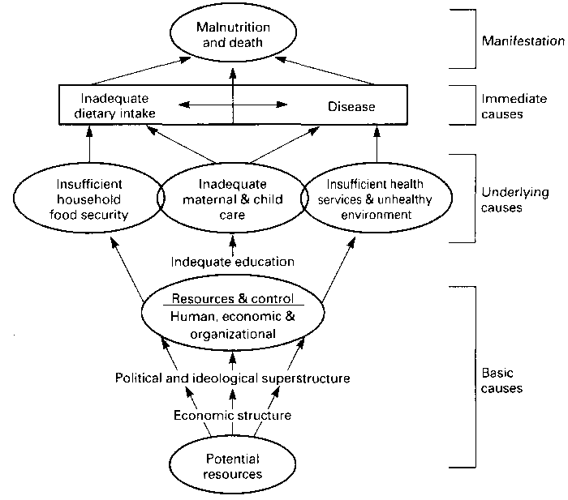b

Annex 3
Conceptual framework on the relationship between malnutrition, infections and poverty

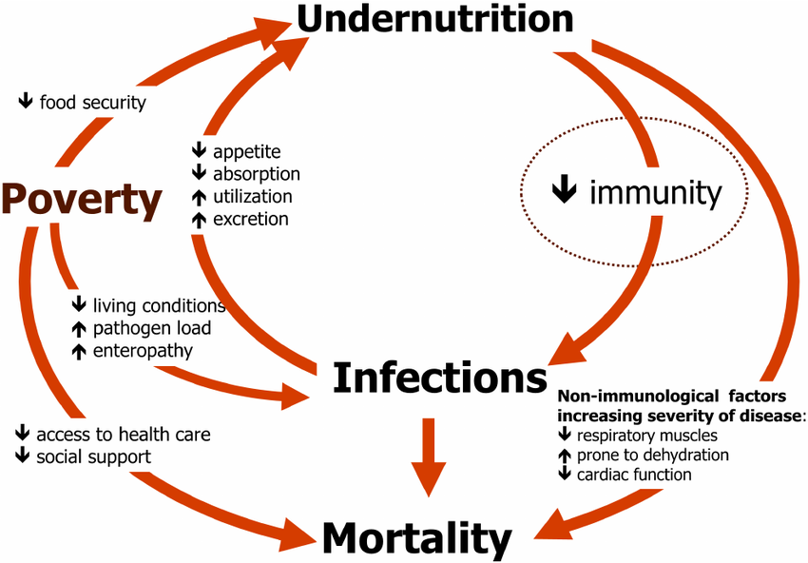

Annex 4
Sustainable Livelihoods Framework

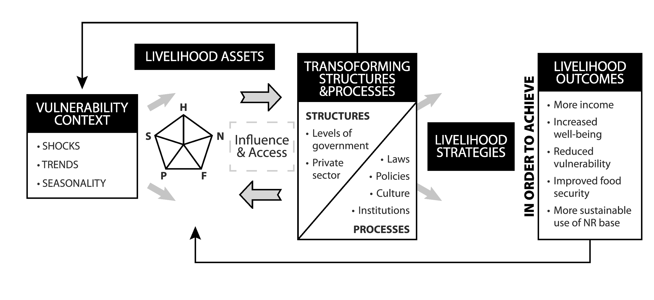

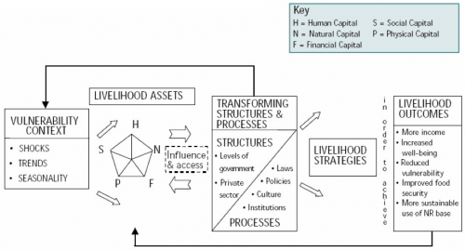

Without precluding the fact that in some instances, only one type of need (for one sector) may exist.
https://www.humanitarianresponse.info/fr/programme-cycle/space/document/multi-sector-initial-rapid-assessment-guidance-revision-july-2015
OCHA Coordinated Assessment Support Section plans to work with partner organisations on a ‘generic’ inter-sectoral conceptual model that could be easily contextualized. Progress on this work is expected early 2017.
For example, if data/information are lacking on certain protection issues, or any other issues, the corresponding needs may be missed, while the conceptual model includes them and the lack of data is made visible and taken into account in the analysis and interpretation.
https://www.humanitarianresponse.info/fr/system/files/documents/files/humanitarianprofilesupportguidance_final_may2016.pdf
https://www.humanitarianresponse.info/fr/system/files/documents/files/humanitarianprofilesupportguidance_final_may2016.pdf

